Hi all!

Here is an unfinished rough sketch of my third chapter for my dissertation, “American Graphicity: Postwar Ethnic Literature and Visual Culture.” The dissertation proposes a type of reading of ethnic literature that emphasizes visuality (vision, visibility, visual culture), which I argue generates new understandings of how perceptions of race are represented in literature, and, in turn, how visuality is utilized formally to represent those formulations. In the previous chapters, I discussed visual conceptions of whiteness in the works of James Agee and Hunter S. Thompson, and the conceits of invisibility and hypervisibility seen in Ralph Ellison’s Invisible Man and Ishmael Reed’s Mumbo Jumbo. As I’ve stated, this is a very rough work, so I would be accepting of any type of feedback, be it large or small. Due to time constraints, I wasn’t able to really develop a lot of the arguments I want to take on, but hopefully there’s enough here to make sense and create conversation.

I will add that I envision the chapter developing a deeper discourse about the relationship between comics and Jewish American culture, one that pays particular attention to the aesthetic characteristics (that is, the formalism) of the comics medium. In the next draft, I also plan to discuss Michael Chabon’s The Amazing Adventures of Kavalier and Clay, as well as other experimental works of Art Spiegelman—I mention it just in case any of you have any insight into such objects!

Thanks for taking the time to read and help develop my work.

– Oscar

Oscar Chavez

Art Spiegelman and the Jewishness of American Comics

In late 2005, the Hammer Museum and the Museum of Contemporary Art (MOCA) of Los Angeles collaborated on a joint exhibition, certainly the largest if not presumably the first of its kind, which endeavored to “establish a canon of fifteen of the most influential artists working in the medium throughout the 20th century.” Appropriately titled Masters of American Comics, the exhibition assembled a diverse set of cartoonists ranging from pioneers of the form, including Winsor McCay and George Herriman, to late-century underground and alternative luminaries, such as R. Crumb, Chris Ware, and Art Spiegelman. The latter, while initially being an enthusiastic consultant for the event, eventually withdrew from the show after discovering that the exhibition would leave Los Angeles for the East Coast, with the comic strip work exhibited at the Newark Museum and the comic book and graphic novel work shown at the Jewish Museum, a fact Spiegelman only became aware of through a New York Times ad. His concern, he later explained, was rooted in the fear that the “aesthetic and curatorial choices…would be distorted into becoming a provincial show about the ethnography of comics” (MetaMaus 125-126). To further clarify, the following is an excerpt from a letter Spiegelman sent to the L.A. museum directors:
“…The fact that the Jewish Museum will be the site within the NYC limits for the seven comic book artist to be exhibited there [makes] central a subtext that was invisible at MOCA: the early comic book (unlike its more upscale cousin, the comic strip) was a largely Jewish creation…I understand that only four of the seven artists in the Jewish Museum’s portion of the show are card-carrying Jews…and that I’m the only one still living who carries that card. But since Maus looms so large in the public’s perception of the comic book’s recent apotheosis, the subject of the Holocaust can trump considerations of form in this museum’s context. The statement intended by the Masters show, an exhibit formed to postulate that comics can actually be some sort of…Art, would be undermined by presenting the medium as some sort of ‘ethnic’ phenomenon.” (126)
Spiegelman goes on to propose an alternative curatorial arrangement, in which the comic strip cartoonists of the earlier period would be shown alongside the comic book artists of the more contemporary period—a way to foreground the developments of the art form over time. After the directors showed no interest in altering their plan, Spiegelman withdrew from the show, “trying to just bite my tongue and not curse too loudly about a significant exhibit that had devolved into a confused mess” (127).
It would appear ironic that the author of Maus, a long-form graphic narrative about a Jewish-American cartoonist and his Holocaust-surviving father, a work that Spiegelman rightfully asserts brought forth the apotheosis of the comic book in the mainstream and arguably continues to stand as exemplar of the art form, would object to the linkage suggested by holding a comics-centered show in a Jewish museum. Using scare quotes around “ethnic” and using words like “provincial,” it almost appears as though Art Spiegelman finds the “confused mess” of the connection between Jewish ethnicity and the art form of comics as insulting. The truth, however—for Spiegelman, for any scholar of comics—is more complicated than that.
Certainly, Spiegelman’s resentment is partially rooted in the historical marginalization of the art form of comics, which has often been mischaracterized as a genre or dismissed outright as a “low,” valueless form of pop culture due to its association with pulp fiction and other ephemeral forms, especially by the guardians of so-called high art. Furthermore, in American academia, serious inquiry into comics work has mostly if not always attended to the cultural, contextual aspects of comics—for example, representations of ethnic identity or its role in, say, the development of teen culture after World War II—while undervaluing its rather singular aesthetics. However, anyone familiar with Art Spiegelman’s work can attest to the cartoonist’s aversion to Judaism or religion for that matter and to his uneasy relationship to his Jewishness at large. In MetaMaus, his reference companion book to his masterpiece Maus published twenty-five years after (largely as a way of definitively addressing the same questions he receives ad nauseam about the comic book), he describes how as a child he used comics as a way to create distance between his parents and him, “It was my assimilation into the American culture in ways that were closed to my parents, and it gave me a zone of safety from them, in that sense. Doing Maus in cartoon form was probably abetted by the fact that I knew it would be opaque to Vladek” (37). To Spiegelman, comics and Jewish ethnicity are polar forms.
When he started cartooning himself, becoming an important figure in the “underground comix” scene of the 1960s, his comics displayed, as we will see in more detail later, a deep interest in the critical exploration and artistic experimentation with the comics form rather than concerns of identity, which of the latter he drew largely negative associations. He explains irreverently, “My research and work wasn’t propelled by any interest in Judaism or Jewishness. If anything, I shared an ambient ‘60s countercultural disdain for that sort of stuff. In fact, from what fairly little I knew of what had happened to my parents and their family, their friends and their world, all I could figure was that being Jewish wasn’t an especially good idea” (“Looney Tunes…” 2).
When Spiegelman first approached the subject of his parents’—Vladek and Anja’s—experience of surviving the Holocaust in Europe in the three-page “Maus” (1972), published in the underground comic Funny Animals, he obscured the historical referents for the two groups (though its implicitness is rather transparent), using “Die Katzen” for the Nazi cats, and “mice” for the Jewish mice. Returning to the same conceit after a few years, he explains,
“…intent on creating the Great American Comic Book Novel, I quickly found…that I couldn’t legitimately narrate the specifics of what happened to my family without referring to their Jewishness, that it was intrinsic to what happened to them, that the only road to the universal lay in the specifics, that I was going to have to settle for going after the Great Jewish-American Comic Book Novel, and that, somehow, doing Maus involved coming out of the closet as a Jew.” (“Looney Tunes…” 3)
Despite this demonstrable aversion to his Jewish identity, Spiegelman, by cartooning one of the greatest works of comics, of memoir, and of the Holocaust, is forever linked to Jewish culture in postwar America. In fact, as he explains, it is because of his Jewishness, as it relates to his parents and to history at large, that he is able to “legitimately” communicate the truth of his parents’ experience and of his own. Nevertheless, in a further elaboration about his relationship (or lack thereof) with his Jewish identity, he juggles his bond with other sons and daughters of Holocaust survivors with his aversion to that label,
“The work seems to have found itself useful to other people in my situation, meaning children of survivors (even though I resist terribly being part of any group other than ‘cartoonists’)….For some other children of survivors, Maus in a sense offered permission to reconfigure their own thoughts about what they’d gone through….That was OK! On the other hand, I didn’t want to be contained in the notion of a Jewish-American artist, and all of these hyphens are issues.” (MetaMaus 103)
Here he rather explicitly uses “cartoonist” in the same manner as ethnicity, the former being the optimal designation. This demonstrates Spiegelman’s dedication to art, specifically to the development of his chosen medium, comics, while signaling that the apparatus of ethnicity can only create the disharmony, the “issues,” which leads to, say, one racial group committing genocide against another. In the simplest sense, art is a means of free expression, while his Jewish-American ethnicity is a notion that entraps or “contains” him—or, more appropriate to our subject matter—ethnicity is a rigid panel that boxes him in.
While the emotional sentiment behind this simplistic breakdown of form and context is understandable, it belies the important collaboration that occurs between medium and jarringly complex narratives in comics such as Maus. The comics form enables Spiegelman to process and explore his relationship with his father and his story, and to do so with an amount of accuracy and attentiveness necessary to faithfully process its particularities. To Spiegelman, “the story of Maus isn’t just the story of a son having problems with his father, and it’s not just the story of what a father lived through. It’s about a cartoonist trying to envision what his father went through. It’s about choices being made, of finding what one can tell, and what one can reveal, and what one can reveal beyond what one knows one is revealing. Those are the things that give real tensile strength to the work—putting the dead into little boxes” (emphasis mine, ibid. 73). The faithful reproduction of memoir is certainly a crucial part of Maus’s success; however, as Spiegelman claims, the processing of information and feeling that occurs within the narrative—the metafictional layer, wherein Art Spiegelman the character and Art Spiegelman the author attempt to make sense, to “envision” the unimaginable, to “tell” the unspeakable, to “reveal” the invisible—brings about the “tensile strength” of the project.
As familial, psychological, and ethnohistorical “revelation” is paramount to Spiegelman’s project, so too is revelation—the ability for viewers to witness in multiple registers—foundational to the medium of comics. In the most apparent sense, I speak of the visual component of comics that differentiate it from other literary or aesthetic forms. The viewer literally sees images, and these images coordinate on the unit of the page to narrativize, to show the passing of narrotological information. As Spiegelman and theorists of comics often underscore, comics is time spatialized, meaning that viewers perceive the developments of the story only through the concerted effort of reading images. However, as a hybrid of not only images but also text, the comics form creates meaning on multiple registers—the textual, the visual, the combination of the two, the dialogue, etc. Spiegelman says about Maus, “I’m literally giving a form to my father’s words and narrative…and that form for me has to do with panel size, panel rhythms, and visual structures of the page” (qtd. in Chute 200). Despite his clear preference for comics and his uneasiness with ethnic issues, in Maus Spiegelman employs the former to elaborate upon the other, showing that in fact there is more to be said about their interconnectedness than not. Therefore, an analysis of Maus that explores the way Spiegelman employs the aesthetic capabilities of comics will reveal to us how he processes and communicates his strained but crucially vital relationship with his father, and by extension, his Jewishness.
In the previous two chapters of this dissertation, I have examined canonical literary texts from different ethnic genres (white literature and African-American literature) of the postwar U.S., positing new heuristic approaches to ethnicity by scrutinizing the use of graphicity in those texts. Graphicity, we can say, is a metric of the visual that can be discerned in works of literature, from the figural (visual metaphor, imagery, discourse of sight) to the literal (use of drawings, sketches, photographs, iconography, or text as a form of image). For example, in the previous chapter, I contrasted the polyvalent conceit of racial (in)visibility in Ralph Ellison’s Invisible Man against Ishmael Reed’s Mumbo Jumbo, which incorporated literal images into its heady postmodernist text. In this chapter, I will concentrate on the work of Art Spiegelman, figurehead for not only the aesthetic prowess of American comics of the contemporary (alternative) period but also as one of the most important literary figures closely (and rather reluctantly) associated with the discourse of Jewish ethnicity in the same period. Rather than parsing out the elements of visuality in Spiegelman’s work, I will examine the way the cartoonist employs the singular medium of comics in order to render his and his father’s personal narratives as survivors, as family, and as Jews.
The study will concentrate on Maus’s memorable conceit of using animals as a way of visually representing races—mainly Jews as mice and Germans as cats, as well as “Poles” as pigs, Americans as dogs, Swedes as reindeer, and so on. I will show how this visual play tackles the ethical concerns of racial representation and stereotypes as well as the ever-important issue of representing something as historically traumatic and ethnically important as the Holocaust. In both these concerns, Spiegelman displays a clear need to place pressure on the cultural understandings that inform the constructs of race as well as Holocaust narratives. Furthermore, I will also shed light on how Spiegelman’s affinity towards his individualistic art form relate to his ethnicity, specifically his Jewishness. Despite Spiegelman’s misgivings, there exists a crucial interconnectedness between the phenomenon of twentieth century American comics and Jewish culture.

Jews and American Comics: An Overview

The historical entanglement between Jewish-Americans and the field of comics (comic strips, comic books, and graphic narratives) is a well-established and –studied subject of cultural critics. Rightfully so, many of these critics will attest, as the comic book was instrumental in offering artistic and economic opportunity to a historically marginalized, oppressed (immigrant) community.
The connection begins with the popularization of the newspaper comic strips in the mainstream, which engendered its Yiddish iteration. Marked by their vernacular nature, Yiddish and the comic strips of the turn of the century shared a similar fate. As Paul Buhle explains in Jews and American Comics (2008), “hostility toward the comic strip ran parallel, during a crucial phase, to the contempt of Jewish elites for Yiddish: disdain for the comic strip as a ‘bastard form’ merging picture and word was not so far from the charge of jhargon, a language neither Hebrew nor German nor Russian but something in between, leveled against Yiddish” (5). The two media expressed “low” class and political humor, so their partnership for artistic self-representation was well-suited. Later in the century, as Jews in the U.S. experienced unforeseen economic opportunities in the mainstream and began their steady march towards racial and ethnic assimilation into whiteness, while also entering a yiddishkayft turn (a modernized and secularized development of Jewish culture), Jewish artists, writers, and publishers found a central place in the comic book world; “nowhere but Hollywood, and mainly behind-the-camera Hollywood, was the Jewish role so influential in a major form of popular art” (9). Here, the open Jewishness of the Yiddish comic strip mutated towards a racial obscuring, contextually speaking, as Jewish writers and artists started proffering in the representation of white, idealized forms in superhero comics and the ilk. In the contemporary turn of the 1970s, coinciding with the iconoclasm and irreverence of the underground comix movement, Jewish cartoonists, such as Art Spiegelman and Harvey Pekar, began to recover the open Jewishness of their work, rendering Jewish culture and self-representations. The field reached its apotheosis with Spiegelman’s Maus.
Of course, the history of comics is also marked by extensive visual-textual representations of Jews by Jews and Gentiles alike. Works such as Fredrik Strömberg’s visual study Jewish Images in the Comics chronicle the different forms that this representation took; unsurprisingly, either intentionally anti-Semitic or not, many resort to comical or plain derisive, exaggerated stereotypes, the main one being the Jewish figure rendered in beard and with a long, hook nose. Art Spiegelman recounts his experience with this racist trope in his article, “Little Orphan Annie’s Eyeballs”: “I remember looking at old cartooning books when I was a kid and learning that a Jew had a hooked line for a nose and large animated hands” (2). The most openly anti-Semitic and proliferated image, which took on an especially important role in the period leading up to World War II, was the renderings of Jews with ratlike qualities, if not representations of them as rats, “vermin,” and similar creatures. This derogatory association, of course, would serve as an important figurative and visual inspiration for Spiegelman in his creation of Maus. Despite its ephemeral, or low, reputation, comics have had an important role in the spread of connotative images of ethnicity, especially for Jews. We will return to this discussion when we begin close-reading Maus.

[At this point in the chapter, I would like to discuss (devoting far less time to this than my discussion of Spiegelman) Michael Chabon’s The Amazing Adventures of Kavalier and Clay (2000). The novel tells the story of two Jewish cousins—Sam Clay, a New York-born aspiring writer, and, Joe Kavalier, a talented artist and a European Jew displaced from his home and family by the looming threat of Nazis—who as partners figure themselves into the booming comic book industry, while navigating the bewildering metropolitan America of World War II. While the characters are fictional (though, certainly inspired by historical cartoonist figures of the time), the novel takes painstaking care to recreate the environment and peoples of the comic book industry through dense amounts of history, allusions, and references. Important to this chapter is the way that the novel repeatedly posits how the not only the superhero genre but the comics form serves as a medium of expression for the personal and community-oriented anxieties of the two Jewish men. Throughout the novel, parallels are drawn between Kavalier’s utter hatred and impotence towards Hitler and his aesthetic mediation of said-anxieties. For example, his images are described as chaotic and as baroque as a battlefield, while the narratives continuously deal with how Clay and Kavalier’s avatar, the superhero The Escapist, beats up Hitler and other fascist villains. When this project begins to feel futile against the terrifying tide of the Holocaust, Kavalier resorts to technical experimentations with the form as a means of transmuting his guilt. After watching a cameo-making Orson Welles’ Citizen Kane, Kavalier is inspired to pushed the boundaries of the form: “All of the dissatisfactions he had felt in his practice of the art form he had stumbled across within a week of his arrival in America, the cheap conventions, the low expectations among publishers, readers, parents, and educators, the spatial constraints that he had been struggling against in the pages of Luna Moth, seemed capable of being completely overcome, exceeded, and escaped. The Amazing Cavalieri was going to break free, forever, of the nine little boxes” (361). In this respect, the theme of escaping, which occurs heavy-handedly throughout the narrative, figures as much into physical escape as formal innovation, linking artistic expression to social action. The novel demonstrates how the art form and its culture share an important connection to real world concerns, despite its under-valuation. I still need to develop the argument a little more, but the novel certainly relates that the problems largely derived from ethnicity can be powerfully addressed and envisioned by something as “trivial” as superhero comics.
This sets up the discussion of Spiegelman’s comics.]

Maus

The discussion of Maus (at least at this stage of the chapter’s development) is split into two distinct yet interrelated characteristics of the graphic narrative, specifically, concerned with Spiegelman’s figuration of race and ethnicity. The first explores the metaphorical, visual conceit of animals as race groups. In the following discussion, I will examine the logic of the conceit, marking moments in the comic book when the conceit is particularly emphasized, or when Spiegelman tests and even ruptures the conceit in punctuated moments in order to show its vulnerability. Ultimately, this close study will demonstrate how Spiegelman exploits the very language and logic of comics to show, on a visual and cognitive level, how the conceit—figuratively rooted in real demarcations of racism—is suspect and dangerous.
The other discussion involves the tensions arising from ethnic affinities, such as religious and ethnic persecution—and how that places pressure on the stability of Jewish identity in this work—as well as ethnic alienation. In other words, I examine those thematic moments in Maus where community is set against the concerns of the individual. This theme relates to our original discussion of Spiegelman’s disposition towards Jewish identity vis a vis his identity as a cartoonist.

Each volume of Maus begins with an epigraph. The first volume (1986) contains the short, ominous quote attributed to Hitler, “The Jews are undoubtedly a race, but they are not human” (4). The second volume (1991) contains this far-more bombastic yet equally demeaning epigraph attributed to a German newspaper article from the mid-1930s, “Mickey Mouse is the most miserable ideal ever revealed….Healthy emotions tell every independent young man and every honorable youth that the dirty and filth-covered vermin, the greatest bacteria carrier in the animal kingdom, cannot be the ideal type of animal….Away with Jewish brutalization of the people! Down with Mickey Mouse! Wear the Swastika Cross!” (3). Both quotes clearly aim to literally dehumanize the Jewish race. The latter links the idealizing of the American cartoon hero, Mickey Mouse, as a signal of Jewish brutalization; it assumes the mouse, the “vermin,” references Jews, playing up a long-propagated characterization (or caricature) of Jews, which has been disseminated in literature, as above, and very often, as visual propaganda, such as pamphlets, political cartoons, and other such comics-related work. An important problem that informs Maus is that comics works by compacting and communicating information, often stereotypes, at the most straightforward sense—but what happens with comics about race? How do you rectify the representation of race when the form often forces you to stereotype? And, when those stereotypes have been so often utilized to dehumanize races?
Other conventional authors could circumvent the problem all together by evading the register of visuality, as so many have before; however, as we have seen, cartoonists do not have that luxury. In fact, Spiegelman does the opposite in Maus, by embracing the derogatory visual metaphorical association between Jews and mice. The characters in the narrative act and speak as humans, but they are shown to the viewer as animals, never acknowledging the conceit except for the few metafictional moments where the character Art (Artie), in talking about creating the comic, brings it up. Spiegelman, by engaging with and reproducing the problematic elements of visual, racial demarcations, challenges the viewer with this image, especially as the narrative unfolds with its historically-charged and humanistic story. Spiegelman writes, “My anthropomorphized mice carry trace elements of Fips’ anti-semitic (sic) Jew-as-rat…but by being particularized they are invested with personhood: they stand upright and affirm their humanity. Cartoons personalize. They give specific form to stereotypes. In Maus, the mouse heads are masks, virtually blank, like Little Orphan Annie’s eyeballs, a white screen the reader can project on” (“Little Orphan…” 2). In other words, as the masks are visual projections communicated through prejudices and stereotypes, they also act as a challenge to empathize with the real people behind the masks, to look past the masks that have been forcibly thrust upon them—to particularize against a sea of anonymity.
This last point is a crucial one to consider in regards to the way ethnicity functions in Maus. Spiegelman reflects on how race is an involuntary condition rather than an elective affinity: “One thing that fascinated me, and it was a horrible fascination that I suspect I share with many non-religious Jews, was the fact that the people sent to their slaughter as Jews didn’t necessarily identify themselves as/with Jews: it was up to the Nazis to decide who was a Jew. As Sartre pointed out in Antisemite and Jew, a Jew is someone whom others call a Jew” (“Looney Tunes” 4). And this imposed identification occurs most often on a superficial level, which is why comics is such an apt medium to explore this visual-verbal tension. A few important scenes in Maus come to mind. In Maus II, at the point in the narrative that Vladek is being interned in Auschwitz, Vladek recounts an anecdote about a particular inmate who complains to the Nazi guards that he is being erroneously held, claiming that he in fact doesn’t belong with all “these Yids and Polacks,” that he is German (figure 1). In the middle of the page two similar-sized and -shaped panels are juxtaposed, the panel on the left showing the pleading prisoner as a mouse. When Art interjects the narrative in the present, asking Vladek whether the man was actually German, the same image as the left panel is reproduced behind him. The pleading mouse has become a pleading German cat, a projection of Art’s imagination (as the man hovers over and behind Art), which is rendered hazily through hatching lines, reflecting Art’s unsureness. The visual transformation demonstrates the fluidity of ethnicity, underscoring the ignorance and arbitrariness of the victimization of the oppressed people. Vladek responds to Art’s question, “Who knows, it was German prisoners also…but for the Germans this guy was Jewish!”, which then moves us into the bottom panel, which depicts the pleading prisoner being stomped to death by a Nazi guard with an all-consuming shadow that shrouds the prisoner, who lies mostly off-screen, except for an outreaching arm and what appears to be the triangular snout of a mouse. Despite his objections, the prisoner dies a mouse, because, as Spiegelman believes, the designation of Jewish is something imposed.
Maus has many moments that highlight the superficiality of race and ethnicity, especially with regards to “passing” as not Jewish. Earlier in the book, when Vladek and Anja find themselves on the occupied streets of Poland and in desperate need of cover, Spiegelman depicts how the two try to pass as Polish by donning pig masks over their mouse masks. Obviously, this visual play is metaphorical, as the truth is that the two hope not to be identified as Jewish by their exterior appearances. In Maus I, the story highlights how this is more difficult for Anja than Vladek, for with her physical appearance—that is, her Jewish features—“you could see more easy she was Jewish” (136). To communicate this vulnerability, Spiegelman, as an unspoken visual cue, depicts Anja as having a long ratlike tail coming out her clothes, a feature that Vladek does not share. A related scene later on poignantly depicts the utter vulnerability and terror of being identified as a racial other, and the racist values that can be projected onto that. Vladek recounts how, while donning his Polish disguise, he is identified by a band of Polish children as a Jew. The terrified faces of the children contrast the mortified, alerted face of Vladek seen over his pig mask. In the second row of panels, Spiegelman wedges the present Vladek, who, in a grimace, explains that “Mothers always told so: ‘Be careful! A Jew will catch you to eat you!’…so they taught their children” (149), between the threatening children and their suspicious parents. The fact that the Polish parents and children expressed fear while Art attempted to swallow his own, shows the impenetrable barrier between empathy and prejudice that racism produces. This scene also highlights how the visuality of race cannot be extracted from the interiority of ethnicity, that the two constructs occur simultaneously, just as text and image sidle along each other in comics.
An important feature that Spiegelman poignantly inserts into the comic are the ruptures to the conceit of ethnic masks, which alert the reader to the authenticity, the human referents, of the narrative behind the figurative artifice of the comic form. We see this in quick moments, for example, when hiding in a storage locker, Anja and Vladek find rats—real animal rats—scurrying in the dark. While in one panel, Vladek comforts Anja by saying that they’re “just mice,” the panel to the right shows the older Vladek explaining to Art that they were in fact rats. In between these two panels, in lieu of the white gutters that usually separate panels, lies a rat rendered dark and menacing. This image of the rat, foregrounding the other panels, serves to contrast the figurative mice of the narrative, in order to signal to the reader that, in fact, Vladek and Anja were real people regardless of their figurative appearances. Spiegelman also injects into the book aesthetic ruptures. He reproduces in full his underground comix-era work, “Prisoner on the Hell Planet,” which is drawn in a very different, German expressionist-inspired woodcut style. Near the end of the graphic narrative, as Vladek nears the end of his Holocaust story, Spiegelman reproduces an actual photograph of Vladek dressed up in a camp uniform. He explains that, after being liberated, he found a photo place which made “souvenir photos,” ostensibly a memento for the period. The photo shows a young, handsome Vladek in a panel frame atilt against the panels of the past and the panels of the present (figure 2). These two crucial examples further emphasize the push and pull of ethnic anonymity, or racial castigation, versus the particular individual. It is this kind of toggling play that informs the concerns of Spiegelman as artist and as a Jewish figure.

[This next paragraph deals with another form of representation, Art Spiegelman’s own, in the important chapter, “Time Flies,” from Maus II. Set in the period after Maus I has been published to universal acclaim, Spiegelman addresses the viewer and reveals his reactions to his sudden fame, to the death of his father, and to the seemingly-impossible prospect of continuing such an emotionally, artistically taxing project. It is a poignant moment, which stands apart from the rest of the book. I want to close-read the work to show how Spiegelman communicates the deep registers of his personal experience and his ethnic identity. As he says in MetaMaus,
“I had to put on a mouse head to enter into my father’s story. It was only over time that I discovered the implications of that. And I elaborated the image further as the author’s ‘photo’ at the back of many editions of the book. It was my intensive rethinking of how to get back into volume two, into a story that I was trying to evade—that is, how to inhabit the oxymoron of presenting life in a death camp—that made me understand I had to fully acknowledge myself as the author wrestling with making a book. It became useful to indicate that, hey, you know what, there are human faces under these mouse heads, on the analyst’s couch, grappling with my father’s legacy.” (149)

This analysis will transition into an analysis of how ethnic community is tested against the concerns of the individual, and how that conflict is represented in comics form in Maus. The book opens with a brief two-page prologue, recounting an anecdote in Art’s childhood. When Art cries to his father that his friends had abandoned him, the anecdote culminates with Vladek providing an ominous lesson to his son (figure 3). In the bottom three panels of the page, beginning with a zoom on Vladek and ending with a pulled-out, hovering perspective, Vladek says to Art: “Friends? Your friends?...If you lock them together in a room with no food for a week….then you could see what it is, friends!...” (6). With its dramatic cinematic work, the prologue sets the tone for the harrowing narrative that follows, but it also sets up the important issue of the self versus the community, be it familial or ethnic. Throughout the work, Vladek repeatedly describes how the fervor and suffering of the Nazi reign caused friends, families, and strangers to turn against others; at one point, he exclaims, “At that time it wasn’t anymore families. It was everybody for himself!” (Maus I 114). In a way, the Holocaust fulfilled its purpose of causing Jews and other oppressed people to become as dehumanized as they were already perceived by their oppressors.
The rest of the study of Maus I will examine how Spiegelman tackles the way the Jewish ethnicity, amassed as a monolith of mice, tests the parameters of community and selfhood, as seen through the eyes of Vladek Spiegelman. For example, I want to analyze a scene from Maus I where the ghettoizing of Jews in Poland begins. In this particular scene of the chapter “The Noose Tightens,” the Nazis hang four Jews suspected of dealing in goods without permission and display their corpses for the ghetto to see. Spiegelman does interesting compositional work to allude to the way that the threats of the Nazis begin to seep into the purview of Vladek and Anja’s family (figure 4). A few important observations about this page: the middle panel with the hanging mice is overlaid with a panel showing Vladek, Anja, and her father. The overlay causes Anja’s father to assume the upper torso of the hanging mice hidden by the panel—his lowered head even duplicates the partially exposed face of the hanging man. It foreshadows Anja’s father’s eventual death in Auschwitz, and it alludes to the way that Nazi violence has begun to invade the space of their relatively safer home. The hanging men, while all donning the anonymous Jewish mice masks and wearing roughly the same suit (minus one gray suited mouse), face in different directions as they hang as a unit. Throughout the novel, Spiegelman signals to the depersonalizing nature of Nazi oppression towards the whole contingent of Jews while also bearing in mind the individuals behind the masks. In the bottom panels of the page, the images focus on the dangling, lifeless feet of the four men. The corporality of the image shows the way that Jewish bodies are so easily objectified and desecrated, stripped of their humanity (literally); however, the text below it, Vladek’s testimony to his relationship with the men he names, creates a dynamic contrast with the images. The juxtaposition of real people to their lifeless corpse underscores the barbarity of the Holocaust.
This is one example in a series that I intend to close-read. I also want to address the way that Vladek’s story, specifically, undermines the generalizations that can be made about Jews during the Holocaust. In particular, I will talk about his exaggerated frugality and conniving resourcefulness, which ventures into confirming problematic Jewish stereotypes, as well as an episode where he is openly racist towards a black American. Episodes like these blur the easy lines between victim and oppressor, Jews and Gentiles, person and community, father and son.]

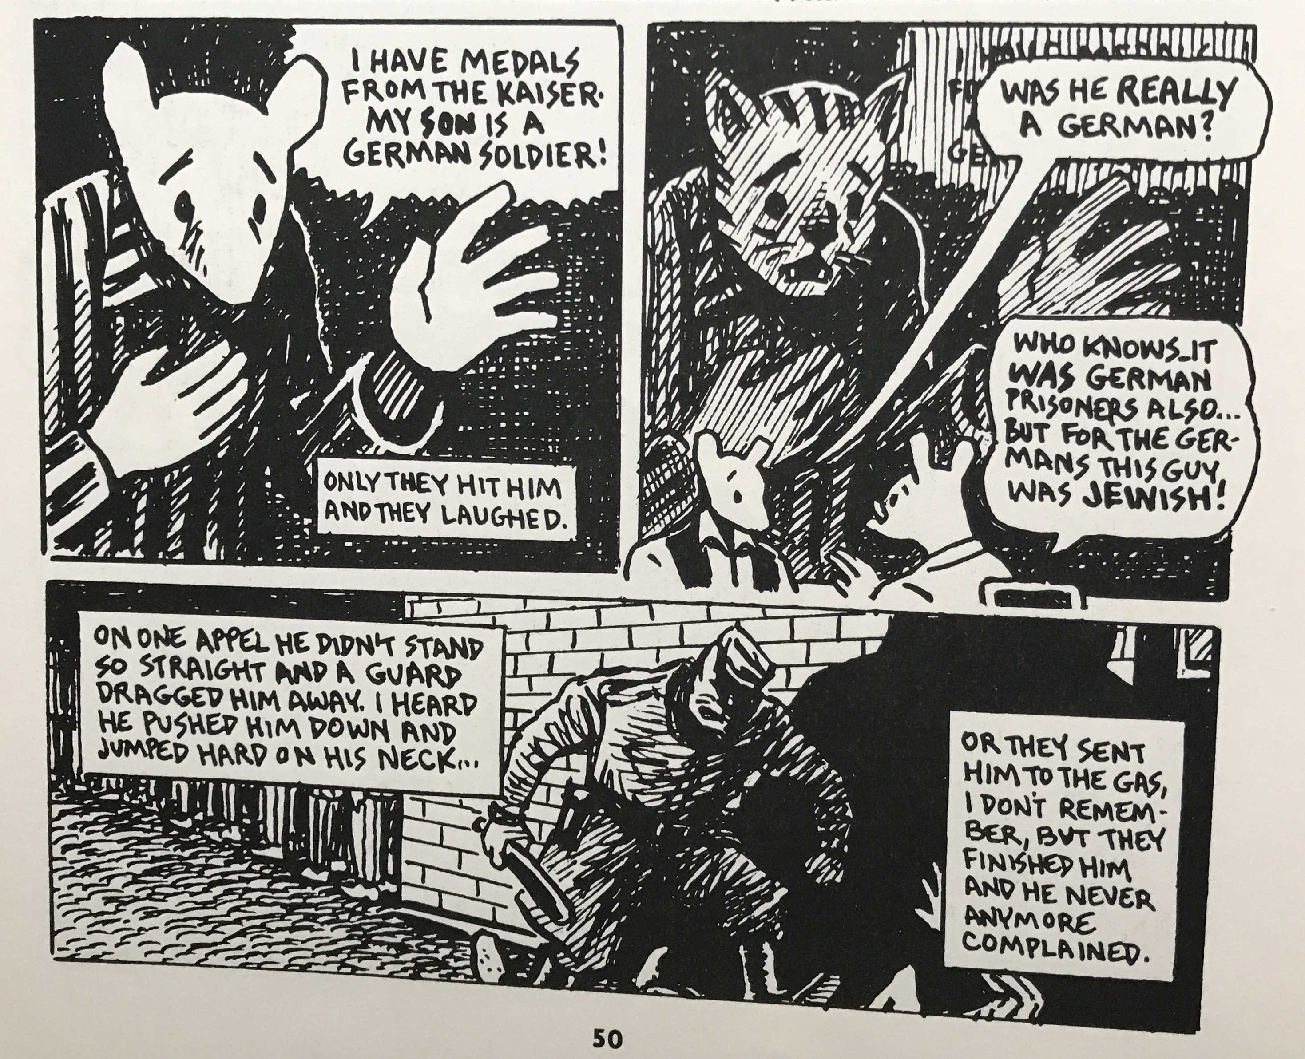

Figure 1. Maus II 50.

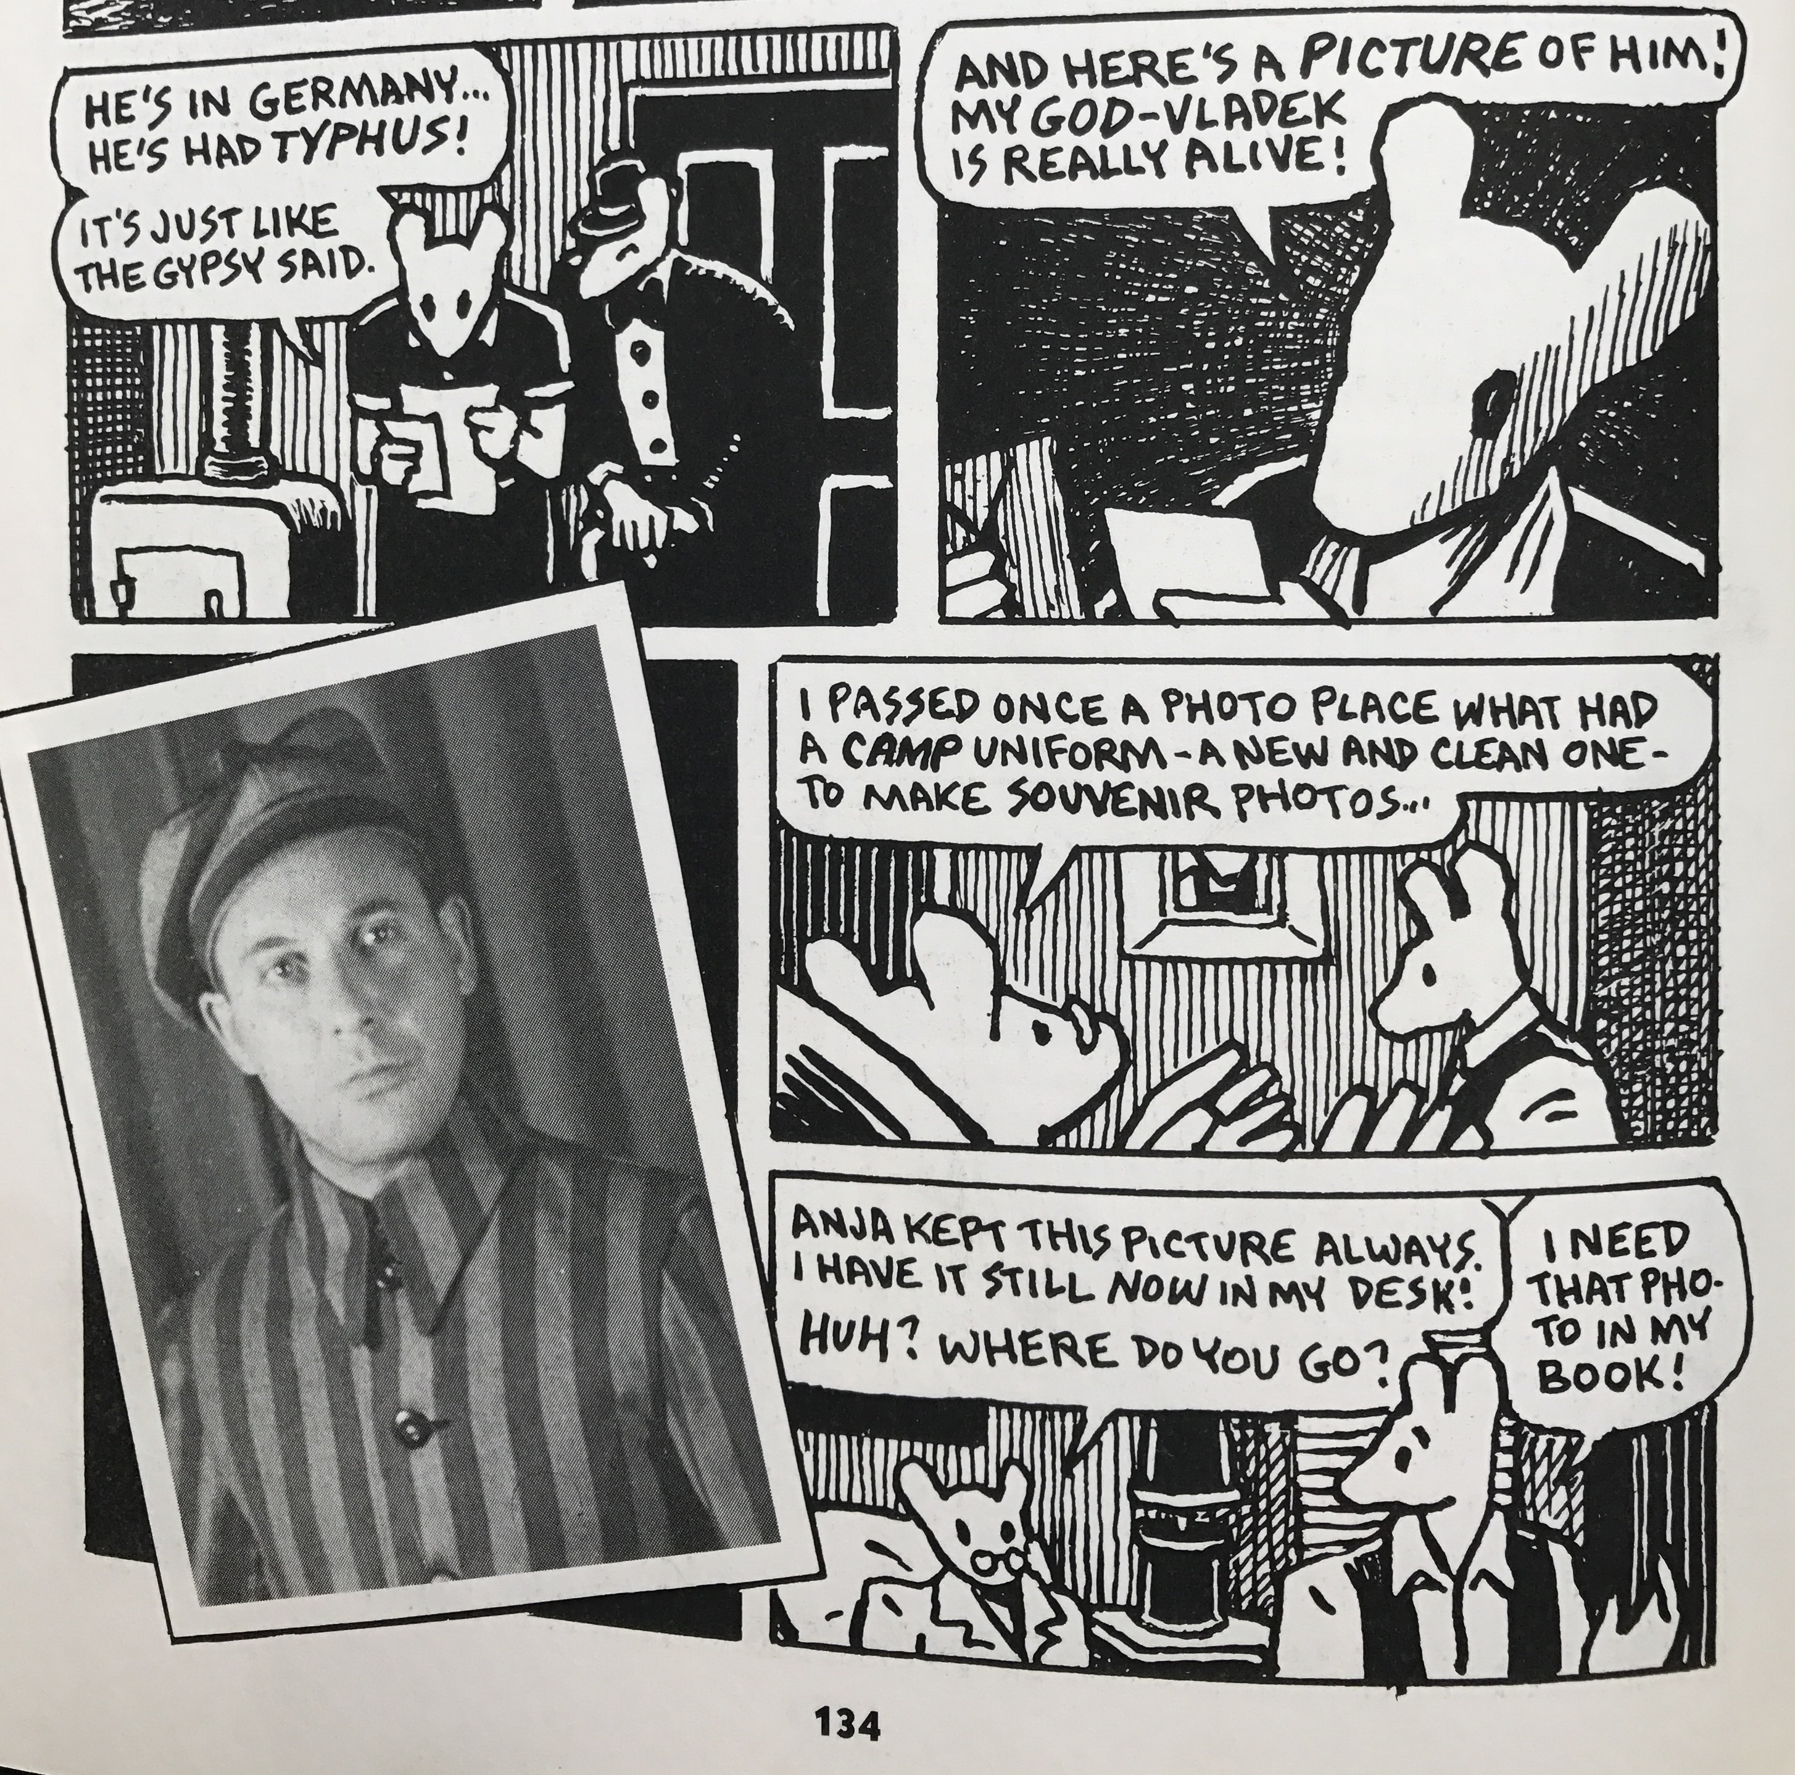

Figure 2. Maus II 134.

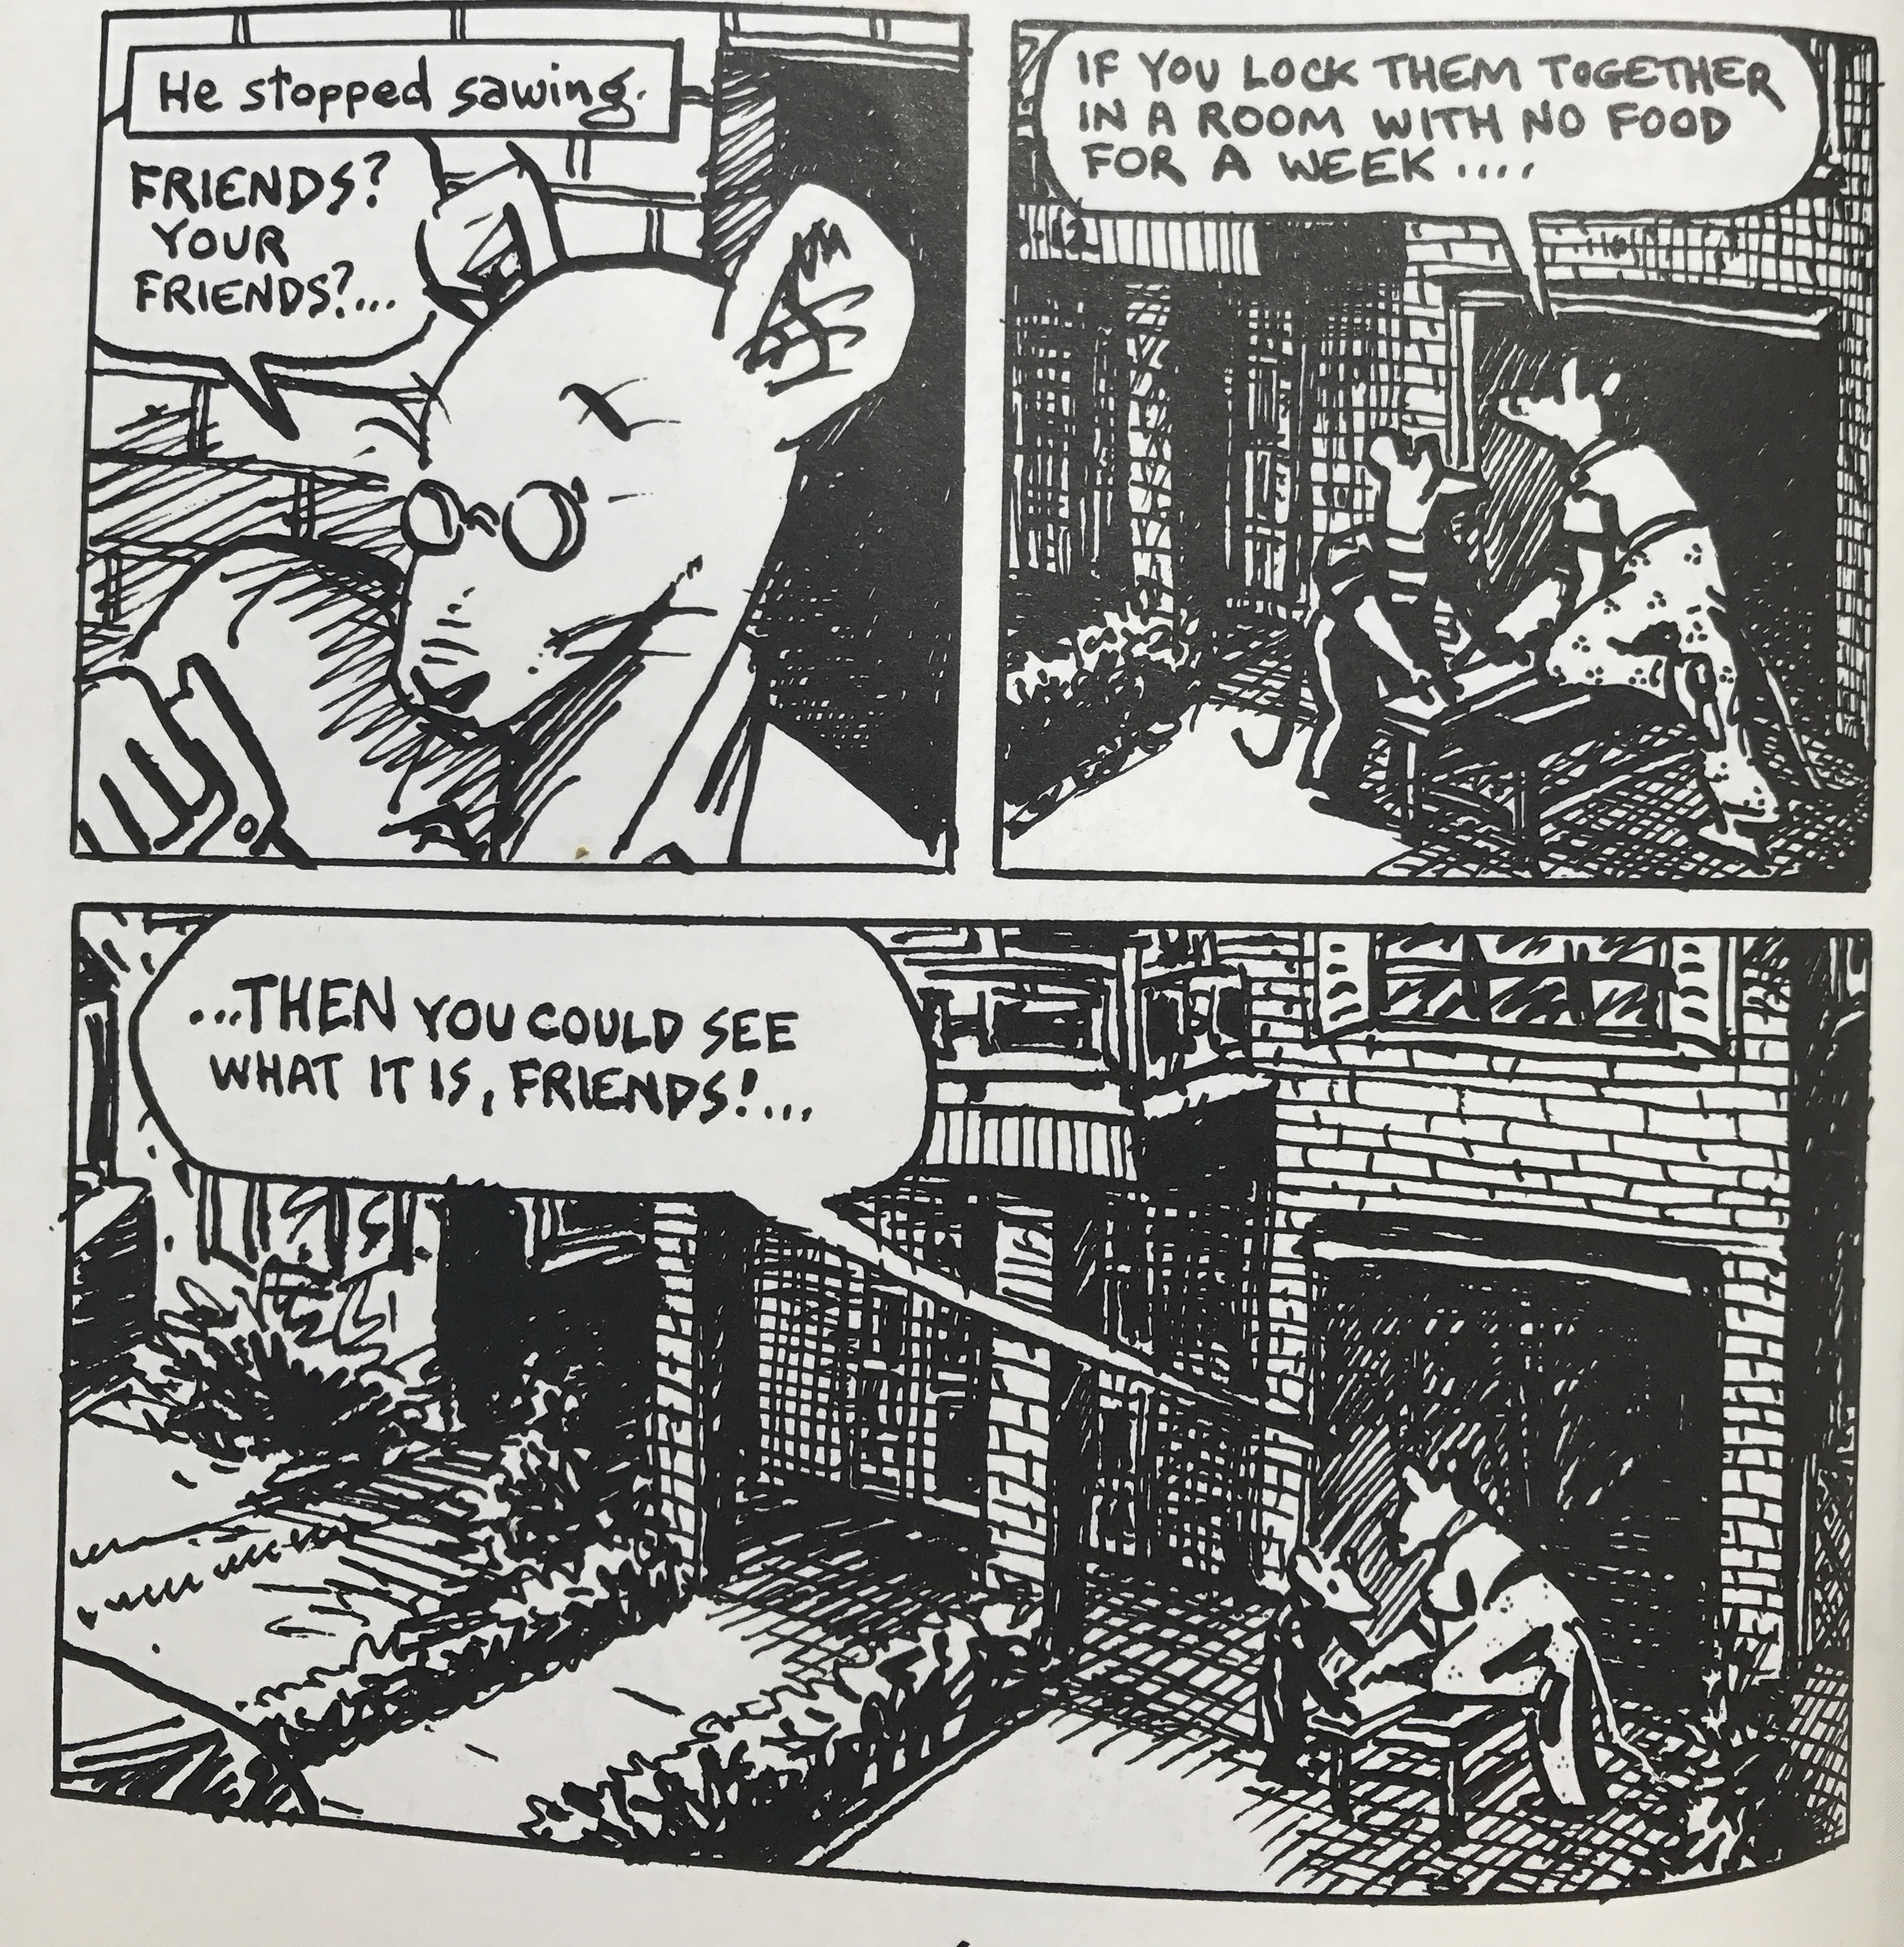

Figure 3. Maus I 6.

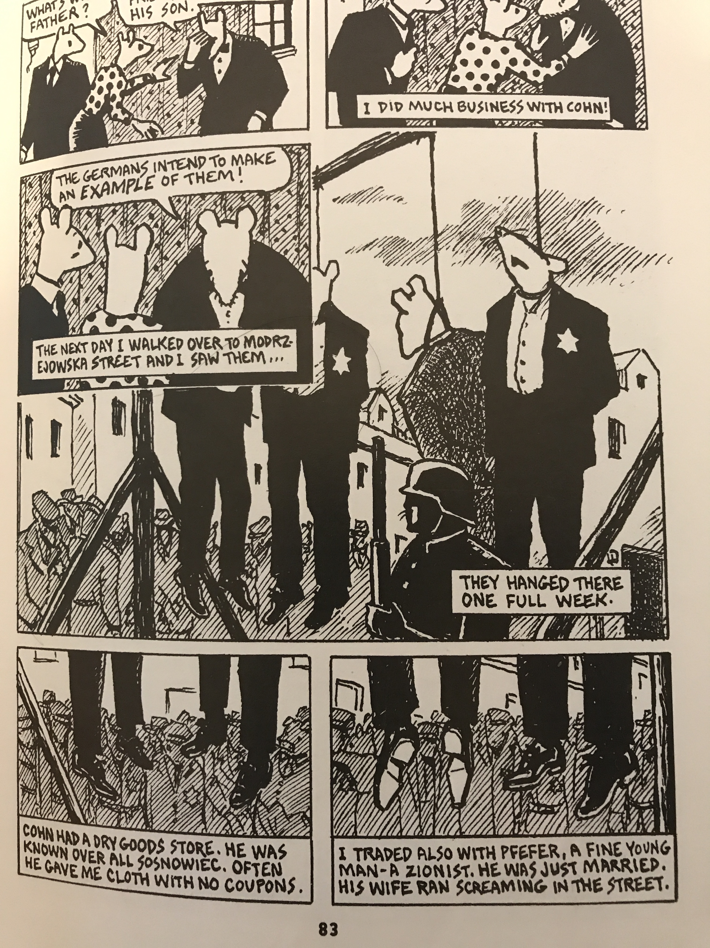

Figure 4. Maus I 83.

https://hammer.ucla.edu/exhibitions/2005/masters-of-american-comics/
Certainly diverse in period and style. However, of the fifteen cartoonists, none were women, and, overlooking the uncertain ethnic makeup of George Herriman, cartoonists of color. (FC)
This provided selection is an excerpt of a longer excerpt that Spiegelman reproduces in his work MetaMaus (2011) of the original letter.
Published as two volumes, the first in 1986 and the other in 1991.
In response to The Museum of Modern Art’s 1990 “High and Low: Modern Art and Popular Culture” show, which, according to Spiegelman, purportedly attempted to “grapple with the then-starting-to-be-fashionable issue of how the popular arts interacted with the more rarefied ones” but, in actuality, “squandered the opportunity, merely ratifying the museum’s long-held tastes and hierarchical predispositions” (MetaMaus 203), he proposed a “Low/low” show, where comics were displayed on their own—not as work attempting to be painting, but rather a formidable and self-contained medium of its own. Many attempts and many years later, his would lead to the development of the Masters of American Comics show. Spiegelman also wrote a scathing review (in comics form) of the High/Low show for Artforum. In a thoroughly clever move, the comic-review begins with a panel which re-appropriates a comics-appropriating Lichtenstein painting, with the dialogue balloon refilled with a histrionic address to the painter: “Oh, Roy, your dead high art is built on dead low art!...The real political, sexual and formal energy in living popular culture passes you by. Maybe that’s –sob—why you’re championed by museums!” (Bold in original, ibid. 202).
This is perhaps a gross generalization of a bygone period of comics scholarship. In recent history, the field has exponentially advanced in its approaches and discussions of comics as an art form.
The definition of comics, like many other artistic, formal terms, is a difficult one to cement. They range from “sequential art” to the deliberately overdetermined definition from Scott McCloud’s Understanding Comics (1993): “Juxtaposed pictorial and other images in deliberate sequence, intended to convey information and/or to produce an aesthetic response in the viewer” (9).
Perhaps a problematic term, considering that hybridization entails a synthetic transformation of its original elements. In comics, text and image can work in concert with each other, or an author can privilege one over the other, and, occasionally, they can be used against each other. (Cite, elaborate)
A further elaboration from the same source: “In the hybrid form of comics, two narrative tracks never exactly synthesize or fully explain each other. In ‘their essence,’ Spiegelman says, comics ‘are about time being made manifest spatially, in that you’ve got all these different chunks of time—each box being a different moment in time—and you see them all at once. As a result you’re always, in comics, being made aware of different times inhabiting the same space. (qtd. in Silverblatt 35)” (201-202).
In my next draft I will list the many texts that would corroborate this statement.
See How Jews Became White Folks & What That Says About America by Karen Brodkin. (The next draft of my chapter will expand on her argument.)
Buhle writes, “Amazingly enough, even as Mad magazine, with its barely disguised Jewishness, advanced during the 1950s, the funny pages of American papers were still a Judenrein, a Jewless world, with the square-jawed Anglo-Saxon males and dainty females of Steve Canyon’s domain arguably the most WASPish of all.” (28)
Spiegelman expresses as much in his article “Little Orphan Annie’s Eyeballs,” writing, “comic strips were literally as well as figuratively generated from stereotypes” (1).
The narrative depicts multiple timeframes and settings, the first being present-day New York, which concerns the relationship between Art and his father, Vladek, as the former tries to chronicle his father’s account of surviving the Holocaust with Art’s mother, Anja. The other period depicted is Nazi-occupied Europe, as the viewer sees Vladek’s account. A final timeframe, shown briefly in volume II, concerns the period after Maus I has been published (to much critical and financial success) and after the death of his father.
Bolding appears in the original textboxes.
Spiegelman expresses in MetaMaus, “The anecdote where Vladek is almost caught by Polish children calling him a Jew when he was in hiding was a source of nightmares for me…It was vivid for me even before I drew it—one of those places where I could enter into Vladek’s story and feel it viscerally. The vulnerability of being the other, that made even little children lethally dangerous.” (28)

