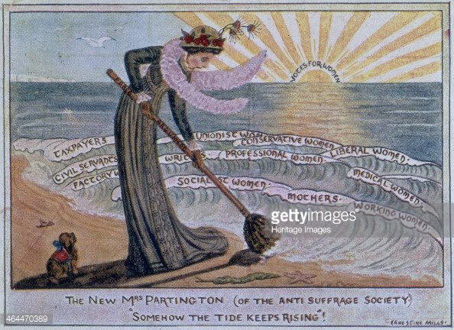

Ernestine Mills, “Somehow the Tide keeps Rising” 1910

Photo by Museum of London/Heritage Images/Getty Images