Table of Contents

IV. Teaching Talent: The Pedagogies of Shinichi Suzuki and Mark O’Connor 2
Introduction 2
Chapter Context 5
Shinichi Suzuki 10
Mark O’Connor 21
Teaching Talent 29
The First Song 39
Eliza 47
Zoe 55
Conclusions 59
Bibliography 64

IV. Teaching Talent: The Pedagogies of Shinichi Suzuki and Mark O’Connor

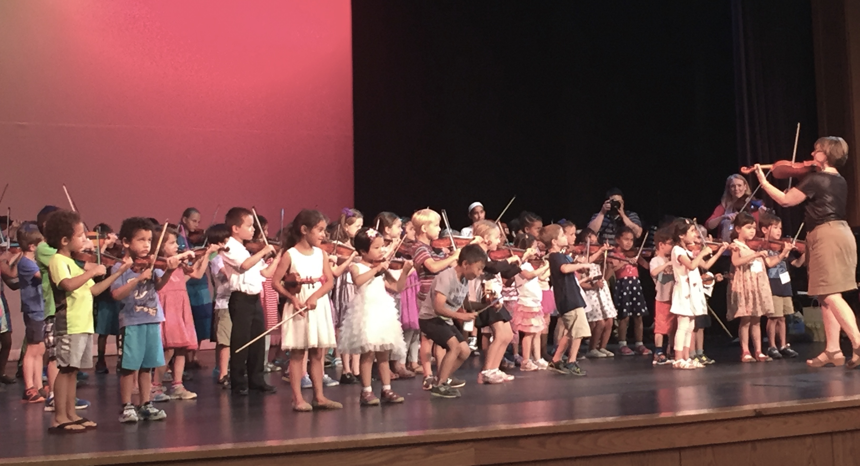
Figure 1. PhoenixPhest Suzuki Institute group class (Eastern Michigan University, Alexander building)

Introduction

Over one hundred students stand on a concert hall stage, arranged by height. Each one holds a violin adorned with some combination of sponges, rubber bands, and stickers. Although the smallest violinists in the front look barely old enough to be out of diapers, they hold their instruments with a nonchalant facility as though it were any other quotidian object. Two adults at the front of the stage address the wiggling legion and coax their scattered attention toward the accompanist beginning to play “Mississippi Hot Dog” (four sixteenth notes and two eighth notes, also known as “Pepperoni Pizza” and “Peanut Butter Jelly,” amongst other frequently culinary mnemonics), on B and then A above middle C. Heeding the pianist’s familiar call, the students simultaneously raise their bows and launch into the rhythmically reinvented melody of “Twinkle, Twinkle, Little Star” in perfect unison. I glance over at the parents in the audience, who have likely heard this song thousands of times (in lessons, home practice, and on the recording that accompanies their book, which every student is expected to listen to once a day), gazing out at the packed stage with pleasure and pride. While this particular performance occurred on a Thursday afternoon of the 2014 meeting of the PhoenixPhest Suzuki Institute near Ann Arbor, Michigan, nearly identical spectacles could have been glimpsed at institutes across the United States that summer, and every summer and school year since the 1970s.
***
An online video confidently entitled “Best ‘Boil ‘em Cabbage Down’ ever!” starts mid-set at the 2010 jazz festival in Marciac, France with Trumpeter Wynton Marsalis and violinist Mark O’Connor sweating under the lights of the festival’s main stage. Marsalis announces that their next number is one of the earliest African American fiddle tunes and, coincidentally, the first song O’Connor learned as a student. Without conceding a second of silence, the fiddler launches unaccompanied into an energetic Nashville shuffle rhythm on his two upper strings and transitions into a relatively unadorned version of the four-note melody of “Boil ‘em Cabbage Down.” The six-piece band enters soon thereafter to accompany O’Connor’s increasingly virtuosic improvisations on the tune, occasionally shaking their heads in admiration at a few of O’Connor’s musical ideas. By the time Marsalis enters with his solo, O’Connor has soared through no fewer than 28 repetitions of the song, from secondary melodies spanning the range of his instrument, to bluegrass-style double stop strokes, to jazzy licks with glissandos and blue notes. The camera cuts to the audience. They are on their feet, without perceptible exception, cheering and clapping.
***
Deeply divergent understandings of musical ability development circumscribe these two scenes. Such understandings are not merely a matter of perspective or passive explanation. Rather, they actively shape the musical worlds of young people—from their ambitions and enthusiasms and personalities to the ways they conceptualize the learning process and establish their self-identity. This final case study focuses not on the perceptions of journalists or judges or fans, but on the ways ideologies of talent operate upon and within pedagogical discourses themselves. I examine two teaching methods practiced by American music educators: one developed by Japanese pedagogue Shinichi Suzuki (1898-1998), and one established more recently by the American violinist and composer Mark O’Connor (1961- ). Each method comprises a set of philosophical and practical approaches to musical instruction built upon a sequenced repertoire of pieces; the vignettes above describe performances of the first song introduced in each method book. In addition to providing quintessential examples of each method’s first songs as Suzuki and O’Connor hoped for them to be performed, these two scenes offer a nuanced metonymical glimpse into each method’s ideologies of ability development.
In this chapter, I contend that these two teaching methods forward radically different ideologies of musical talent—and, by extension, music itself. Beyond affecting students’ educational outcomes, I argue that these differing approaches to learning demonstrate the multiple ways that beliefs in natural ability perpetuate access to social and cultural capital. While Suzuki argued that “talent is no accident of birth” and that all children are capable of being intentionally and lovingly shaped into talented learners and musicians through his method, O’Connor celebrates a conception of talent closer to that discussed in the previous chapter, building his method upon the assumption that some students will be more motivated and musically gifted than others, and crafting the repertoire in a way that will serve the needs of this diverse range of student interests and potentials. Though the positions of these methods sketch out the contours of the familiar nature-nurture debate, neither of these communities ascribes to one side of this false dichotomy: the Suzuki parents, students, and teachers with whom I spoke readily acknowledge the existence of biologically derivative individual differences between students, and members of the O’Connor community recognize the necessity of repetitive practice and the teacher’s role in the realization of students’ musical potentials. The multifaceted ways each method responds to differences between students, however, reveals the complex mechanisms through which ideologies of talent are mobilized in the process of teaching and learning.

Chapter Context

Even within the realm of string instrument instruction, the Suzuki and O’Connor methods exist amongst countless others available to contemporary American music teachers. I focus on these two methods because they represent two relatively distant nodes within a much larger constellation of approaches I have witnessed as a researcher and educator. Much more often, music teachers—in private lessons, public schools, and elsewhere—ascribe to idiosyncratic combinations of method book materials, understandings of talent and exceptionalism, and teaching techniques that have been influenced by the highly visible and accessible Suzuki industrial complex (as I have come to call it) as well as the more traditionally American ideologies that Mark O’Connor has curated and characterized in his method.
Although both methods have been adapted to a variety of instruments, I focus here on the violin, the primary instrument of both Suzuki and O’Connor and the one most commonly associated with each method. The violin is also particularly instructive for this project: it is both widely practiced and notoriously difficult to master, a quality that brings questions of talent and ability development to the fore; musicians who find success as violinists confront a wide range of explanations for their abilities that relate to the typology of talent in manifold ways, not least in their frequent designation as prodigies or geniuses. The violin is also a historically multifaceted instrument with ties to a variety of genres and cultural traditions—a quality important both to Suzuki and O’Connor, if for different reasons, and for a project that asks questions about understandings of musicality, which often vary amongst musical traditions, genres, and cultures.
While I begin by discussing Suzuki and O’Connor themselves, I am most interested in the ways these philosophies are interpreted and lived—in each method’s collective pedagogical praxis, to summon Paolo Freire’s understanding of the term as a never-ending cycle of critical reflection and action. The chapter’s data, therefore, are drawn from ethnographic research I have conducted with Suzuki and O’Connor teachers and families over the course of six years, including semi-structured interviews, audio and video footage, and in situ notes from my time as a participant-observer. In addition to attending a wide range of performances, private lessons, group classes, festivals, summer institute events, and teacher certification courses, I have also become immersed in both methods through my career as a teacher, youth orchestra conductor, and the director of a small music school in Chicago. Moreover, the analysis of individual lessons in the latter part of this chapter aspires to offer a musicological rendering of what Frederick Erickson formatively described as a “natural history approach to studying taught cognitive learning.” To do this, albeit with limited space, I have focused in on one private violin lesson taught according to each method, conducting deductive analysis of the video and audio footage. I have aimed not only to reveal what students did and did not learn, but how they learned it—what Erickson has described as a “process report”—and, ultimately, to demonstrate what this teaching and learning process can reveal about the rolls and results of each method’s distinct conception of talent.
Patricia S. Campbell once described her work in the ethnomusicology of music education as occupying “the cracks between education and musicology”; I see my musicological interrogation of talent in this chapter in a similar light—though I also aim to suggest ways to fill the disciplinary cracks that Campbell described. The chapter’s goals, therefore, are multi-pronged: to contribute to the growing but still insufficient ethnomusicological literature on music education, to demonstrate music’s possibilities as a rich and multifaceted window into larger themes in the study of teaching and learning, and, not least, to offer practicing music educators like myself an opportunity to critically reflect upon and revise their own views.
While the pedagogical ideologies and musical repertoires designed by Suzuki and O’Connor permeate the stories I tell, I focus in particular on two teachers who embody these ideologies in their day-to-day teaching experiences. By zooming into the scale of the individual studio (followed by the even more specific individual lesson), this chapter is not equipped to compare the outcomes of these methods on a larger, national scale. Instead, however, I hope to lend vivid color and detail to my analysis of each method. In the Suzuki realm, I have spent the bulk of my time with the Northern Virginia Suzuki Music School, primarily the studio of Ronda Cole, a teacher who has been developing her highly researched and rigorous application of the Suzuki approach since the 1960s. Within the more nascent O’Connor Method community, I have observed the teaching of Pamela Wiley, a former Suzuki teacher (a common attribute of O’Connor Method teachers) based in Charleston, South Carolina. Wiley worked closely with O’Connor to develop the method books, the first of which was released in 2009. Unlike Suzuki, who passed away in 1999, Mark O’Connor is frequently present at the institutes and workshops promoting his method, but has never dedicated time to teaching or the study of education due to an active and successful career as a performer and composer. And so, while I have spoken with O’Connor about his method and taken teacher training courses with him, I focus here on the method as it is interpreted and practiced by Pamela Wiley, an experienced teacher with an active studio.
Thus far, I have referred to the pedagogical interventions of Suzuki and O’Connor as “methods,” a word fraught with ambiguity in pedagogical circles. In general teaching contexts, it is understood as “a set of principles, procedures or strategies to be implemented by teachers to achieve desired learning in students” that vary according to teachers’ treatment of the subject matter and their beliefs about how students learn. Within the musical realm, methods are often synonymized with method books, musical textbooks that designate a specific sequence of pieces and exercises. In other contexts, however, music teaching methods are defined more holistically—as in the case of the Kodály or Dalcrose methods—and are intended to include a set of pedagogical philosophies, objectives, and teaching techniques alongside the musical curriculum. Unsurprisingly, Suzuki and O’Connor conceptualized their “methods” in meaningfully different ways: for Suzuki, the pieces served as a conduit for a specific and holistic approach to teaching children, and so the books were merely one small aspect of the overall approach he developed; for O’Connor, the “method” is precisely the sequence of songs and arrangements contained in the books. Indeed, to stave off misunderstandings that her teaching practice focuses solely on the repertoire in the Suzuki method books (a frequent practice of string teachers without Suzuki training who misleadingly claim to be “Suzuki teachers”), Ronda Cole insists upon calling Suzuki’s pedagogical contribution an “approach” rather than a method. While acknowledging Cole’s intervention, I refer to both Suzuki’s and O’Connor’s pedagogical contributions—the content of their method books as well as the “methods” teachers use to teach that repertoire—as methods, for terminological ease and comparative reasons.
Although music teachers often discuss methods in a positivistic light—certain songs are taught in certain orders to varying degrees of success—the process of teaching music according to one method or another is inherently political. From a discourse analytical perspective, a teaching method might be described as a way of inculcating students into a particular ideological-discursive formation that reproduces the social norms and values of the method’s architect. Or from a musicological perspective, one could describe a method as one particular way of defining and presenting the concept of music and the goals of music making for new students. Here, I examine the pedagogical priorities teachers trained in each method are expected to convey, but also the allowances that emerge in the cultural and historical context in which the method is being applied. In the context of this project, then, a method not only provides students with a specific repertoire to play, but actively forms their understanding of music’s place in society and its role in their personal lives; it argues for the importance of certain musical skills over others; and it advocates particular conceptions of what it means to be creative, musical, and musically talented.
This chapter’s trajectory moves from general to specific—from intentions to realizations in specific educational encounters. First, I consider writings by and about the founders of these two methods to evaluate the historical and philosophical conditions of their inception.

Shinichi Suzuki

Talent is no accident of birth. In today’s society a good many people seem to have the idea that if one is born without talent, there is nothing he can do about it; they simply resign themselves to what they consider to be their ‘fate.’ Consequently they go through life without living it to the full or ever knowing life’s true joy. That is a man’s greatest tragedy.

So begins the text of Nurtured by Love, a collection of reflections and stories by Shinichi Suzuki that is assigned to teachers and parents across the United States as an introduction to the teaching method Suzuki himself called Saino Kyoiku, or “Talent Education.” At the heart of Suzuki’s mission in establishing a new pedagogical approach was an alternative understanding and treatment of talent as a concept. Suzuki opposed beliefs—prominent both in Japan and the West during his lifetime—that children were born with innate aptitudes for music or any other specialized skill. To offer one example, in Leopold Auer’s method book written around the time Suzuki started playing the violin himself, the famous performer and teacher discouraged students without the requisite natural gifts from pursuing the instrument: “One great mistake lies in the failure of so large a majority of those who decide to devote themselves to music—to learning some string instrument, the violin, for example—to ascertain at the very outset whether nature has adequately supplied them with the necessary tools for what they have in mind.” Instead, Suzuki argued that, just as all children acquire the ability to comprehend and express themselves in their mother tongue through early and consistent participation in the language, children are able to acquire the same type of fluency with music—to acquire talent, as he defined it. As Suzuki explained in Nurtured by Love and many other forums throughout his life, these beliefs were influenced by his musical and linguistic experiences in Japan and Germany, by his upbringing in (and later, formal study of) Zen Buddhism, and by a range of Western literary and philosophical works—most significantly by Leo Tolstoy.
Unlike most Japanese children of his generation, Shinichi Suzuki grew up surrounded by violins. But unlike most children who grow up surrounded by violins, he did not learn to play the instrument until his adulthood. Shinichi’s father, Masakichi, was the son of a prominent samurai and trained to continue his family’s tradition of making Japanese samisen and koto stringed instruments. Largely in response to the growing emphasis on European music and culture during the Westernization push of the Meji period in Japan, Masakichi Suzuki turned his attention to the violin instead, and eventually became the first manufacturer to develop a factory method for producing the instrument. After Shinichi Suzuki’s graduation from the Nagoya Commercial School in 1916, he was expected to work full-time in the factory. However, a series of circumstances—perhaps beginning with the acquisition of his first record, Mischa Elman playing Schubert’s Ave Maria and continuing with a bout of bad health that prompted his travel away from home—rerouted his early adult life. Instead of devoting his time to the international distribution of Suzuki Violins (and, by the 1920s, an assortment of other instruments) like his two older brothers, Shinichi began his autodidactic journey as a violinist around age 20: “To think the violin, which I had considered a toy, could produce such beauty of tone! Elman’s ‘Ave Maria’ opened my eyes to music. I had no idea why my soul was so moved. But at least I had already developed the ability to appreciate this beauty. My profound emotion was the first step in my search for the true meaning of art.”
Suzuki went on to study in Tokyo, which had become a hub for classical music during the Meji Westernization period of the late nineteenth century, sponsoring European musicians to teach and perform there. At the age of 22, Suzuki traveled to Berlin in pursuit of an even more powerful pedagogical experience, staying eight years in all: “I went to hear everybody, from famous performers to rising young artists, for I wanted to find someone of whom I could truly say, ‘This is the man I want for a teacher.’” After months of searching, he decided to pursue famous performer and teacher Karl Klinger, with whom he studied as a private pupil, and became acquainted with an elite circle of performers and other musically educated professionals, including (as Suzuki asserts in his accounts) Albert Einstein. As Suzuki explained in Nurtured by Love and in talks recounted to me by teachers who attended them, this musical community deeply shaped his view of the possibilities of playing and experiencing music. He described physically transcendent experiences listening to canonized German composers; he studied composition and orchestration; he courted and married a young German musician, Waltraud Prange, whom he met in Berlin. Margaret Mehl, who has written extensively on the history of Japan and its complex relationship with the West, argues that the Suzuki method “developed in a field that is wholly Western in origin and even regarded as representing one of the supreme achievements of Western civilization.”
Notwithstanding these Western influences, other elements of the Suzuki method were deeply informed by Suzuki’s Japanese education and identity. Before traveling to Europe, he became interested in practicing Zen Buddhism beyond the experiences he had as a child, and undertook studies with Fuzan Asano, his mother’s uncle and a prominent Zen priest known throughout Japan. Indeed, around the time Americans were first adopting the Suzuki method, they were also undergoing their first major exposure to Rinzai and Soto Zen Buddhist practices. Robert Fink, who has drawn important connections between the American “discovery” of Zen Buddhism and other concomitant repetitive cultural practices (including the Suzuki method, the Baroque recording boom, and the minimalist music movement) gaining traction at the time, remarked that Suzuki’s particular Zen affiliation was unclear. Suzuki’s aforementioned master, however, was in the Soto school and he often quoted Dogen, a foundational figure in the Soto tradition; Suzuki’s pedagogy, too, emphasizes gradual mastery through calm introspection and observation. While many basic tenets of the Suzuki method can be connected to Zen philosophy, one of the most notable aspects, especially in the context of Suzuki’s (re-)definition of talent, is its particularly Soto-inspired understanding of creativity. While Western ideas of artistic creativity focus on the production of an innovative object, or the expression of the artist’s unique voice (evident in the O’Connor method’s characteristically American celebration of this idea of creativity, which emphasizes composition and improvisation), Zen-inspired understandings of creativity often focus on the cultivation of inner experience and character through the process of “creating” art before considering innovation.
In the context of music, then, the quality of a musician’s sound and proficiency with the instrument serves as evidence that she has cultivated a rich inner relationship with music; technique, though necessary, is never the goal in itself but a symptom of a musician’s mind-body oneness. This type of mastery is achieved through the traditional Japanese concept of kata, literally “form” or “mold,” a pedagogical practice that emphasizes imitative repetition in the interest of achieving an embodied understanding of the artistic form being studied. Through kata, a student pursues fulfillment and creativity through rigorous, repetitive imitation of artistic masters in a way that slowly allows the student to embody and occupy the actions of a proficient and respected artist. As education scholar Koji Matsunobu notes, “The creative goal of kata-training is ‘to fuse the individual to the form so that the individual becomes the form and the form becomes the individual.’” Suzuki emphasized that the ultimate goal of his method was for children to acquire a noble mind and a beautiful heart through their musical education, not to achieve any particular level of technical virtuosity (though, as the example of Ronda Cole’s teaching will illustrate, high levels of technical achievement can also result from this degree of musical immersion and mindful cultivation). While American Suzuki teachers and parents frequently noted in interviews that this aspect of Suzuki’s pedagogy was particularly novel and provocative for them, this idea is more familiar in Japanese cultural contexts. The motto of Suzuki’s commercial school, for instance, translates to “first character, then ability”—a mantra he repeated frequently when discussing his own pedagogical approach.
Repetition of physical motions is essential both to kata pedagogy and the Suzuki approach. Indeed, repetition is perhaps one of the most dependably preserved aspects of the method (but also one of the most misunderstood, as we will see in O’Connor’s engagement with Suzuki’s ideas). Such repetition is especially present in the ways students are instructed to practice—repeated motions, musical sections, as well as daily practice schedules and lesson routines—but also in the limited range of repertoire covered in a student’s first years, and the form and contents of group classes and summer institutes. Robert Fink has noted that this degree of repetition proscribed by the Suzuki method was particularly “uncomfortable” for American students and their families. I have observed, however, such discomfort results mostly in the studios of teachers who did not fully understand or explain the intentions and meanings behind such repetitive practices. For instance, after months of repetitive practice in other contexts, every student in Ronda Cole’s studio is tasked with critically repeating a particularly difficult passage in the final Book 1 piece, a Gavotte by F. J. Gossec, 1500 times (see figure 2) in order to “graduate” from the book. In order to play the passage cleanly, the student needs to be able to control the placement of their second finger enough to place it on a C# and then a C♮ quickly afterwards, and also to be able to lift each finger with rhythmic consistency in the descent from their fourth finger to the open string. I have seen Cole introduce this challenge to students, which is partially designed to help them conquer a difficult finger pattern, but partially to insure that all students have thoroughly internalized and embraced the purpose and process of repetitive practice. While a few students initially wince at this challenge, most have already learned the rewards of such extensive careful repetition and accept the assignment without incident. Indeed, by the time Cole's students have finished learning the Gavotte and graduate from Book 1, they are able to perform the piece flawlessly at an impressively quick tempo, a feat that separates them from many other students their age (most of Cole’s students graduate Book 1 before the age of 8)—which onlookers at institutes and recitals often attribute to the students’ “talent.”

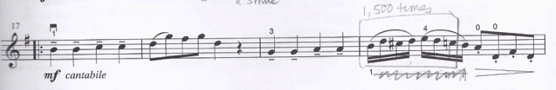

Figure 2. “Gavotte Spot” (in drawn box) in Ronda Cole’s reference copy of Book 1. All of her students are required to copy all of the markings in each book before they are permitted to begin studying the songs it contains.

Returning to the story of Suzuki’s method development, only after his diverse musical experiences in Japan and Europe did he begin contemplating the issue of pedagogy. A few months after their wedding in Berlin, Suzuki returned to Japan with Waltraud to begin a career as a musician and teach at the university level. The story of how Suzuki first thought to develop a method has been retold so many times that it has gained a mythological quality, but in almost all versions of the story, the violinist had a type of epiphany after being tasked to teach lessons to three year-olds Toshiya Eto and Koji Toyoda (both of whom grew up to be professionals). As Suzuki described it,
One day when we were practicing at the house of my younger brother, it hit me like a flash: all Japanese children speak Japanese! This thought struck me like a flash of light in a dark night. Since they all speak Japanese so easily and fluently, there must be a secret; and this must be training. Indeed, all children everywhere in the world are brought up by a perfect educational method: their mother tongue. Why not apply this method to other faculties? I felt I had made a tremendous discovery.

This moment of epiphany (often described in the American literature as a flash of genius, an ironic but emblematic example of the ways Western understandings of creativity and genius intermingle with Suzuki’s basic belief in the cultivated nature of ability) prompted Suzuki to turn exclusively to the education of very young children in the 1930s. It is worth noting that, as Chapter 1 has discussed, neither Suzuki’s idea of talent as cultivation nor the metaphor of music as a language were entirely new. Regardless, his method quickly became emblematic internationally of a cultivation-centric approach to education. As Suzuki’s success became more widely known, his school raised the funds to make a video recording of one of their recitals and sent it to the American media. John Kendall and other American teachers first visited the Talent Education school in Matsumoto, and then Suzuki began his formative visits to the United States, beginning with his students much-documented tour in 1964. From that point, Suzuki taught hundreds of teachers around the world and saw the establishment of Method associations around the globe.
Much ink has already been spilled on Shinichi Suzuki’s life, philosophy, and his powerful personal presence as a teacher and speaker in the United States. No sources, however, continue on to discuss the ongoing life and culture of the Suzuki Method in the two decades since Suzuki’s death in 1998. [About SAA, middle-aged and elderly women who studied with Suzuki, its huge costs and profits, the newsletter and hundreds of conferences/institutes. Niceness literature as footnote.] The main emphases of the method as it is taught today include: the concept of the “Suzuki triangle,” which expects parents to act as a home teacher on the six days each week the student does not see the Suzuki teacher; the expectation that parents will read Suzuki’s Every Child Can, attend and take notes at every lesson, and begin violin lessons with their child to model dedicated practice and musical immersion; daily listening to the CD or MP3 recording of the student’s current book; regular group classes in which many students come together to play the common repertoire and practice ensemble skills; amongst other features the subsequent sections on Cole and her students will illustrate in more detail.
Thanks in part to its pervasiveness, the “Suzuki Method” summons a wide range of associations. Regardless of whether a musician or parent or sees the approach as enlightened or ineffective, the ubiquity of the Suzuki name within (and beyond) American educational circles is undeniable. Such ubiquity renders inquiry into “the method” both rich and challenging. On one hand, I have easily been able to access and observe hundreds of teachers and students associated with the method. On the other hand, partly because of the varied approaches to teacher training and the number of uncertified teachers using the method books, and partly due to more structurally and culturally significant interpretations and reappropriations of Suzuki’s ideas, the method’s record-breaking popularity corresponds to a wide variation of implementations, some of which bear no resemblance to the pedagogical approach practiced by Shinichi Suzuki during his lifetime. Moreover, some of the main emphases of contemporary Suzuki teachers correspond with certain American parenting philosophies and styles, and other aspects have been adjusted to more directly speak to the goals of American parents. For example, as Annette Lareau has discussed, the more commonly middle- and upper-class “concerted cultivation” parenting style “entails an emphasis on children’s structured activities, language development and reasoning in the home, and active intervention in schooling” that jives well with Suzuki’s vision of parent’s active role in cultivating music immersively, like a language—one that requires significant educational, financial, and temporal privileges. Indeed, one of O’Connor’s and Wiley’s objections to the Suzuki Method’s model is the types of families and students excluded by such stringent requirements, which are virtually impossible for working-class families who practice what Lareau has called the “achievement of natural growth” (Lareau’s use of “natural” better describing the perceived, rather than the actual, learning process), which involves children being “granted more autonomy to manage their own affairs in institutions outside of the home,” both because of ideological approaches to learning and childhood, and because of financial and logistical necessity. This mutually reinforcing nexus of (social, cultural, socioeconomic) capital and ideology is at the heart of this chapter—in other words, why some students, in a deeply segregated and systemically inequitable American educational climate, are able to discard their beliefs in natural ability and successfully cultivate the variety of musical skills that appear to others as signifiers of innate talent. It is a question I aim answer by the end of the chapter.
Nonetheless, contemporary Suzuki teacher trainers and Suzuki himself have both aimed to reorient the European-influenced conversations around talent this dissertation has explored, rejecting questions like those being asked by influential thinkers and musicians around the time Suzuki was developing his method, like Auer (quoted above) and Carl Seashore: “which children possess musical ability of a high order and may therefore be given the opportunity to become artists?” Rather than engaging with discourses that assumed talent to be something innately possessed in greater quantities by budding geniuses or future superstars, Suzuki did not avoid the term or idea of “talent,” but redefined as something acquired through exposure and education: “man is born without talent.” Rather than connecting the development of talent with the common goal of fostering geniuses like those discussed by Francis Galton, Suzuki stated that the telos of a talented child is not achieving a position on the far end of a Gaussian curve, but rather achieving a happy and noble life: “My prayer is that all children on this globe may become fine human beings, happy people of superior ability, and I am devoting all my energies to making this come about, for I am convinced that all children are born with this potential.”
As a pedagogue and as a person, Shinichi Suzuki embodied the goals of his pedagogical approach—just as Mark O’Connor’s multi-genre celebrity, virtuosity, and sense of American nationalism embodies the principals of his teaching method, as the following section discusses. Suzuki never achieved extraordinariness as a performer, but, as so many teachers who studied with him have mentioned to me, he undeniably cultivated an intimate and inspiring relationship with the inner process of making music, and he transmitted this love for the lived practice of musicianship to the teachers and students he instructed. Rather than seeking distinction with his own playing, or contributing original musical compositions or even interpretations of the canonized literature he included in his method, Suzuki hoped that his method would encourage more parents to give their children an opportunity to gain some degree of fluency in music-making. Ironically, to summon his American contemporary Carl Seashore a second time, Suzuki believed in the potential ubiquity of his method to the point of suggesting an approach suspiciously reminiscent of eugenics to help all children be given the joy of playing music: “Many babies who could have been educated failed to be educated on account of poverty. But there is also failure due to bad educational methods. It should be the responsibility of the state to see that this does not happen.” While Suzuki was not alive to witness the approach of the O’Connor method, he may have equated the more lassiez-faire approach of the new method’s teachers with this category of bad educational methods—though certainly not using the same type of rhetoric O’Connor has lobbied against Suzuki. Nevertheless, the tension Suzuki expresses in the quotation above—something I describe as the fundamental paradox of talent as it functions in pedagogical and larger social discourses—is not only central to each method’s assertion about natural ability, but its interaction with race, class, and privilege.

Mark O’Connor

“In the A New American School of String Playing, rather than merely counting the beats in a measure, we want you to feel rhythm and groove. That is creative. Counting beats can be academic. Rather than playing in unison all the time in group class, we want you to play harmony, counterpoint and rhythm. Not just having to listen to your own part of the music for years.”

Unlike Suzuki, who studied European music, married a German woman, and traveled frequently to the United States and other countries to learn from other teachers and discuss his method, the national influences and motivations of Mark O’Connor’s pedagogy are unilaterally conceived. Amongst the many reasons he sites for founding his method, almost all deal specifically with Americanness: for instance, the creative supremacy and richness of American music in particular, the diverse pedagogical needs of American students not being addressed by other (primarily non-American) methods and schools, and America’s need for a new generation of innovative composers and musicians to represent the country’s rich tradition of string music on the global stage. At the heart of the method’s many metaphors and goals around American music is a certain affirmation of individuality, creativity, and, indeed, a purposeful rejection of Suzuki’s assertion about the nature of talent. For Mark O’Connor, talent—a word he uses often in discussions of his method, in addition to frequent mentions of genius, virtuosos, prodigies, and related ideas discussed in Chapter 1—is linked to each musician’s inherent uniqueness and desire for individual expression. Instead of endorsing anything remotely repetitive or uniform, the O’Connor method emphasizes inspiration, improvisation, and individuality, explaining that students exposed to the inherently appealing American repertoire of the books, and given an opportunity to have fun with the music, will experience a spark of interest and desire that will subsequently drive them to pursue the more technical aspects of the instrument.
O’Connor often sites his own exceptionally successful career as a performer and composer as a testament to the possibilities of his method. Born in 1961, he came of age around the same time that Suzuki’s violin method was gaining momentum in the United States. As he describes his origin story—one repeated often at his institutes and in interviews with journalists—he was first exposed to music through learning classical-style guitar as a young child. “With the guitar, I was talented, but I felt restricted from some natural pathway for myself. I had an innate sense that if I got hold of a fiddle, the whole music world would open up to me. I begged for three years, and when I finally got one, it turned out to be true.” Once O’Connor began fiddle lessons, he explains that his ascent to stardom, made possible by his dedicated “stage mother,” as he affectionately called her, was rapid: his first teacher, the 14 year-old classical/folk player Barbara Lamb, recognized his enthusiasm for fiddling and encouraged him to attend the National Old-Time Fiddlers Contest in Weiser, Idaho. It was there that O’Connor first witnessed renowned fiddler Benny Thomasson and experienced a moment quite similar to what Suzuki described with his first major teacher, Karl Klinger, if for a set of different musical reasons: “When I heard Benny, I was transfixed. … I knew right away he was the master and he was the one I wanted to emulate. If you gave him a theme, he'd create a variation that was as strong or even stronger than the original. Even at an early age, that blew me away.” The following year, under Thomasson’s guidance, O’Connor became the youngest contestant ever to win the Grand Masters Fiddle competition at age 13, winning dozens of other competitions after that point—on the violin as well as the guitar and mandolin.
The young violinist went on to study jazz with violinist Stéphane Grapelli in his late teens and, as he described on his website, subsequently “became the most in demand session musician of any instrument and in any genre for a 3-year period, appearing on more top ten hits in the country, recording over 500 albums, and recording with everyone - Dolly Parton, James Taylor, Paul Simon, Randy Travis, The Judds, the list is too long to print.” In addition to performing as a classical, bluegrass, and jazz violinist, O’Connor became active as a composer of classical music inspired by other American genres—penning, for instance, an improvised violin concerto in which the soloist’s part contains only reference chords that require the player to extemporize for the duration of the 40-minute scored symphonic piece.
Each of O’Connor’s diverse experiences is reflected in his vision of the method—which he, and then Pamela Wiley, conceived as representing a more comprehensive, representatively diverse, “American Music System” (AMS). His first forays into the educational realm were a series of summer programs, beginning with a fiddle camp in Nashville in 1994. The camps attracted aspiring fiddlers (and fiddlers inspired by O’Connor) every summer from that year onwards, though the camps assumed many different names and were held in a variety of locations; it is these camp experiences that O’Connor sites as his inspiration for founding a more comprehensive method that represents the specifically American context of his musical education. As he recalled, “I've always wanted to be part of an American school of string playing. I had always read about the European tradition of violin playing from Russia, Germany and France. But as I got further into classical music, I noticed there was no school of American violin playing. The styles that are taught here in conservatories are European.” The first volume of O’Connor’s method book series was published in 2009, and the first summer institute he held under the official “O’Connor Method” label was held at the Berklee College of Music in 2011. The books and their sequence of songs, which O’Connor presents as the backbone of the method (unlike Suzuki’s more philosophical conception of his method), consist not only of North American-derived repertoire, from “Boil ‘Em Cabbage Down” to songs from the classical, folk, Latin, jazz, rock, ragtime traditions, but of a semi-autobiographical blend of pictures and stories from O’Connor’s first experiences with the tunes, historical information about the songs, and suggestions for variation and improvisation. More than simply offering songs to play, these method books epitomize O’Connor’s attitude toward the learning process: students should focus on the beauty of the songs, cultivate a sense of wonder and inspiration from great performers (like O’Connor) playing the same pieces contained in the books, and technical proficiency—and the desire to cultivate it—will follow. Elements like posture, technical precision, and repetitive practice are not an end within his conception of American music pedagogy, but a means to the end of a student’s enjoyment and creative engagement of a song, and rarely the main focus of teachers using the method books. It is evident that this “achievement of natural growth” model reflects O’Connor’s own recollection of his learning process—one he sees as ideal, and applicable to any student.
O’Connor did not craft the method books on his own; he neither has the experience teaching beginner violinists nor the type of writing training essential for an effective educational publication. Early on in the process of conceptualizing the method, O’Connor worked closely with a number of other educators and musicians, with particular input from Bob Phillips, an experienced school string instructor and teacher educator. Later on in the process, O’Connor became acquainted with Pamela Wiley through a seven-year relationship with her daughter, a violin teacher and accomplished performer. After being introduced to O’Connor’s sequence of repertoire, Wiley, a long-time Suzuki teacher, was immediately convinced that the method was an improvement upon her current method, which I discuss further in the subsequent section. In short, the O’Connor method books and teacher training courses contain a conspicuous admixture of perspectives—regarding parent involvement, weekly practice, which skills to teach, how to teach them, etc. This admixture has resulted in students, parents, and teachers engaging with the books in significantly more diverse and customized ways than those within Suzuki communities. Rather than reflecting some type of flaw in the application of O’Connor’s method, however, this diversity fits well with his (and Wiley’s) conception of the method—that exposure to the repertoire and a diverse set of inspiring performances of it is the most essential piece of the larger puzzle.
Despite his denial that his books were specifically modeled after the Suzuki method, O’Connor has promoted his method as a replacement for Suzuki. As has increasingly noted, he does not intend for his books to be used as a supplement, but a fundamentally different approach to learning music. Whether as a musician, composer, or as the spokesperson for his educational enterprises, O’Connor has constantly emphasized the lack of creativity, individuality, and certain musical skills in the American classical string community—something he argues that the Suzuki method embodies and perpetuates. For example, at the first iteration of his Manhattan-based O’Connor Method camp, O’Connor described his experience of looking for children’s string lessons in the Bay Area: “I just signed them up for violin classes and I would show up and they’re all playing in unison the melodies of these little minuets and etudes, over and over again for years, and in two years, invariably they both wanted to quit, and they did.” In a blog post entitled “Suzuki’s BIGGEST Lie,” O’Connor summarizes his case against Suzuki (revealing, as usual, much more about his own positionality than Suzuki’s philosophy):
Was it all just about money, selling an exotic product from Japan to unsuspecting American violin kids? Certainly that place nor did the man know much about classical violin in 1950s. In the aftermath of the treachery and the deception, Suzuki’s pedagogic advice should be considered an undesirable approach in learning to play the violin, such as his insistence for a constant repetition of a small body of repertoire from 250 years ago for sometimes up to 5 and even 10 years, memorization-ear-training as opposed to ear-training one can use musically, taking violin along with the parent in lessons, all-unison group class for many years with others playing the same line, and no creative musical training, theory, improvisation, composition, or stylistic diversity […] The Suzuki Method basically develops technique by way of massive amounts of repetition along with obedience-based learning (follow my hand, do as I do, I am always right and you are always wrong approach) that has spawned the least creative 50-year era in violin history.

To O’Connor, the Suzuki method’s outdated repertoire, emphasis on thoughtless repetition, and focus on uniformity is the archetypical example of many non-American schools of string playing that fail to capitalize on the creative potential of students, eventually causing them to stop enjoying music lessons and stop playing entirely.
Upon examining the number of similarities between the two methods’ books and educational toolboxes, however, O’Connor’s professed rivalry with Suzuki begins to seem more like a pedagogical Oedipal complex. Although his method was designed in part to render the Suzuki method obsolete, the specter of Suzuki’s pedagogical position arose continually in my fieldwork with O’Connor teachers, summer camps, and even in his own writings. For instance, on a slide O’Connor showed my class of teacher trainers in 2016, he quoted himself saying, “Children are born into this world as good little citizens already possessing beautiful hearts.” I was immediately reminded of the more widely distributed quotes of Suzuki, which states, “Teaching music is not my main purpose. I want to make good citizens. If children hear fine music from the day of their birth and learn to play it, they develop sensitivity, discipline and endurance. They get a beautiful heart.” While O’Connor’s misinterpretation (or intentional modification) here is important—Suzuki is claiming that children acquire beautiful hearts through musical talent education, and O’Connor is describing children as innately equipped with beautiful hearts—the similarities are also representative of many aspects of the O’Connor method stance. The Jeffersonian understanding of talent that O’Connor supports—the mythos of the creative spark, the discovery of inner genius through exposure and inspiration, an archetypically American creative force that exists as latent potential in certain students—is partly threatened by Suzuki’s assertion that a student’s failure to become a proficient musician is a failure of the teacher, parent, and environment—in essence, the method of music instruction—rather than an innate lack.
While generally agreeing with O’Connor’s position about music and musicality, Pamela Wiley (and many other O’Connor method teachers) takes a much more inclusive view of the method’s relationship with Suzuki’s philosophies and the teaching techniques promoted within the Suzuki industrial complex. Though Wiley supports the ideological assertions that O’Connor is making about repertoire, musicianship, and creativity, she often quotes Suzuki in lessons and has tried to dispel the notion that the two approaches are incompatible. Rather than seeing it as an antithesis, Wiley has described the O’Connor method as “an evolution of the Suzuki method,” continuing on to note, “I don’t think Mark would have had any success if the Suzuki method had not done the groundwork.” While I have also argued that these two methods are not utterly antithetical and revisit their many commonalities and shared goals in the chapter’s conclusion, their contrasting treatments of musical talent are indeed vastly different. O’Connor’s sense of rivalry is, in fact, symptomatic of an individual-centered perspective to music making that also values the idea of individualized distributions of talent. This perspective is present in the many fiddle competitions in which O’Connor method students often participate, as well as the general celebration of stardom and musical celebrity essential to American musical culture more broadly. Such a focus on the outward achievement and individual (improvisatory, creative) expression of individual musicians was absent from Suzuki’s own framework, and is still not emphasized in the undeniably Americanized contemporary Suzuki industrial complex.
In large part because O’Connor conceives his method to be a curated and contextualized sequence of songs, the teacher trainings and summer camps that he has arranged are not as uniform or pedagogically particular as the Suzuki institutes and trainings I have attended around the country. As we will see in the case of Wiley’s approach to teaching her wide variety of students, the result of this emphasis on songs over specific teaching points or philosophical orientation of those teaching points is the celebration of a wide variety of musical experiences, preferences, skills genre focuses—and, as was present in the discourses of the O’Connor camps and teaching contexts I have observed—discourses that acknowledge the presence of natural ability in students. As O’Connor stated in an email to his method’s listserv, “I can help teachers find those lightbulb moments with their students with the amazing materials and lessons plans from the O'Connor Method.”
I have just given a brief overview of the inception of these two teaching methods—the founders’ own music-educational experiences, their goals in establishing a new method, their conceptions of the distribution and cultivation of musical ability. However, O’Connor has never maintained his own studio, and Suzuki’s own teaching experiences were geographically and historically removed from the ways his method is practiced today by American teachers participating in the Suzuki industrial complex. The remainder of the chapter, therefore, zooms in on the ways two teachers have applied and adapted these methods over the course of decades. While the methods’ assertions about music learning serve as powerful guides and inspirations for these teachers, their lived experiences with hundreds of students over the course of their careers have further reinforced and refined their ideologies of talent, natural ability, and the ideal role of music education.

Teaching Talent
Over the course of my first several years of fieldwork, a striking number of parents, students, and teachers named this chapter’s main interlocutors, Ronda Cole and Pamela Wiley, as exemplars of the pedagogical possibilities of their respective methods. Both teachers are accustomed to serving as models for their method; they have worked as teacher trainers at institutes around the country; their students are accustomed to being video-taped and observed for teachers in training. In this section, I weave together discussions of Cole’s and Wiley’s formative experiences, teaching philosophies, and pedagogical techniques—all of which are guided by their differing positions about the nature of musical talent. Indeed, the title of this section and chapter, “teaching talent,” is intended as a double entendre: while Wiley has configured her teaching around the position that her students are the “talent” whom she teaches, Cole maintains that her students become talented learners, and she teaches them how to be talented. Following the broader discussion of these two teachers, I analyze lessons in which Cole and Wiley each introduce a student to their first notes on the violin.
By way of introduction, let us set the stage (or rather the studio) by examining Cole’s and Wiley’s teaching environments. These teachers’ physical studio spaces, and the broader places in which they are located, encapsulate their teaching praxes so clearly that I could almost forward this chapter’s argument without including human characters whatsoever. The Northern Virginia Suzuki Music School (NVSMS) was founded by Ronda Cole and is collaboratively run by Cole and the other two teachers whose studios it includes: David Strom (since 2003) and Chris Sanchez (since 2015), both of whom were trained by Cole. All of the private lessons of NVSMS take place on the lower level of Cole’s contemporary, custom-built house, situated on a hilly lot enveloped by trees in the affluent Washington D.C. suburb of McLain, Virginia. When a student and their practice parent arrive, they park on Cole’s steep driveway and walk around to a separate studio entryway in the rear of the house. Removing their shoes from their feet and the violin from its case in the tile-covered reception area, the student and parent enter Cole’s large studio room and place their music on a stand in front of her. Only water is permitted in the studio; all else remains in the car.
Every corner of Cole’s studio is arranged with intention. She always sits in the same chair, and the students always stand facing her on the same part of the rug beneath their feet (after they graduate from the foot chart that trains them to adopt this position). The clock hangs on the wall directly behind the student in Cole’s line of sight, such that it does not distract the student and she can keep close track of the lesson’s segments without conspicuously averting her gaze. Mirrors concealing closets full of music and related items in the back of the room reflect the wooded backyard framed by a large picture window, and more importantly, the back side of students as they play, enabling both parents and Cole to observe and correct students’ posture from multiple vantage points. Photos of Suzuki and former students—LisaBeth Lambert of the Philadelphia Orchestra, Megan and Liz Freivogel of the Jupiter string quartet, Nick Kendall of Time for Three—line the walls, interspersed with awards and certificates Cole has accumulated during her nearly five decades of teaching. The large Persian rug that covers most of the floor features a flower in the center on which wiggly students are permitted to jump to burn off excess energy—which has become a type of ritual in the studio. On the back of a baby grand piano beside Cole’s teaching chair are an arsenal of toys and props that she uses to convey various teaching points. The couch on which parents sit as they observe, taking detailed notes for home practice, is positioned close enough for them to see every detail of Cole’s instructions, but far enough behind the student that they do not impose on their child’s attention. Cole does not teach lessons in any other space, aside from her weeks spent at summer Suzuki institutes across the country. In order to study with her, some families drive for hours from distant corners of the D.C. metropolitan area before parking, finally, in the correct spot in her steep driveway. Students sometimes arrive as early as 6am in order to fit in an hour-long lesson before school.
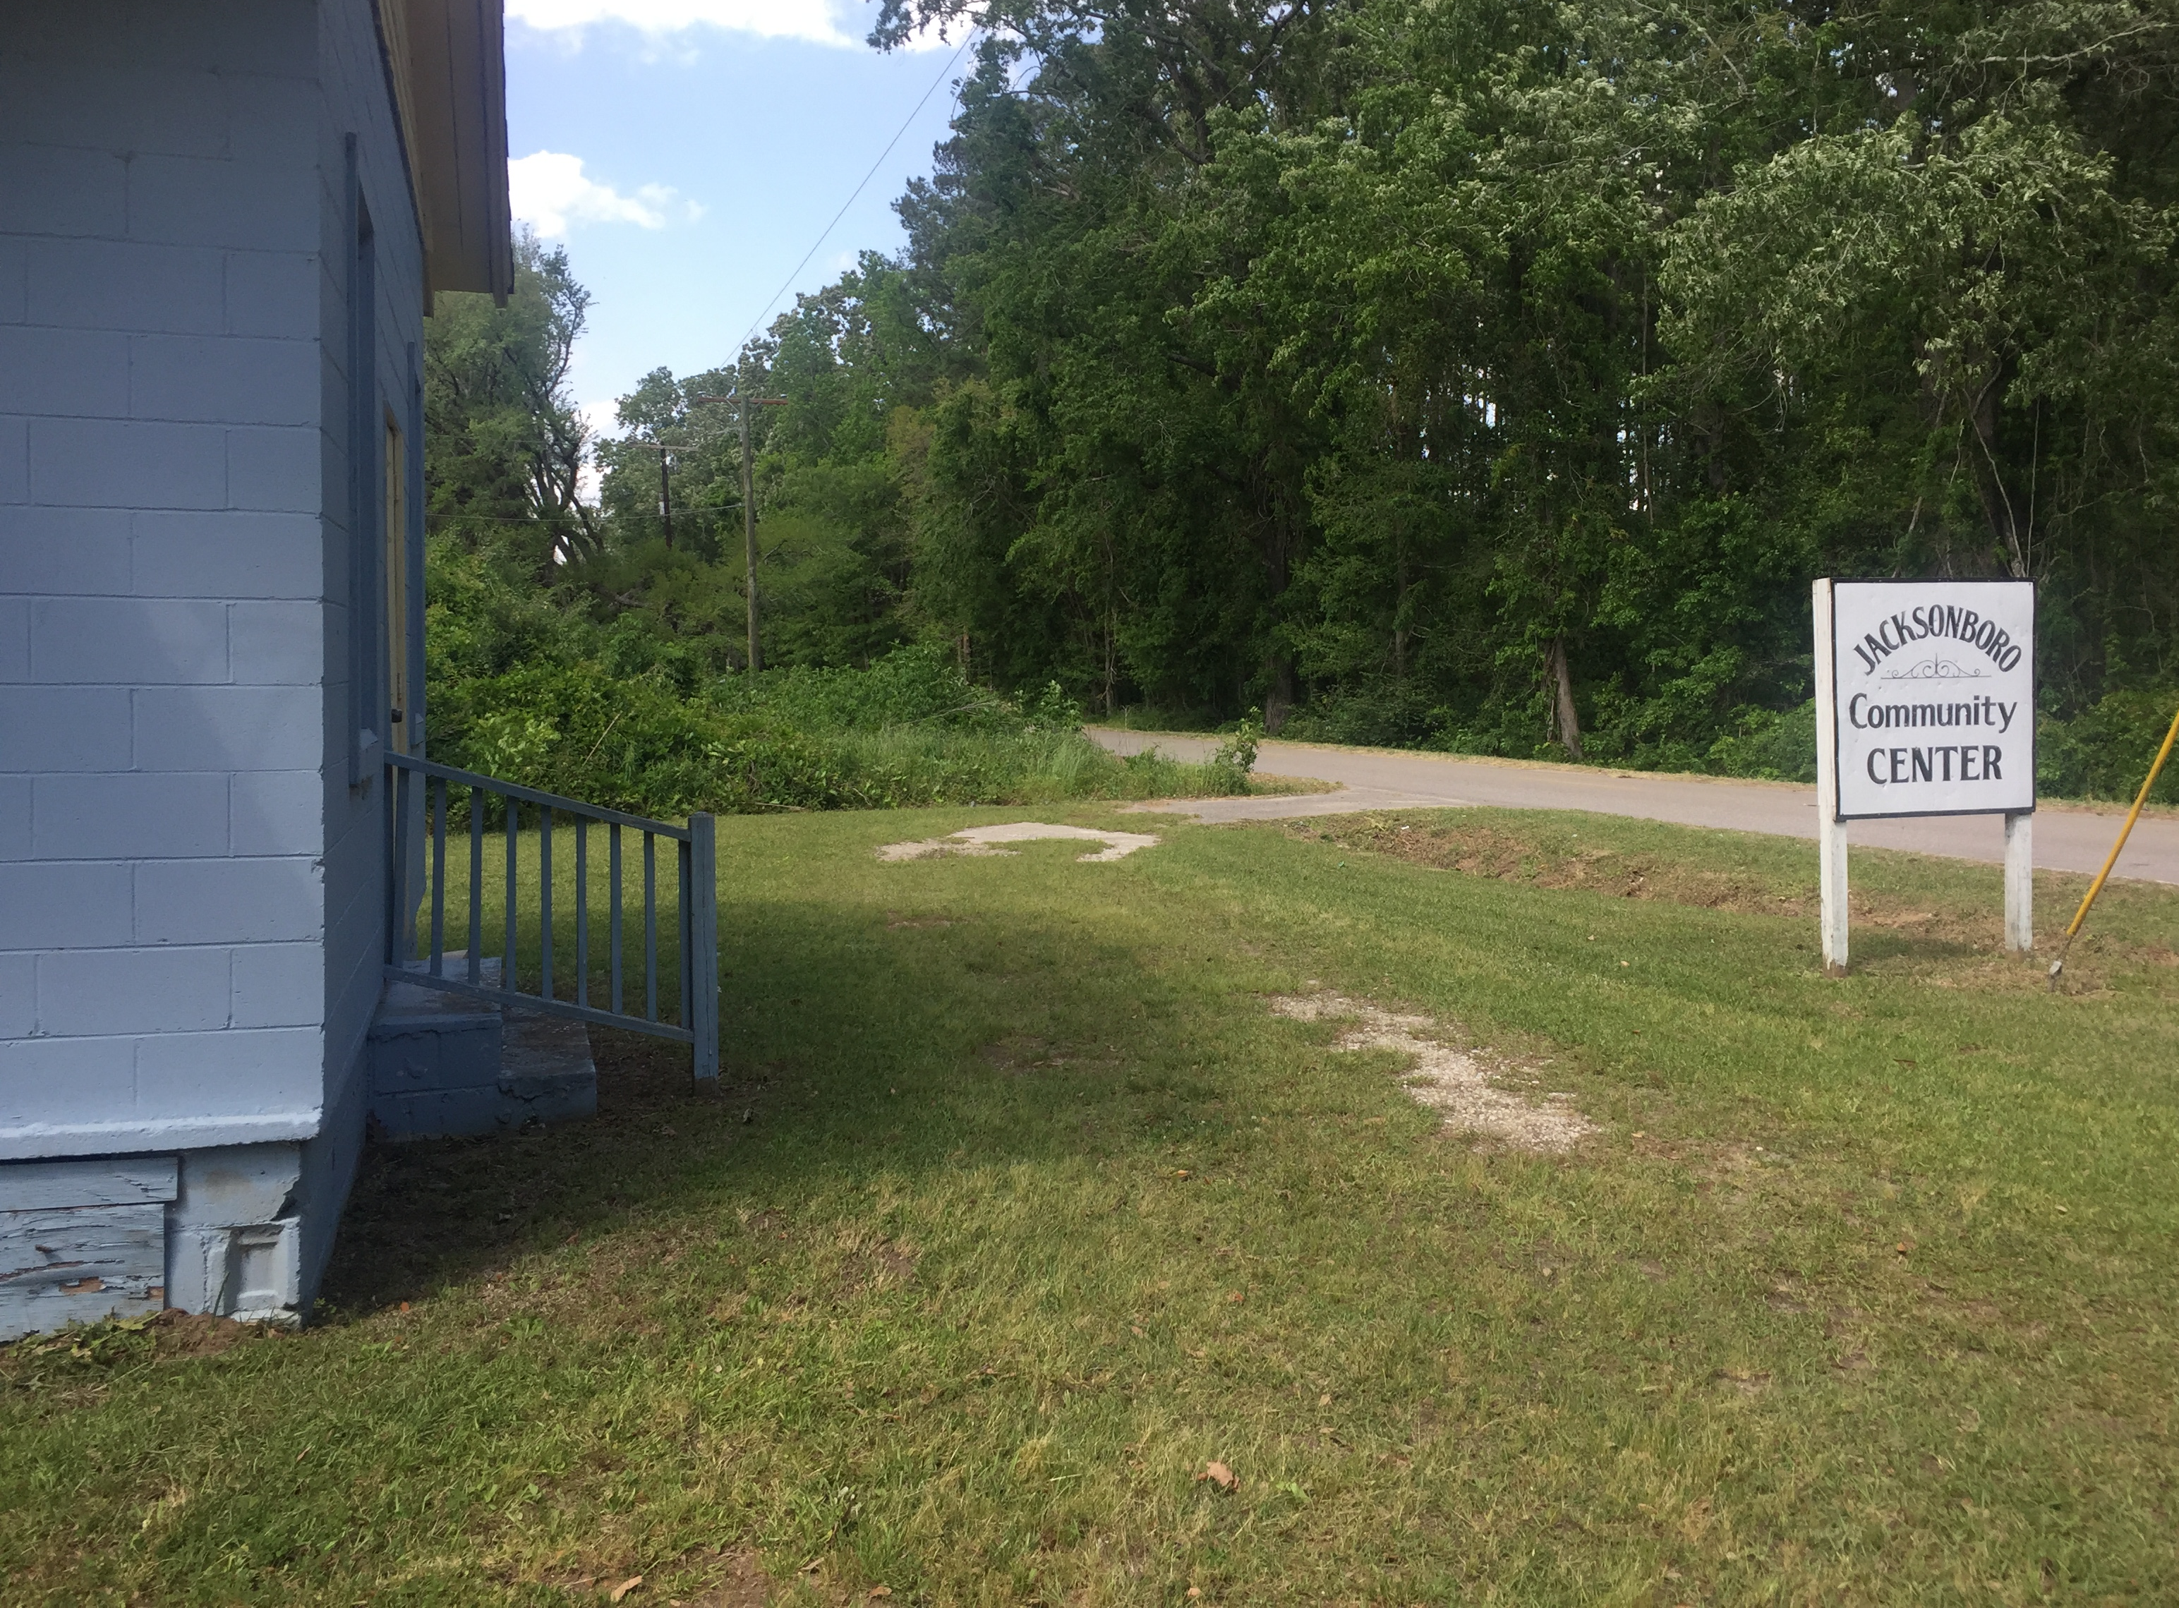
Figure 3. The site of Pamela Wiley’s Jacksonboro Fiddle Club
In contrast, Pam Wiley’s teaching spaces serve as physical manifestations of her pedagogical diversity and flexibility. Over the course of a week I spent with her in South Carolina, she taught in a room she and her husband (also a violin teacher) rent in Charleston; a recreation room of a Methodist church; a community music center called Hungry Monk; her house in the unincorporated rural town of Jacksonboro; and the school building of a Baptist church in the small city of Walterboro. We also drove to the home of a family in an affluent area of Mount Pleasant, where Wiley’s daughter (also a violin teacher) teaches the five children lessons, and visited the former site of the Jacksonboro Fiddle Club (pictured in figure 3) down the road from Wiley’s house, which she founded to offer lessons and violins to children in the area who would not otherwise be able to learn the instrument. Wiley’s most regular studio space in Charleston is sprinkled with instruments—an electric piano, an amp, a guitar, her own violin, and a few other fiddles on display. Sometimes parents are present in the small room; sometimes they drop their child off and leave. In the course of each lesson, Wiley drifts between instruments and locations in the room, accompanying, demonstrating, and providing harmonic and other musical context for the students’ playing.
Regardless of the particular location, Wiley brings her guitar and her violin with her, otherwise adapting to the spaces in which she and her students convene. Indeed, the single lesson she taught in her home, which we will examine in detail below, was only located there because it was a convenient location and time for the family, who had recently contacted Wiley for an introductory lesson after hearing about her free Jacksonboro fiddle club. In contrast to the stringent policies of Cole’s studio—a sign instructing students not to touch the wall when taking off their shoes, the understanding that no food will be in sight, let alone consumed during their lesson—Wiley’s students often munch on chips or drink soda between songs, and sit in a chair while playing in a way they find comfortable.
These differences between Wiley’s and Cole’s relationships with their teaching spaces are not happenstantial; Wiley would neither particularly care nor practically be able to mandate that her students never eat or drink during their lessons, and Cole would not so successfully and immediately establish the attention to detail she achieves in students without demonstrating the same level of detail in the environment she has cultivated. Wiley creatively adjusts and adapts to the eclectic and multi-sited American communities she serves; Cole requires the families who are able to access her studio to adjust and adapt to her necessarily uncompromising space. As it is with these teachers’ treatment of spaces, so it is with their treatment of students, and the development of their musical abilities.
Both teachers’ backgrounds, while strikingly similar in certain ways (they are almost exactly the same age and existed in the same social circles during the decades that Wiley was a Suzuki teacher, amongst much else) also provide important insights into their teaching approaches. Ronda Cole was raised in a musical family in New York and learned to play the violin from a young age, granting her an ability to discriminate pitch that rivals any of the most accomplished classical musicians. As Cole recalled, “we went from hearing my mother play in church as the organist and we would pretty much sit in the living room like Norman Rockwell kind of family, and have that station on and eat dinner and Beethoven in the air.” In thinking back about these early experiences, Cole noted that they granted her musical interests and sensitivities that facilitated her highly meticulous teaching style later on: “I didn’t know I was learning to be talented then, but I was.”
Pamela Wiley grew up in a small town in Minnesota, also in an affluent family, but without as much early exposure to music making as Cole. Her interest in playing music piqued during her teenage years, attending a high school which only offered a band program. Taking up percussion, Wiley became increasingly invested in music (in a variety of contexts), auditioning for all-state orchestra on the timpani in her sophomore year. It was only at that point in her life, at age sixteen, that Wiley observed string playing in person for the first time. As she recalled,
So I was in the Minnesota all-state orchestra as the timpanist—I’m getting the chills when I say this—without ever having heard symphonic music, seen a violin […] And I can remember the conductor […] at one point he said, ‘Miss Peterson! You are entrusted with one of the timpani parts of all time and all you can do is just stare moony-eyed at some pimply-faced violinist.’ He thought I was just being a goofy teenager, and I was being, like, traumatized, I mean, my life was changing, I was falling in love with violin, I was falling in love with symphonic music, I was figuring out, have I missed this boat, or how can I get in on this?

Wiley’s recollection of this first impression of the violin radiates the type of enthusiasm and awe that she exuded in every lesson I saw her teach. Her subsequent path to becoming a professional violinist—practicing intensely during her college years, playing in the Harrisburg Symphony and becoming increasingly involved in Old Time and other non-classical styles—also reflects her attitude toward music more generally. Her goal, as she noted, “is that people will feel self satisfied by playing music, and they’ll play in their community orchestras, or fiddle jams, or at home with their kids, and they’ll play music because it’s music, and not because they want to compete to get to the all-state orchestra and then get to the college orchestra and then get out there [as a professional].” Wiley is self-professedly not as sensitive to subtleties of pitch as some musicians (unlike Cole and her students, Wiley often uses a tuner to check each of her own and her students strings), and she often discusses her late start as a violinist. To her, the type of exceptional skills required for a professional (classical) career are beside the point of learning music. Rather, in her own playing and that of her students, she aims to cultivate a sense of “musicality,” an ability to understand, appreciate, and enjoy playing music—to achieve a type of fluency (to summon Suzuki’s mother tongue metaphor, which Wiley often references herself) rather than some type of exceptionality or virtuosity. This diversity of genres and skill sets and types of natural ability fit into Wiley’s conception of an “American Music System,” a phrase she first heard from Mark O’Connor and which she believes his method books embody. She defined this system as “like the river system or the mountain system or the circulatory system. It’s just organic and grass-roots based, and not—it doesn’t have rules from above, it’s not highly organized, it’s not institutionalized. […] And of course it’s going to be different for everybody. […] If you’re looking for a cohesive definition of the American Music System, that would go kindof against the grain of the whole thing.”
Over the course of their extensive teaching careers, both Cole and Wiley have developed nuanced understandings of the environmental and biological influences of musical ability. Both offered stories and explanations that supported recent scholarly literature in genetics, neuroscience, and cognitive psychology: namely, the influences of nature and nurture constantly interact, and neither is fully responsible for a student’s success (or failure) as a musician. As Wiley summarized, “I think both things are true, I think talent is a result of nurturing and education, and that there’s something inborn about it.” Cole acknowledged, “we’ve got what we’ve got,” but understands this fact as a marker of possibilities rather than limitations. Wiley, too, noted, “you have to do the best with what you’ve got.” She elaborated, using other traits as a metaphor for musical abilities,
You’re born a certain way. And some people are born, you know, just by luck, they’re born beautiful. They have beautiful eyes and beautiful hair, and beautiful features, and they can be models, you know. And some people are born—they can run really fast. And everybody can train […] and learn to run faster than they think they can. But there are some people who are just strung up right inside. Something about their muscles and their legs, and something about the way they’re connected to their brain, that they’re going to be able to run faster than anybody else, that’s just given. And it’s just the way we’re born, and that’s the hand you’re dealt. My dad always said, ‘you have to play the hand you’re dealt.’
Despite their mutual support of an interactionist interpretation of musical ability development, however, Cole and Wiley have reached different conclusions about how this framework relates to their conception and treatment of “talent.” Echoing Suzuki’s sentiments, Cole noted that she stringently avoids making pronouncements about whether a student is more or less naturally musical, even quietly in her own mind; indeed, she does not understand “musicality” to be a single quality at all, but as a diverse compilation of musical and non-musical skills. “If you’re saying this child is very gifted and this one isn’t, you’re going to teach them differently. Of course you have to teach them differently, but you change your expectation of what’s possible and what you’re going to do. Which, whenever I catch myself in that, I am so full of self-loathing.” While Wiley agreed that “I don’t talk about it, I think it’s destructive to the kids to think about talent,” she acknowledges that she considers certain students to be more naturally “gifted”: “I’ll come home and use that terminology [gifted, talented] with John. But I just mean that they’re quicker at it.” As the latter part of this statement implies, Wiley does not believe that these differences in natural ability interfere with her goals for her students: “What most people call talent—your child is talented—that level of talent is accessible to everyone.” Rather than conceiving the development of talent as systematically as Cole, Wiley more readily assents to her students’ differences: “Like the tortoise and the hare thing. The hare can run fast right away because he’s that way, and the tortoise wins the race because he’s slow and steady and he wins the race. So which one’s more talented?”
The issue around which Cole and Wiley diverge most regards their understanding of their roles as teachers in relation to the interaction between environment and cultivation. Cole, like Suzuki, takes almost complete responsibility for her students’ achievements, seeing education simply as an equalizing force: “Whatever’s not there, it’s my job.” As she explained of Suzuki teachers, “We have to grow that for the child, the parent and the child participating of course, but our job is to grow that for them.” Instead of seeing musical ability as a single entity, Cole envisions a collection of “threads” that, once identified, can always be developed: “I am awakening the hundreds of threads of learning that need all to be in place, ultimately. And very few children just show up with everything fully charged, all those avenues of learning and sensitivity and perceptions.” She added that teaching is not always an additive process, but one of “taking something away.” Cole described this aspect of her role as analogous to a therapist, stating, “I know I can’t completely unravel psychological damage that walks in here. I can help. […] But I can’t totally clean the slate.” Whether intentional or not, Cole’s reference to a tabula rasa—and Locke’s Essay Concerning Human Understanding that famously forwarded the concept of the human mind as a blank slate—is appropriate. Indeed, Locke’s intervention against hegemonically motivated appeals to innate knowledge and ability is strikingly similar to Suzuki’s philosophies around music.
Rather than envisaging a specific set of competencies members of her studio must all develop, Pamela Wiley takes a broader vision of each student’s musical growth and therefore a less thorough (or invasive, depending on one’s perspective) approach to her role as teacher. As her tortoise and hair comment above suggests, even Wiley’s understanding of talent acknowledges and celebrates diverse viewpoints—a level of acceptance and flexibility she brings to her teaching. Wiley does not assess and address each individual “thread” in her students, but presents them with a wealth of musical information, challenging them to pick up as much as their desire and ability allows: “I mean there’s the, ‘ok you’re not ready for this, so you have to get a better position and better tone and better this and better that.’ […] ‘You want to play this? Rise to the occasion.’ There’s either the ‘be prepared for it,’ or the ‘rise to the occasion.’ So I’ll go for the rise to the occasion.”
Although Wiley teaches multiple lessons each week, she has noted that private lessons are not the most ideal format for her teaching goals. As she noted to me, “‘music education’ is an oxymoron. Because once you take music and chop it up and organize it […] and make things testable and Every Good Boy Does Fine and all that, it ceases to be music.” Referencing the idea of music as a language, she thinks that students should more ideally be immersed consistently in informal, natural musical habitats—an essential aspect of what she describes as the American Music System. “Music is a language. And let me tell you, there is no organized way that kids learn their language. […] They’re submersed in the environment, and they learn to speak the language to fit into the environment, period. They don’t do step by step, they don’t do the Twinkle of learning to speak English, and then the Lightly Row. They don’t learn grammar, they don’t learn the rules, they don’t start tearing their language apart until they’re in the 3rd grade.”
Unsurprisingly, the ways Wiley and Cole teach students is similar to the way they approach teacher education within their methods. Wiley accepts that teachers will not all share the same priorities, level of intensity, level of education—in short, that they will not necessarily be like her or want to exactly imitate her teaching approach. Rather, she hopes for as many teachers as possible to utilize the O’Connor method, experience the songs and the ways they are played across the country, and to teach students in a way that works for them. Cole, on the other hand, feels strongly about her (famously successful) interpretation and application of the Suzuki method; she gives highly detailed instructions about teaching every note each song (as with her students, she gives teacher trainees photos of her marked-up Suzuki books to copy into their own books and teach). In addition, she tells teachers specific ways to construct studio policies, format group class, form relationships with practice parents, and also provides teachers with exact words and metaphors to use to evoke the desired psychological or physiological response in students.
Wiley adapts; Cole requires. And so it is with their treatment of talent. Wiley builds upon each student’s unique foundation of natural ability; Cole crafts a particular approach to learning on what she regards to be a blank slate (which must sometimes be cleared). This pedagogical physics is shaped by each teacher’s ideologies about the role of music, the goals of music education, and understandings about the nature of ability development. The following section transitions to Cole’s and Wiley’s more specific teaching contexts via a discussion of the first piece in each method book, vignettes of which were introduced in the chapter’s opening paragraphs. These first pieces serve as an opportunity to examine the relationship between the intentions of the methods’ founders and the lived application of these methods by two women with more than five decades of experience.

The First Song

Tens of thousands of violin students around the United States share a common formative experience: the first piece they learned to perform on the instrument was a series of rhythmic variations to “Twinkle, Twinkle, Little Star.” But since 2009, an increasing number of beginner violinists (though nowhere close to the population of “twinklers”) have trained their bodies and minds to perform a different first set of notes, instead: those to the American folk tune “Boil ‘em Cabbage Down.” The technical requirements of each song provide different allowances around the way young players approach the violin; moreover, the ways Cole and Wiley teach these songs reveal a multitude of ideological differences between their methods: which technical and musical knowledge is most fundamental, which skills should be taught explicitly and which temporarily (or enduringly) left unmentioned, how to approach a new piece of repertoire (as sound, as musical notation, as a game, as part of a culturally and historically bounded practice), and, importantly, how to practice and approach the learning process.
When asked why he selected “Twinkle” as the first piece in the method book, Suzuki explained that children from any number of cultural backgrounds would already know how to sing it, as it was “probably the best-known song universally. Every child knows it in his own language.” This sense of familiarity is connected to one of the basic tenets of Suzuki’s mother tongue approach, discussed above. Instead of introducing the legato theme of “Twinkle” as the first entry in Book 1, Suzuki composed a set of rhythmic variations (figure 4) more appropriate for a beginner’s bow stroke than the long, slow bows of the original melody; such long, connected strokes require a more proficient and flexible bow hold to play with a beautiful tone, which Suzuki hoped to cultivate from the very beginning of a student’s playing experience. The variation rhythms were also chosen with familiarity and fluency in mind; Suzuki adapted Variation A, for example, from the opening of Bach’s popular Concerto for Two Violins (included in Book 4 and Book 5 of the method). Each of the rhythms was idiomatic of the Baroque style, the repertoire of which was increasingly relevant to the string-playing world in the West and Japan alike as Suzuki was developing his method over the course of the twentieth century.
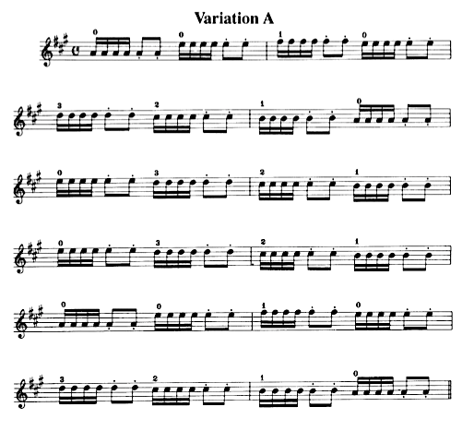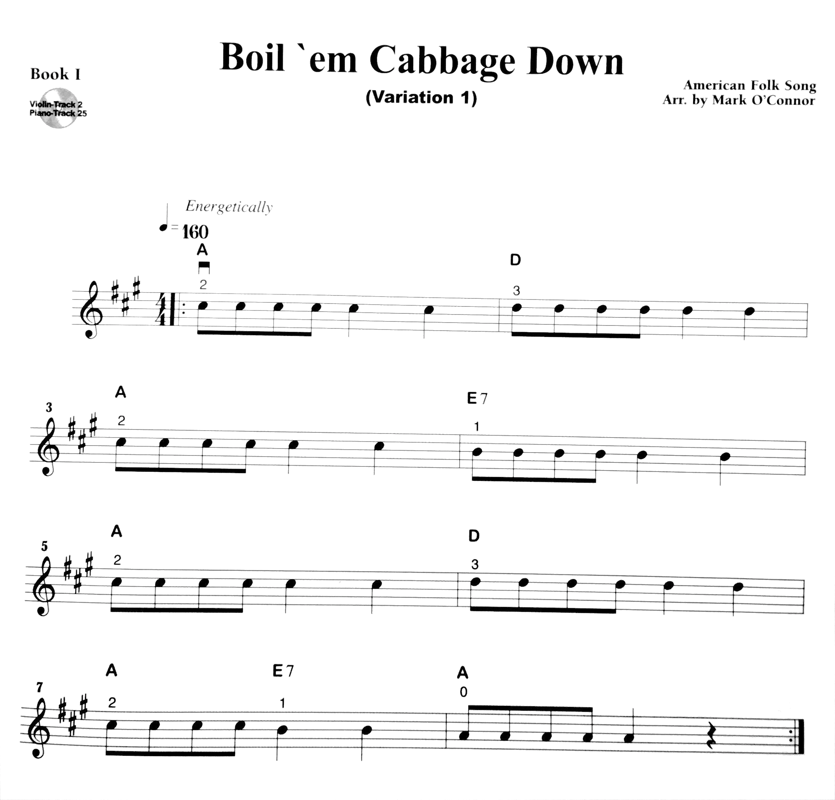
Figure 4: The first variations presented in the Suzuki and O’Connor method books, respectively

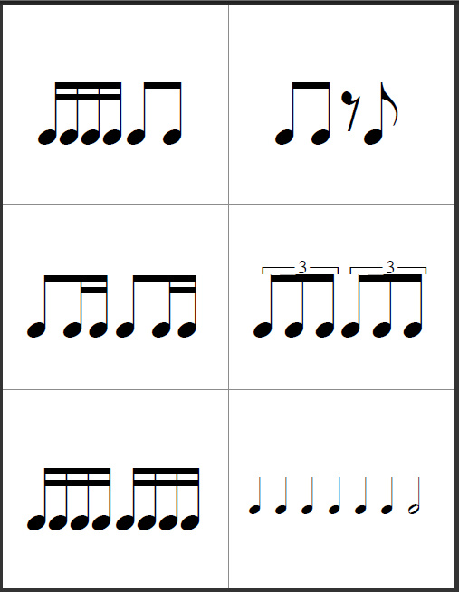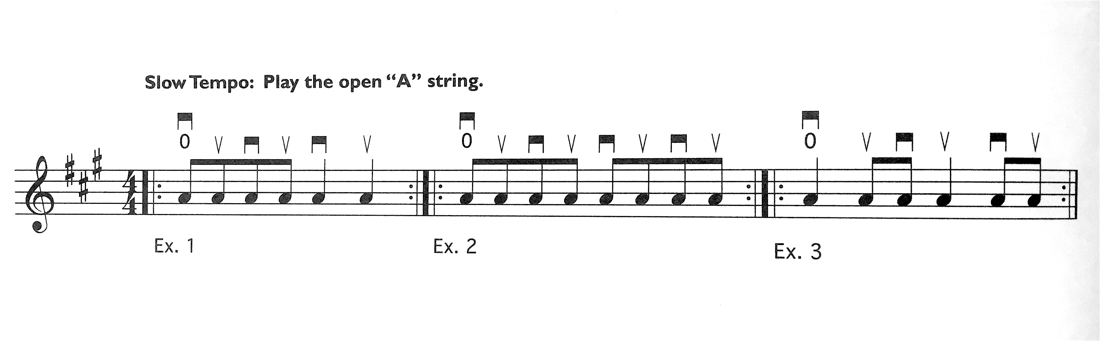
Figure 5: Twinkle variations A, B, C, D, E, and Theme; The first three variations in O’Connor’s Book 1
To Suzuki, the melody of “Twinkle, Twinkle, Little Star” was not inherently significant in itself, though the song’s note order is conducive to teaching students a balanced left hand position. Rather, the well-known song provided an opportunity to cultivate a particular approach to learning music as a language—a process that starts from the earliest age and involves constant repetition and parental involvement. Suzuki believed that all students immersed in the sounds and the motions of “Twinkle” would eventually develop the ability to play it with ease—one of the central points in his lifelong contention that musical talent is something all children are able to acquire.
Though O’Connor mentions an entirely different set of goals around his repertoire choice, the similarities between the first songs in the Suzuki and O’Connor method books are worth noting. “Cabbage,” like “Twinkle,” is a well-known, centuries-old folk tune with stepwise fingerings in A Major that involves a significant amount of repetition, structurally and rhythmically—not to mention that it introduces the same first rhythmic pattern as Suzuki’s Variation A (see figures 4 and 5). With a characteristic dose of antagonism, however, O’Connor argues that “Cabbage” “is a much, much better starting tune” than “Twinkle” in part because it “allows for technical acquisition and creativity to take place at the same time.” Indeed, the two founders’ different understandings of creativity are evident in the way they advocate students to approach these first songs. As discussed above, O’Connor conceives creativity in terms of improvisation and individual personal expression, whereas Suzuki ascribed to a more traditionally Japanese understanding of creativity, which involves a certain richness of inner experience (rather than outer variation) acquired through extensive repetitive and imitative practices. O’Connor’s favorite example to demonstrate the merit of “Cabbage” as a first song was the performance described at the start of this chapter: a virtuosic, improvisation-dominated jazz rendition which (he always notes) received a standing ovation; Suzuki’s preferred promotional material (included on the covers of many editions of his books) for “Twinkle” was an image of thousands of students standing on stage performing the piece with ease and joy, in perfect unison.
Wiley has elaborated upon O’Connor’s argument about the advantages of introducing students to the violin through “Cabbage” over many other common beginner songs. As she has written, “Not only is this beginning tune a great little melody for teaching whole and half steps from a home base central to the hand (C# on the violin), but the melody is also an obvious chord progression. The initial move from C# to D carries such an obvious chord change with it that the students sense harmonic movement from the very beginning.” Indeed, Wiley sees “Cabbage” as a fitting introduction to one of her missions as an O’Connor method teacher, which she calls “the Three M Principle: Music is More than Melody.” Instead of focusing on the perfect execution of the song’s melodic notes, Wiley uses “Cabbage” as an opportunity to discuss rhythmic subtleties, bowing feels, harmonic progressions, different aspects of music ensembles, and ear training (of aspects beyond melody). As the following section demonstrates, Wiley prioritizes introducing her students to these more inclusive musical principles, allowing them to hold their instrument in whatever way they can to begin participating in the process of music making.
Students’ first experience with “Twinkle, Twinkle, Little Star” is vastly different in Ronda Cole’s studio. Before attending their first private lesson, Cole requires every new student and their designated “practice parent” to observe hours of private and group lessons and develop the habit of regularly listening to the Suzuki Book 1 recording on a daily basis. This type of preparation inculcates students and parents into a series of studio norms they will be expected to follow once they start lessons. As Cole explained of this introductory process,
And so my process now is that they have to observe for at least three months. They’re observing lessons, they’re mostly observing group classes, and in the last month they go to individual lessons. And the parent is getting the education of, wow, we’re not just playing little tunes and goofing around, this is really an educational opportunity. A broadening one. And in the meantime the child is getting very very eager—why can’t I have a violin, why can’t I have a lesson with the teacher, why not me? So, I’ve got a parent where they belong and a child where they belong.

During this extensive preparatory period, the prospective family sees current practice parents taking detailed notes on every aspect of each lesson in order to repeat the tasks in their entirety at home each day, asking detailed questions if they are unsure about a particular task or goal; they see that no students show up a week after their previous lesson without having listened and practiced essentially every day; they discover that it is not unusual for students and parents in Cole’s studio to have carefully repeated a particular motion, set of notes, or other assignment upwards of a thousand times in the course of their week of practice. It should be noted, too, that while Cole prides herself on the fact that very few students in her studio have quit playing the violin, this introductory period screens out families who are not prepared to invest the type of time and attention (not to mention money) that Cole requires.
Once new students finally pick up their violins to begin the process of playing “Twinkle,” it is under a highly controlled process that only results in a bowed note after weeks of preparation—preparation that is as rigorous as it sounds, but nevertheless full of playful challenges, jokes, and small celebrations that help the young student maintain a feeling of success after mastering each small task. In these first lessons, the parents and teacher focus on helping the student remember the exact placement of their feet, the angles of their knees and spine, the precise position and movements of the joints in their right arm to the rhythms. In short, no detail of the student’s development into the full set of Twinkle variations is modified, aside from the way the violin is fit to a student’s body with sponges and rubber bands. No matter how long it takes (some students work on Twinkle for years before being deemed ready to “graduate” and move onto the second song of Book 1), every member of Cole’s studio plays the piece with a similar level of polish, playing in perfect unison in the studio’s regular group recitals.
A student learning “Boil ‘em Cabbage Down” with Pamela Wiley encounters an entirely different set of goals and expectations. Wiley has developed techniques to help her new students produce the song’s melodic contours as quickly as possible, resulting in a wide range of postures and sounds. Some students achieve a relatively in-tune and rhythmically accurate rendition of the song, and others move on to subsequent songs in the book without correcting every technical or musical aspect that Cole might deem to be substandard. Rather than prioritizing technical proficiency, Wiley aims for her students to engage with the Cabbage variations in a way that reproduces a more “organic” communal process of music-making. In other words, Wiley hopes to cultivate the desire to achieve technical proficiency through trial and error, through what she calls a “rise to the occasion” approach. Through this more hands-off process (relative to Cole’s), some students are quickly able to absorb a significant number of skills, techniques, and elements of an effective playing posture; others do not pick up as many details and continue to play at a more basic level until explicitly instructed. From the very beginning, Wiley’s students are encouraged to learn through improvisation, experimentation, and exploration—on their own, but especially in group settings—regardless of how they are holding their violin or bow.
I first encountered the “Boil ‘em Cabbage Down” video described at the start of this chapter in the 2015 teacher certification course for O’Connor’s method in New York City; our instructor, Pattie Hopkins Kinlaw, presented the video as an example of the method’s flexibility. O’Connor posted this video on his Facebook page as a testament to the inspirational potential of the song. “See how far we can take the tune and see how the French jazz audience reacts to it,” he wrote in the post. “Folks, you wouldn't be getting this kind of response no matter how well we improvised on Twinkle, Twinkle Little Star - and the children can feel the power of their little beginning tune and the difference it makes.” Pamela Wiley has emphasized how the pedagogical possibilities of “Cabbage” are not simply imposed upon the song because it was chosen as the first tune in the method; rather, its American cultural context as an orally transmitted folk tune without a fundamental attachment to the Werktreue ideal is inherently designed for a range of ability levels and a range of interpretations. And while the method intentionally incorporates music associated with a variety of performance practices (including compositions from American composers of Western art music) Wiley notes that this diversity and flexibility is one of the method’s great assets. As she explained, “American music is the best music for learning, for teaching, because it’s so adaptable to any level. I mean, Mozart didn’t write any beginning tunes. And Brahms and Tchaikovsky. But Cabbage can exist on this level or this level or this level. It’s supposed to. You’re supposed to change it. And you’re not supposed to change Bach.”
The inherent flexibility of the O’Connor method’s repertoire grants each student significant freedoms during the process of learning. What O’Connor teachers like Wiley identify as each student’s level of “talent” or “giftedness,” then, emerges in part from each student’s unique response to these freedoms. In contrast, all of Cole’s Suzuki students are held to a matching set of standards (regarding learning attitudes, technical skills, practice routines, and otherwise) that complement the rigidity and uniformity of the method’s Werktreue-compliant repertoire. Within this Suzuki-oriented paradigm, differences in natural abilities only present as longer or shorter amounts of time mastering each step; Cole takes it upon herself to enable each student to perform Twinkle, and every subsequent piece, with a precisely calibrated posture, accurate intonation, a clear tone, and expressive dynamics.
In the following sections, I examine these beginning stages of each teacher’s approach in greater detail through a close analysis of videos that chronicle two lessons: the first with Ronda Cole’s student Eliza (5 years old) and the second with Pam Wiley’s student Zoe (12 years old). As discussed above, my analysis of the music and the talk contained in the lesson unfolds as a narrative account, as Erickson and others have discussed. In the course of each of these lessons, both girls will play their first note on the violin. While Zoe played this note in a matter of minutes after she and her parents met Wiley, Eliza had almost reached the end of her second lesson, after months of preparatory observations, parent preparation, and at-home listening.

Eliza
Like every lesson in Cole’s studio (regardless of whether its focus is Twinkle or Tchaikovsky’s violin concerto), Eliza’s second lesson began with the sound of an A-440 emanating from the tuner-metronome sitting by the teacher’s chair. Like all of Cole’s beginners, Eliza is asked to sing A before hearing the reference note, a daily practice that results in almost 100% of Cole’s students developing a sense of perfect pitch—one of the most common signifiers associated with innate talent. After starting out slightly sharp, Eliza adjusts her voice to reach an A, smiling while she sings as Cole turns on the tuner and shouts “Hurray!” to celebrate her success at this task. As Cole reminds the 5-year-old, singing A had been the first part of her homework, and she had accomplished it.
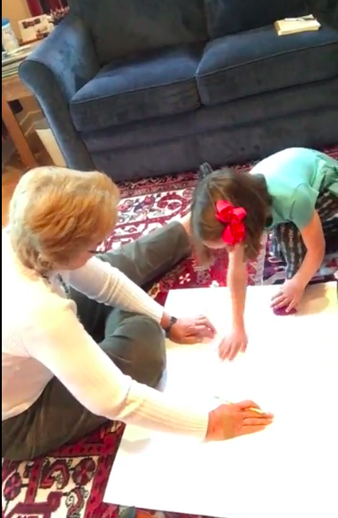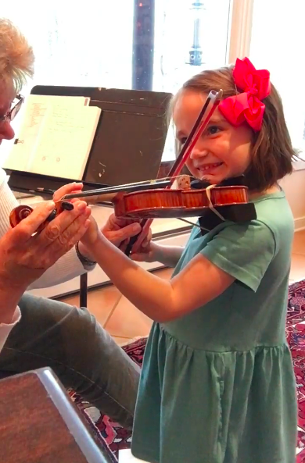
Figure 6. Making a foot chart Figure 7. Eliza’s first note using bow and violin

The next task in Eliza’s lesson would not become a regular occurrence, though it affects every subsequent moment of her time in Cole’s studio. Leaving her chair, Cole takes a poster-board the family had brought and helps Eliza make a foot chart (figure 6). With the girl’s assistance—helping her gain an attachment to and responsibility for the chart she will use for her first months of lessons—Cole traces the student’s feet in their “resting” (red) and “playing” (green) positions, as well as making an outline of her violin to visualize the angle at which she will tuck it under her left arm when she is not playing. “Okay there's your red and green. And I kind of like that there because the resting position is when the feet are in the red.” On the other edge of the chart, Cole outlines the toes of her own feet as well, not only symbolizing her intimate involvement in these first literal and figurative steps of Eliza’s playing experience, but also establishing the proximity and angle at which the girl will stand in front of her from that point onwards. This proximity allows Cole to reach out and adjust Eliza’s feet and knee joints, the angle of her hips, shoulders, and head, and, later, her bow hold and violin position, helping her both feel and consider the angles and sensations of the standardized posture Cole has refined over the course of her teaching career. As she told Eliza, who looked on with her full attention while pulling at her dress in excitement, “this is your chart, but I'm kind of part of it.”
This six-minute foot chart event was not simply a procedural necessity. Rather, it points to the level of attention and time Cole devotes to honing her students’ posture from the very start. As with every aspect of Cole’s teaching, the chart provides Eliza with multimodal opportunities to internalize the lesson it conveys: the positions of her feet are not only descriptively referred to as “resting” and “playing,” but are also color-coded, and carefully shaded in at home as a part of her practice; her feet are manually manipulated to match the chart by Cole and her mother, and Eliza will practice moving her feet on her own (while maintaining “soft,” unlocked knees) to the correct position repeatedly on a daily basis, until it becomes “easy” and entirely subconscious—seeming intuitive to an uninitiated observer. While I first judged Cole’s foot chart ritual to be an arbitrarily fastidious detail that delayed students’ playing experience, over time I observed how this procedure epitomizes Cole’s ideology of talent—which, as discussed above, she conceives instead as process-oriented “talented learning.” For Cole, proficient violin playing that appears and feels easy does not begin with sounds, or the violin or the bow, but with attention to every angle of the body. By emphasizing the importance of her feet (and, as the remainder of the lesson illustrates, almost every other aspect of her posture) before Eliza attempts her first note, Cole ensures that the student’s body will become attuned and eventually habituated to the correct positions (rather than having to break “bad” habits later), and that her first attempts to produce a sound will be successful.
After positioning Eliza on her new chart, Cole launches immediately into the next segment of the lesson. “Very good, okay. What song am I doing?” Eliza had also prepared for this section of the lesson at home, and right as Cole finishes clapping the rhythm of the first Twinkle variation, Eliza smiles and declares, “Mississippi Hot Dog!” Another celebration of success. Rather than moving on to another rhythm, Cole builds upon this achievement, connecting the rhythmic sounds the student recognized with its embodied counterpart by asking her to clap the rhythm, too. They chant together while clapping, “Mississippi Hot Dog.” After two repetitions, Cole introduces another layer of musicality to the exercise by suggesting a different dynamic and the type of motion it requires, “Now do it small.” They clap and chant softly, “Mississippi Hot Dog.” After clapping a second, slightly more complicated rhythm, “Stop, big bow, stop, big bow,” Cole asks Eliza for a more complex type of movement, taking her right hand, prompting her to remember the important details of her home practice assignment:
Cole: Shake my hand with that one. Where do we start?
Eliza: Higher than-
Cole: Higher than your nose. And will your elbow be?
Eliza: Bent.
Cole: Okay. And the next thing we do is breathe, right?
They both take a deep breath and shake hands (enabling Cole, too, to sense if Eliza knows the rhythm, and to subtly correct and guide her hand if necessary) to the rhythm of Twinkle Variation C, plunging their joined hands from the level of Eliza’s nose to the level of her belly button. Proceeding through the rhythms of other variations, Cole reminds Eliza not only to start the handshake rhythms above her nose and to bend her elbow as she moves, but to keep her right shoulder down and relaxed: “Did you know you could raise your arm without raising your shoulder? Watch me, watch me, look at my shoulder.” These are not insignificant kinesthetic tasks for a 5-year-old to achieve, and as Eliza’s eyes begin to drift away from this confusing set of motions to look at the birds through the picture window, Cole immediately notices, raising the volume of her voice and reminding the girl of another aspect of her assignment (there are big eyes drawn into the notebook beside Cole), telling Eliza to ask her eyes to maintain focus on the teacher: “Uh oh! Uh oh! Look at me!” Eliza smiles, acknowledging this agreement and meeting Cole’s eyes again.
In the course of this “Twinkle rhythms” section of the lesson, then, Eliza has already attended to the most difficult motions of the Twinkle variations. She has played the correct order of down-bow and up-bow strokes by starting above her nose and descending while shaking Cole’s hand; she has started to notice and control her gross and fine motor skills, relaxing her shoulder and bending her elbow while using a selective set of muscles to raise her wrist and forearm; she has started to develop the habit of breathing in anticipation of a musical phrase; with guidance, she has connected the words and rhythms of each Twinkle variation with these complex arm movements. Although Eliza has yet to touch her violin by about halfway through her lesson, her time spent practicing these preparatory steps ensure that she will feel at ease and in control when she does pick up her instrument.
Signaling another transition, Cole reaches for Eliza’s violin: “Okay. Let’s put your violin up. Very nice.” She places the violin at the precise angle she had explained to Eliza and her mother the previous week—the same angle that her advanced students use to practice Paganini Caprices or Bach Preludes efficiently and painlessly for hours—guiding the girl’s left arm forward and placing her thumb on the violin’s neck. “Shoulders are always sleeping, right? Your head doesn’t sleep, just your shoulders, okay? What song?” Cole take’s Eliza’s bow and plays Mississippi Hot Dog, generating the first violin sounds of the lesson. Eliza’s eyes light up in response to the clear sound on her small violin and she begins to smile, listening to the rhythm she already knows by heart. After identifying all of the Twinkle rhythms again in this manner, Cole takes Eliza’s tiny violin and plays it herself, prompting the girl to identify songs into the middle of Suzuki Book 1, as Eliza had been listening to the recording for months (in fact, even longer than that, as her older brother had already been studying with Cole). While Eliza correctly identifies the earlier songs in the book, she gets confused by the A major melodies of the songs “Allegro” and “Perpetual Motion.” Cole gives Eliza some information to attach to the melodies, imbuing the order of notes with additional meaning:
Cole: This is a piece that Dr. Suzuki wrote to make children happy. Does it work? Its name is Allegro. And Allegro in Italian—that's another language—means happy. Can you hear happy in this? [Plays the first four notes]
Eliza: Yeah!
Cole: It really feels happy doesn’t it?
Eliza: Happy, Happy… [Singing the melody of “Allegro”]
Cole: [Singing along with Eliza’s melody] Happy, happy, look at me I'm happy. You could make up a song about that.
Eliza: [Smiling]

Following this conversation, Cole and Eliza discuss what “Perpetual Motion” means, as well, singing “tick tock tick tock tick tock” to the melody’s uniquely perpetual stream of eighth notes. In addition to helping Eliza develop what Cole calls an “inner song”—the ability to hear in one’s mind a quintessential, musically expressive rendition of the repertoire they will play before (and while) they perform it on their violins themselves—this activity and discussion introduces Eliza to the idea that every song was written by someone, and for a reason. In later lessons, Cole will begin requiring Eliza to pick one “special listening” piece each week, arriving at her lesson prepared to announce who composed it, who performed it, and what it was called, using correct pronunciation and projecting her voice—skills she will use when she announces her piece in performances. She will also be asked to remember the title and composer of every piece she learns to play.
The final section of Eliza’s lesson turns again to her bow hand, now incorporating the bow itself as well as adding the fine motor movements of her fingers to the gross motor movements she had practiced a few minutes earlier. Again, Cole presents the information in multiple modalities and styles, helping her to feel and conceptualize the highly detailed instructions for holding the bow. Cole arranges Eliza’s hand onto the bow, repeatedly noting the bump in her thumb, the relaxed feeling of her muscles, the spaces between her fingers, and the flatness of her knuckles; she tells the girl that she should be able to feel air blown through the spaces her fingers create on the bow, helping her feel and conceptualize the negative space. Cole blows onto Eliza’s fingers to help her test this theory. “Did it go through?” “Yeah.” Rather than giving these instructions once, Cole circles back around several times to each of these aspects of the bow hold, helping Eliza—as well as her mother, who is taking notes and occasionally offering Eliza additional reminders as she looks on—practice the type of patience, diligence, and care she will need to repeat this activity every day at home. Seeing that Eliza has not quite internalized the required thumb bump (and after a few minutes spent trimming her thumb nail to enable it to touch the bow at the correct place), Cole adds a layer of personification to the process:
Cole: Uh oh, still a bump though. [Modulating her voice higher, and meeting Eliza’s eyes just a few inches away from her face] This is pretty tricky to teach your thumb to do that. But you’ll be a really persistent teacher. Keep telling it, and tell it again, and tell it again, and keep telling it until it remembers, okay?
Eliza: Okay.
Ronda: Hey thumb! Be soft and bent! Soft and bent, soft and bent. We should make a twinkle variation out of soft and bent, huh?
Eliza: [Nods and smiles]
Lindsay: (laughs)
Ronda: Alright. Well, okay. I want you to make that bow hold so many times a day nobody would believe it. So many. So if you can get that, spaces and soft thumb, we might even play a few notes.

With this added motivation, combined with the time spent cultivating the mindful attention required to control the automatic response of her thumb joint, Eliza maintains a correct bow hold and Cole decides to reward her by putting bow to string. Placing the violin on Eliza’s shoulder, Cole places her hand on the bow, as well, guiding her as they produce the rhythm of Mississippi Hot Dog. The violin’s sound is clear, and Eliza’s face immediately explodes into a smile (figure 7).
Ronda: Whoa! Your first note!
Lindsay: You just played the violin!
Ronda: What a nice sound! I like it!
Lindsay: Wow!
Everyone in the room—even the cat that had been walking in and out of the camera’s view—stopped to celebrate this long-awaited moment. After repeating the motions of Mississippi Hot Dog a few times with Eliza’s bow hold still carefully positioned with a bent thumb, Cole takes her hand off of the bow for a few seconds. Seizing this rare moment of freedom, the 5-year-old manages to saw her bow excitedly across the A and E strings about four times before Cole reclaims control, lightly scolding, “hey, hey, hey!” Eliza’s mother Lindsay, understanding Cole’s intentions, explains to Eliza, “You don't play unless your form is right.”
After discussing exactly how Eliza and Lindsay will practice the skills covered in this lesson at home every day, Cole directs the student’s attention back to the foot chart she had been standing on since the start of the lesson: “Now we can take our thank you bow. And you will be on your red feet. Next week your mom will finish your chart, and you will be sure to know which ones are red.” Eliza, who had already learned what to say with each lesson’s concluding bow, looked up at Cole and said, “thank you for teaching me, Mrs. Cole.” Bowing as a marker of respect to the teacher and the audience is one of the most consistently maintained of Suzuki’s rituals in contemporary Suzuki studios. In addition to marking the beginning and end of each lesson and performance, the practice of bowing symbolizes the amount of authority and respect granted to teachers like Cole—not a given in modern American cultural contexts that often group music teachers with childcare providers, tutors, or hired entertainers.
Although this lesson illustrates the many ways that Cole establishes behavioral and technical fundamentals with a new student (fundamentals which later appear to onlookers as natural or innate to these students), it is remarkable how many expectations and behaviors had already been normalized and made implicit before this second lesson began. In part because Lindsay has become familiar with Cole’s expectations through practicing with Eliza’s older brother, she already understands the level of detail she needs to note in each lesson (which is why she consistently appears in the corner of the video, watching Cole’s interactions with her daughter). She has also learned the vital importance of asking questions if any aspect is ambiguous, so Eliza does not practice something incorrectly dozens or hundreds of times between lessons. If viewed out of context, too, Eliza’s behavior in this lesson may be perceived by an onlooker as unusually calm and cooperative; but her months of observation of the culture lived by other young violinists in the school, combined with the type of environment her parents have cultivated around violin playing, has likely cultivated a sense of significance around the instrument, rather than seeing it as a playful activity or an entertaining side-project. Indeed, even Eliza’s palpable enthusiasm for being able to sing the Suzuki songs and produce the first sounds on the violin cannot be attributed largely to some innate desire, as that desire has been carefully cultivated. As Suzuki wrote, “We have caused [the student] to acquire that desire.” It is a phrase of Suzuki’s that Cole repeats often.

Zoe
While Zoe’s first lesson with Pamela Wiley offers a wealth of information about her approach and philosophy as a teacher, it is important to note that no single lesson with Wiley could be considered “typical” in the same way as the highly structured lessons of Ronda Cole. Zoe’s lesson took place at Wiley’s home in Jacksonboro in what is usually her dining room, and lasted for the better part of an hour, the teacher taking her time to explain certain aspects of the instrument and become more familiar with the family, whom she had never met. Before Zoe and her two parents arrived, Wiley had laid out violins of every size that she had acquired for her free local fiddle club, not knowing what size instrument Zoe would require, or if she would have been able to rent or purchase one before arriving. The first few moments of this lesson, then, involved discussion of logistics (“let me get a shoulder rest on here”) and introductory conversations (“So does anybody in your school play violin?”). After this introductory conversation of no more than one minute on the hour-long video, Wiley takes both the violin and the bow without further ceremony and places them in Zoe’s hands:
Pam: Stand up and, um, I'm just gonna put this on your shoulder, like that. And have you put your arm out here to see if it's the right.... Just straight out. Yeah, that's a good size for you to start out. And then just put your hand here. And then just turn your head out this way.
Zoe: This way?
Pam: Yeah, just so you're looking down here. Okay? And what I'm gonna do is put the bow there and put your, just put your hand on it like just drape your hand, your fingers on it. Just like, like this. Not, not grabbing it but just, that's right. And then put the thumb underneath. Go this way. Yeah. And you just spread them out. I just wanna show you what, how it works first and then I'm gonna teach you how to do it.

And, after these explanatory words and a few guiding motions, Wiley prompts Zoe to begin moving her bow back and forth, helping her create her first notes on the violin. The student, who has been a bit reserved until this point in the lesson, begins to smile in response to the sound. And with these minimal playing instructions, which gave the student just enough information to consistently make a sound on the A string, Wiley takes her left hand and starts playing the notes of “Boil ‘em Cabbage Down,” instructing Zoe to continue moving her bow back and forth. The student’s first notes, then, occur within the first few minutes of meeting Pamela Wiley. Having established this basic motion, Wiley dedicates the remainder of the lesson to refining the student’s ability to play this set of notes. Regardless of whether the structure of the lesson was explicitly planned or progressed intuitively, Wiley’s teaching points proceeds in sections of equal length, about six minutes each, with intermissions for discussion and for Wiley to rummage around for various objects she needs for the lesson (rosin, the O’Connor book and CD, her violin and guitar). After these first sounds, Wiley will explain the theory behind violin playing, help Zoe place her own left hand on the fingerboard, address the bow hand in more detail, and, toward the end of the lesson, encourage the new student to put each of these new skills together at once, accompanying her with chords on the guitar as she plays “Cabbage” without any assistance.
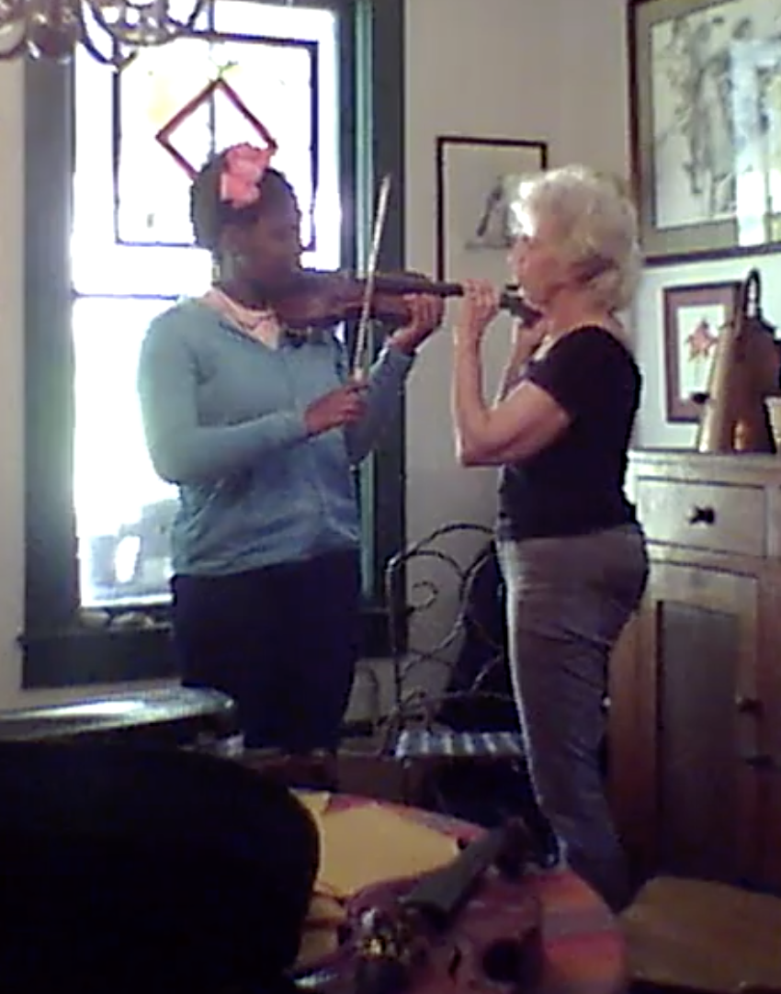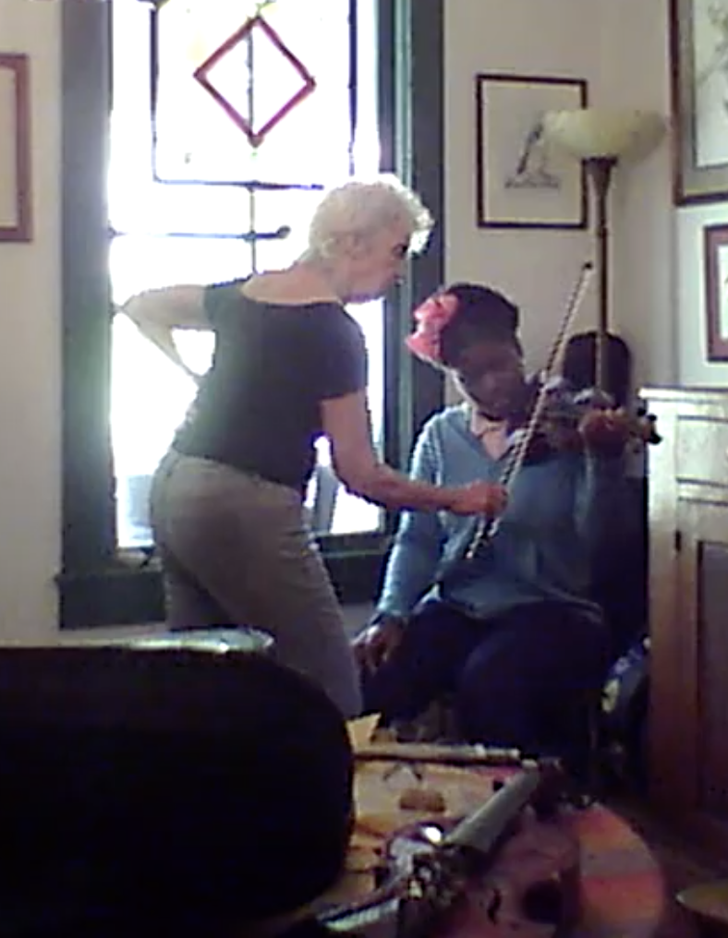
Figure 8. Zoe’s first notes (bow hand) Figure 9. First notes (violin hand)

Although she had taught beginner Suzuki students using an approach similar to Cole’s during her decades as a Suzuki teacher, as an O’Connor teacher Wiley intentionally shows Zoe “how it works first” before instructing her more specifically “how to do it.” This order of operations, beginning with musical sounds and concepts, and working back to gradually refine techniques later on, contrasts starkly with Cole’s approach—a process akin to blocking out an image of an oil painting with a large brush, or chipping away at a piece of marble, rather than carefully rendering the transparent and permanent shapes of a watercolor painting one layer at a time, as Cole does when she “sets up” her beginners. As she commented at one point in the lesson, “Some of the methods spend a whole lot of time on how to hold the violin, and how to hold the bow, and how to just play an open, you know, I don't know. Seems pretty boring to me. [laughs] So I give the kids more credit than that. I think they can really play from the very beginning.” This order of musical learning—moving from general musical concepts to specific skills—is also guided in part by Zoe’s age and former experiences, which constitute anything other than a blank slate in terms of her musical experience as well as more general qualities, like her personality and attitudes toward the learning process. As she does not concern herself with the concept of a blank slate, however, Wiley does not require her beginners to start lessons at any particular age, accepting adults as well as children of any age who are interested in learning, adjusting the way she teaches accordingly.
After repeating this introductory bowing activity again with the notes of “Twinkle, Twinkle, Little Star” and asking Zoe to adjust her bowing rhythms to the lengths of the song’s recognizable melody, Wiley devotes the subsequent six minutes of the lesson to explaining the physics of playing the violin and the theory of the notes it produces. Explaining the role of the left hand in creating different notes by pushing down the string while Zoe holds the violin, Wiley demonstrates the principle of higher and lower notes: “if I push the string down here, now that's the end of the string. [Moving her finger further up the fingerboard each time] So now it's gonna make a higher note. And now it's gonna make a higher note. And now higher one. And a higher one.” After learning that Zoe already plays the piano, Wiley proceeds to describe the specific notes and steps included in Cabbage, commenting, “This is gonna be so easy. [laughter] You’ll be my genius beginner.” Although she clearly did not intend this comment literally, describing to me in a subsequent interview how she does not tell her students whether she thinks they are talented, this aside is one example of the O’Connor method teacher’s response to the vastly different abilities and perceived aptitudes of her students. In joking about Zoe being a genius beginner, Wiley is likely commenting about the ease at which Zoe will learn and signaling that she will adjust her instruction so that it is appropriate for her.
In the following segment of the lesson, Wiley turns to Zoe’s left (violin) hand for the first time (figure 9). With an equally concise set of instructions, she helps the student begin making a sound within seconds: “So just make that little shelf there, right. And then put the hand behind here. And it's your middle finger that will come down to this [pointing at a tape she had just added to designate the location of C#]. And what you wanna aim for is this side of the finger.” In her instructions to Zoe, Wiley does not command, but rather justifies, hoping to equip her with a holistic set of tools to understand how violin playing generally works. Indeed, this approach lines up with Wiley’s attitude about musical ability development and her role as a teacher: each student is comprised of a unique set of aptitudes, pre-existing skills, desires, and musical preferences. In recognizing and celebrating these unique starting points and aptitudes, Wiley presents a broad swath of information and watches how quickly the student responds, and how much she is able to remember. Acknowledging (perhaps because I was in the room) that she was only roughly sketching out the complex technique for Zoe, Wiley comments, “I'm gonna back up and do some other stuff about how to hold the violin, the bow. But I just really wanna get you playing first.” Walking Zoe’s left hand through the process of placing her fingers for each note of Cabbage, the student plays the full melody for the first time on her own with both hands.
[Then, Wiley gets into a more detailed discussion about holding the bow, to help Zoe understand the general principles of producing a sound (instead of Ronda, who aimed to enable Eliza to do the correct bow hold, without room for error of interpretation). Again, rather than making absolute pronouncements about the “correct” way to arrange her fingers, knuckles, etc., as Cole did for Eliza, Wiley justifies her instructions, implicitly granting the student agency and authority as a musician to make an informed decision about how to hold the bow in response the information Wiley provides:]
So this thing about having the thumb bent. You can play like that [with a straight, rigid thumb] and it works to a certain extent. But the bow slips around a lot when you do this [demonstrates bow slipping from bridge to fingerboard]. When you have your, um, thumb like this, it kind of, um, it kind of slips around. And then you have to kind of push on it to keep it from slipping and then you get kind of a funny sound like that. If your thumb is bent like this, it turns on a set, a certain set of muscles in your arm that work better.

[Finish the last pieces of the lesson—troubleshooting after Zoe comments that “it doesn’t sound right” after playing on her own for a bit. This is emblematic of Wiley’s approach, “fixing” things after sketching out the general picture rather than building up every detail, every habit, from the ground up. This is exactly a reflection of her understanding of ability development—shaping and influencing from the top down rather than creating from the “bottom up.” Discuss her joke about her being the Bernie Sanders of violin teachers, and Ronda being the Ronald Reagan—which, indeed, has just as socioeconomic implications about the way these women teach, and whom they teach, as philosophical ones.]
[Conclude by discussing what Wiley does not discuss: how to practice, what exactly to practice, what the parent should be doing or not during that process (aside from one comment about helping Zoe hold the bow as she prepares her bow hold). This open-ended approach embodies her ideology of talent—it is each student’s prerogative to figure out how to put all of these complex pieces together, “figuring out” (a phrase Wiley uses all the time, and Cole never uses) the individual mindsets, approaches to practicing, and the details of posture and technique—largely from observation.]

Conclusions
Ronda Cole and Pamela Wiley approach their students’ learning from drastically different vantage points—both of which are intimately connected to their understanding about the nature of talent. Cole takes responsibility for every minute detail of a student’s learning (and approach to learning) takes no detail for granted. Wiley believes that it is not her place to persuade students and families to
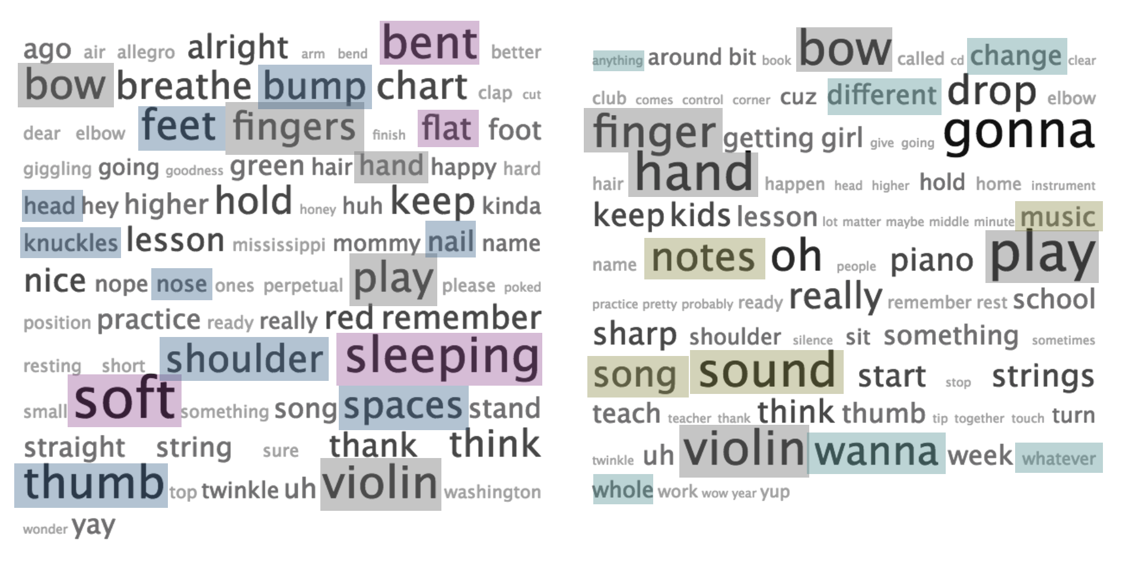
Figure 10. Word frequencies in Ronda Cole’s and Pamela Wiley’s teaching talk (respectively)

[Discuss this as a way to wrap things up!! Cole on the left, Wiley on the right. I’ve highlighted groups of words that capture their differences in some ways. The greater complexity (especially relative to Eliza’s age) and variety of words in Cole’s lesson, and the greater accessibility and general nature of Wiley’s discourse. Indeed, there are words that are not at all common to the teachers’ vocabularies—for instance, Wiley’s discussion of change and difference, and MUSIC; Ronda’s discussion of the many individual body parts, hardly any mention of practice on Wiley’s side; The emphasis on more holistic concepts in Wiley’s lesson, and specific parts of Eliza’s body in Ronda’s lesson. While one of the more prominent body parts Wiley mentions is “hand,” Cole breaks the hand up into its component parts in discussions—fingers, nails, thumb, knuckles.]

Wiley and Cole, despite their many ideological differences, have arrived at a number of common understandings about the concept of innate talent and how it relates to teaching. [Discuss their discovery of the Dweck mindsets—how you don’t tell students that they are talented or not (even though Pam believes that some are more inherently musical). Discuss the role and embracing of repetition, the idea of music being learned thoroughly through the embracing of repetition and focused practice, as Ericsson and others have found (despite different ideas about an ideal musician and the end goals of their teaching—porch fiddler and amateur orchestra player versus exceptionally proficient classical orchestral player and soloist),
In one of my interviews with Wiley, she referred to a quotation by Calvin Coolidge to explain her understanding of the role of natural talent in the cultivation of ability—a quotation that I remembered seeing posted on the bulletin board outside of Cole’s studio. “Nothing in this world can take the place of persistence. Talent will not; nothing is more common than unsuccessful men with talent. Genius will not; unrewarded genius is almost a proverb. Education will not; the world is full of educated derelicts. Persistence and determination alone are omnipotent.” [Important to note that this is how ideology works—we think we are doing one thing and describe it in a certain way, but ultimately act out and perpetuate a different reality. What is a good example in the critical literature for this phenomenon?]
[Another quality that Wiley and Cole share pedagogically is their level of experience: with almost a century of violin teaching between them, neither is approaching their students from a place of uncertainty, inexperience, or experimentation, as is the case with many younger teachers. Cole has continuously innovated and honed her teaching style to most deeply achieve her understanding of Suzuki’s vision for students, which means that in addition to honing her students’ ears on highly subtle melodic lines, she does teach her students “more than melody” and other aspects of musicality that O’Connor has criticized Suzuki teachers of ignoring. And similarly, Wiley made a deliberate choice to abandon many of the detailed instructions and uniformly high standards (like Cole’s) that she once followed as a Suzuki teacher in favor of a different set of priorities and ideologies of ability, which she sees as more valuable for her vision of musicianship. If there were room to extend this chapter’s research questions further, I would also have analyzed the teaching techniques and shifting understandings about talent of less experienced teachers in each method, as the different pedagogical hierarchies Cole and Wiley pursue in their teaching become all the more apparent in the case of new teachers who often focus on fewer skills in lessons. In observing the students of these younger teachers, therefore, their method and pedagogical focus is more immediately apparent. Often, students of younger Suzuki teachers have not yet mastered playing their instrument with other players or an accompanist; in contrast, students of younger O’Connor teachers often have not established a posture and familiarity with repetitive practice that allows them to play accurately and consistently in tune. If I had studied these younger teachers instead, we might be faced with a different set of considerations: many O’Connor families believe that Suzuki students quit more often because they become bored and burned out from repetitive practice; Suzuki teachers believe that O’Connor students develop habits that are difficult or impossible to break, preventing them from playing at a high level.
[Mention more explicitly the connection between beliefs about inherent musicality and the “music” that that musicality is meant to achieve. In other words, if music is something genuinely like language, and the aim is to learn to a level of fluency so that you can use the language to express yourself, take in and enjoy others’ expressions of the language, and generally be a part of a community, then Wiley’s approach to help as many students get to that amateur level of fluency is the most logical option. But, if that language is conceived more specifically. Similar to the actual language lessons Cole gives (reciting poetry to practice comfort presenting oneself and how their speaking will be received, not letting her students say like or umm, making them project and enunciate and not use certain words that promote an undesirable perspective) is not meant to be simple practical fluency, but demonstrate the extensive possibilities of language use: its potential to signify intelligence and social status, in essence to win within the system that believes that a student’s linguistic expression and vocabulary is an indication of their innate intelligence. For Cole, music is not only a folk practice (though it is that too) but a way to introduce character—loving kindness, humility, and craving for excellence.
[On the difference between students who are following sets of rules they don’t understand and internalizing the music more holistically. Wiley: ]
There’s a difference between following instructions that appears to the world to be making music, and actually making music. And I said most music education has the danger of creating this first kind of experience, where children follow instructions, they’re good kids, they do what they’re supposed to do, they learn Minuet 1…and they do the practicing, and then they play it, and it appears to be music to most people. I can tell immediately whether a child is playing music, playing from their right brain and playing from their heart, really playing music.

This understanding does not imply that a high level of proficiency is required—nothing close to the exceptional abilities of the students in Cole’s studio.
[How does this chapter fit into the bigger context of the dissertation? Every family that enrolls in the studios of Cole and Wiley has been exposed to the plurality of ideologies of talent discussed in each of the previous chapters, but especially Chapter 1. In the context of Wiley, those ideologies mingle with and influence the ways Wiley teaches students and works with parents; in the case of Cole, she systematically relieves them of the many dominant perceptions of innateness and exceptionality and helps them live according to a new understanding]
[Conclude with a discussion of privilege. Ronda’s students have a lot of it—so the barrier of entry is much higher. Pam’s students don’t necessarily have the many privileges, so the access/opportunity is greater, but privilege eventually enters the equation and helps students with certain advantages cultivate skills more successfully than the ones from mobile homes with no money for nice instruments or summer camps with absent or working parents, or those whose parents have not been socialized into a concerted cultivation approach that Lareau has discussed as ultimately more able to take advantage of educational opportunities—in school, but also in music lessons. In both situations, even in Ronda’s, exceptional musical skills, perceived as talent, will come to students with some combination of privileges. There are always exceptions—like Pam’s student in the small Walterboro Baptist community whose interest is driving her to learn more quickly than her friend of a similar age who takes lessons alongside her.]

Bibliography

Auer, Leopold. Violin Playing as I Teach It. Frederick A. Stokes Company, 1921.
Behrend, Louise. The Suzuki Approach. Alfred Music, 1971.
“Bob Phillips | Alfred Music.” Accessed May 12, 2018. https://www.alfred.com/authors/bob-phillips/.
Bresler, Liora. International Handbook of Research in Arts Education. Springer Science & Business Media, 2007.
Campbell, Patricia S. “Ethnomusicology and Music Education: Crossroads for Knowing Music, Education, and Culture.” Research Studies in Music Education 21, no. 1 (December 1, 2003): 16–30.
Clarke, Mark A. “The Scope of Approach, the Importance of Method, and the Nature of Technique.” Georgetown University Round Table on Languages and Linguistics, 1983, 106–15.
Collins, David R. Dr. Shinichi Suzuki: Teaching Music from the Heart. Morgan Reynolds, 2002.
“Demographics.” Suzuki Association of the Americas. Accessed August 23, 2017. https://suzukiassociation.org/about/stats/.
Erickson, Frederick. “Taught Cognitive Learning in Its Immediate Environments: A Neglected Topic in the Anthropology of Education.” Anthropology & Education Quarterly 13, no. 2 (1982): 149–80.
Fairclough, Norman L. “Critical and Descriptive Goals in Discourse Analysis.” Journal of Pragmatics 9, no. 6 (December 1, 1985): 739–63. https://doi.org/10.1016/0378-2166(85)90002-5.
Fink, Robert. Repeating Ourselves: American Minimal Music as Cultural Practice. University of California Press, 2005.
Freire, Paulo. Pedagogy of the Oppressed. Herder and Herder, 1970.
Garson, Alfred. Suzuki Twinkles: An Intimate Portrait. Alfred Music, 2001.
Hermann, Evelyn. Shinichi Suzuki: The Man and His Philosophy (Revised). Alfred Music, 1999.
Honda, Masaaki. Suzuki Changed My Life. Alfred Music, 1976.
———. The Vehicle of Music -- Reflections on a Life with Shinichi Suzuki and the Talent Education Movement. Alfred Music, 2002.
Hyers, Conrad. Once-Born, Twice-Born Zen: The Soto and Rinzai Schools of Japan. Wipf and Stock Publishers, 2004.
Kendall, John. The Suzuki® Violin Method in American Music Education. Alfred Music, 1973.
Landers, Ray. Is Suzuki Education Working in America? Alfred Music, 1987.
Lareau, Annette. Unequal Childhoods: Class, Race, and Family Life. University of California Press, 2003.
Locke, John. An Essay Concerning Human Understanding. T. Tegg and Son, 1836.
Mark O’Connor. Best “Boil 'em Cabbage Down” Ever! - Mark O’Connor/Wynton Marsalis, 2011. https://www.youtube.com/watch?v=fyt646v4hxA.
“Mark O’Connor - Posts.” Accessed August 30, 2017. https://www.facebook.com/markoconnorfanpage/posts/10152109106701140.
“Mark O’Connor - String Ties.” No Depression, December 31, 2003. http://nodepression.com/article/mark-oconnor-string-ties.
“Mark O’Connor Official Website - Bio.” Accessed September 14, 2017. https://markoconnor.com/bio.
Mehl, Margaret. “Cultural Translation in Two Directions: The Suzuki Method in Japan and Germany.” Research and Issues in Music Education 7, no. 1 (September 1, 2009).
———. Not By Love Alone: The Violin in Japan, 1850-2010. Sound Book Press, 2014.
O’Connor, Mark. “KLINGLER Rejects SUZUKI as His Student in 1923,” 2015. http://markoconnorblog.blogspot.com/2013/09/suzuki-klingler-not-what-you-expected.html.
———. “Mark O’Connor Manifesto: A Reemerging American Classical Muisc,” 2010. http://www.oconnormethod.com/AcademicDocs.html.
Seashore, Carl Emil. The Psychology of Musical Talent. Silver, Burdett, 1919.
Sefton-Green, Julian, Pat Thomson, Ken Jones, and Liora Bresler. The Routledge International Handbook of Creative Learning. Routledge, 2011.
“Shinichi Suzuki.” Suzuki Association of the Americas. Accessed April 7, 2016. https://suzukiassociation.org/about/suzuki-method/shinichi-suzuki/.
Sternberg, Robert J. Handbook of Creativity. Cambridge University Press, 1999.
Suzuki, Dr Shinichi, and Mary Louise Nagata. Ability Development from Age Zero. Alfred Music, 2014.
Suzuki, Shinichi, and Waltraud Suzuki. Nurtured by Love: The Classic Approach to Talent Education. Alfred Music, 1983.
“Suzuki’s BIGGEST Lie.” Accessed September 8, 2017. http://markoconnorblog.blogspot.com/2014/10/suzukis-biggest-lie.html.
“‘Talent Education’ Expands Throughout the World.” Accessed September 5, 2017. http://www.suzukimethod.or.jp/english/E_mthd121.html.
“The Formation of the Mark O Connor Fiddle Camps.” Accessed September 14, 2017. http://markoconnorblog.blogspot.com/2016/12/the-formation-of-mark-o-connor-fiddle.html.
“TWINKLE, TWINKLE, LITTLE CABBAGE.” Accessed August 24, 2017. http://markoconnorblog.blogspot.com/2012/07/twinkle-twinkle-little-cabbage.html.
Wartberg, Kerstin. “Shinichi Suzuki: Pionier Der Musikerziehung.” Deutsches Suzuki Institut, 2009.
Westwood, Peter S. What Teachers Need to Know about Teaching Methods. Australian Council for Education Research, 2008.
Yoshihara, Mari. Musicians from a Different Shore: Asians and Asian Americans in Classical Music. Temple University Press, 2007.

Evelyn Hermann, Shinichi Suzuki: The Man and His Philosophy (Revised) (Alfred Music, 1999), 54.
Mark O’Connor, Best “Boil 'em Cabbage Down” Ever! - Mark O’Connor/Wynton Marsalis, 2011, https://www.youtube.com/watch?v=fyt646v4hxA.
The Nashville Shuffle most conspicuously involves a long-short-short bowing pattern.
While some versions of the song (often those with a vocalist) play it with a verse-chorus structure, the A and B sections have the same chord progression and melody (I-IV-I-V; I-VI-I-V-I) and are therefore indistinguishable in instrumental versions like this one by O’Connor and Marsalis.
Pam Wiley, one of the co-founders of the O’Connor Method whom I discuss in detail later in the chapter, has referred to this constellation, which includes both O’Connor and Suzuki method practitioners as well as every other music teaching approach used around the United States, as the American Music System. Rather than painting the Suzuki and O’Connor methods as oppositional or antithetical—a tempting way to frame their relationship based on some of the recent rhetoric about them—I ascribe to Wiley’s characterization, which emphasizes the many points of connection and commonality that have shaped the communities that practice them.
As O’Connor has argued about the instrument, “Why the violin? Because the heritage of our country is musically encapsulated in it. Native Americans, African Americans, European Americans, and immigrants from elsewhere in the world have favored it in manifold musical styles for centuries. The violin – or fiddle, if you prefer – bridges the gap between traditional American music and classical music, for it is the most prevalent instrument in both domains.” Mark O’Connor, “Mark O’Connor Manifesto: A Reemerging American Classical Muisc,” 2010, http://www.oconnormethod.com/AcademicDocs.html.
Paulo Freire, Pedagogy of the Oppressed (Herder and Herder, 1970).
During these years, my fieldwork often occurred during week-long periods of time, both for week-long summer camps and institutes, and when I shadowed teachers to observe all of the lessons and classes in their regular weekly teaching schedules. In addition to 2-5 weeks of this type of fieldwork each year, I regularly observed teaching within my Chicago community, and taught in my own music school, private studio, and youth orchestra. In my own teaching contexts, I engaged with materials and ideas from both methods.
Frederick Erickson, “Taught Cognitive Learning in Its Immediate Environments: A Neglected Topic in the Anthropology of Education,” Anthropology & Education Quarterly 13, no. 2 (1982): 149–80. 140 and 161, respectively.
Erickson.
Patricia S. Campbell, “Ethnomusicology and Music Education: Crossroads for Knowing Music, Education, and Culture,” Research Studies in Music Education 21, no. 1 (December 1, 2003): 17.
Peter S. Westwood, What Teachers Need to Know about Teaching Methods (Australian Council for Education Research, 2008).
In the case of violin, common method books include Strictly Strings, Essential Elements, All for Strings, A Tune a Day, and The String Builder, for instance.
Perhaps the most rigorous theoretical discussion about methods has taken place in the literature on teaching English as a second language. For a discussion of the difference between method, approach, and technique, see Mark A. Clarke, “The Scope of Approach, the Importance of Method, and the Nature of Technique,” Georgetown University Round Table on Languages and Linguistics, 1983, 106–15.
As Mark A. Clarke put it, "Method is the profession's counterpart of an Escher painting." See “The Scope of Approach, the Importance of Method, and the Nature of Technique,” Georgetown University Round Table on Languages and Linguistics, 1983, 106–15.
Norman L. Fairclough, “Critical and Descriptive Goals in Discourse Analysis,” Journal of Pragmatics 9, no. 6 (December 1, 1985): 739–63.
In other words, Suzuki’s understanding of music, music-making, practice, parenting, and many other related fundaments of his method originated in the context of early 20th century Japan. Regardless of whether contemporary American teachers are replicating his original vision, their interpretation of his goals and ideas has produced a new and different approach to teaching and learning in comparison to other traditionally American methods in circulation.
Shinichi Suzuki and Waltraud Suzuki, Nurtured by Love: The Classic Approach to Talent Education (Alfred Music, 1983).
Leopold Auer, Violin Playing as I Teach It (Frederick A. Stokes Company, 1921).
Hermann, Shinichi Suzuki.
Margaret Mehl, Not By Love Alone: The Violin in Japan, 1850-2010 (Sound Book Press, 2014).
Mehl.
Suzuki and Suzuki, Nurtured by Love.
Suzuki and Suzuki, 74.
In his series of attacks on the veracity of Suzuki’s now-mythologized life stories and the legitimacy of his method, O’Connor conducted a series of “investigations” about whether Suzuki actually studied with Klinger and knew Einstein, and to what extent. As the evidence for either side is minimal, the issue is still up for debate. For O’Connor’s accusation, see Mark O’Connor, “KLINGLER Rejects SUZUKI as His Student in 1923,” 2015, http://markoconnorblog.blogspot.com/2013/09/suzuki-klingler-not-what-you-expected.html.
Margaret Mehl, “Cultural Translation in Two Directions: The Suzuki Method in Japan and Germany,” Research and Issues in Music Education 7, no. 1 (September 1, 2009).
Hermann, Shinichi Suzuki.
The former was more prominent in the States and emphasized the active pursuit of enlightenment with absurd questions, koan, at the heart of its pedagogy; the latter was a more meditative practice where the only “goal” per se is fullness of experience. Conrad Hyers, Once-Born, Twice-Born Zen: The Soto and Rinzai Schools of Japan (Wipf and Stock Publishers, 2004).
Robert Fink, Repeating Ourselves: American Minimal Music as Cultural Practice (University of California Press, 2005).
One traditional Japanese saying is particularly evocative of Suzuki’s approach, as he constantly used the metaphor of a seed, often rice, being nurtured and cultivated: “Rinzai teaching is like a brave general who moves a regiment without delay, while Soto teaching is like a farmer taking care of a rice field, one stalk after another, patiently.” See Hyers, Once-Born, Twice-Born Zen..
Julian Sefton-Green et al., The Routledge International Handbook of Creative Learning (Routledge, 2011).
Liora Bresler, International Handbook of Research in Arts Education (Springer Science & Business Media, 2007).
Sefton-Green et al., The Routledge International Handbook of Creative Learning.
Koji Matsunobu, “Creativity of Formulaic Learning: Pedagogy of Imitation and Repetition” in Sefton-Green et al.
Suzuki and Suzuki, Nurtured by Love, 66.
Fink, Repeating Ourselves, 227.
Kerstin Wartberg, “Shinichi Suzuki: Pionier Der Musikerziehung” (Deutsches Suzuki Institut, 2009). Regarding the spread of this story, I have heard it told in lessons, in institute assemblies, in the Suzuki Journal, on the websites of Suzuki teachers explaining the method, and in personal discussions with a range of teachers.
Wartberg.
Suzuki and Suzuki, Nurtured by Love, 2.
In particular, see the discussion of Suzuki’s direct adoption of some of the Hohmann violin method in Mehl, “Cultural Translation in Two Directions.” “There are so many similarities between the preface of Hohmann’s Practical Violin School – which may possibly be up to 140 years old – and the Suzuki method, that one cannot help but wonder if Suzuki knew of this method when he developed his philosophy” (5).
John Kendall, The Suzuki® Violin Method in American Music Education (Alfred Music, 1973).
Suzuki Associations currently exist in [FILL OUT]
Hermann, Shinichi Suzuki; Kendall, The Suzuki® Violin Method in American Music Education; Suzuki and Suzuki, Nurtured by Love; Dr Shinichi Suzuki and Mary Louise Nagata, Ability Development from Age Zero (Alfred Music, 2014); Alfred Garson, Suzuki Twinkles: An Intimate Portrait (Alfred Music, 2001); Masaaki Honda, The Vehicle of Music -- Reflections on a Life with Shinichi Suzuki and the Talent Education Movement (Alfred Music, 2002); Mari Yoshihara, Musicians from a Different Shore: Asians and Asian Americans in Classical Music (Temple University Press, 2007); Fink, Repeating Ourselves; “Shinichi Suzuki,” Suzuki Association of the Americas, accessed April 7, 2016, https://suzukiassociation.org/about/suzuki-method/shinichi-suzuki/; David R. Collins, Dr. Shinichi Suzuki: Teaching Music from the Heart (Morgan Reynolds, 2002); Mehl, Not By Love Alone; Ray Landers, Is Suzuki Education Working in America? (Alfred Music, 1987); Louise Behrend, The Suzuki Approach (Alfred Music, n.d.).
I have discussed the Suzuki method with a range of non-Suzuki teachers and parents, professional musicians, and non-musicians. While a handful had heard of the method but had little knowledge of it, the remainder of respondents offered a wide range of thoughts, from negative opinions (the method does not provide students with adequate reading skills; the method is robotic and dull for students and burns them out) to positive ones that refer to a number of qualities of the method as described here.
Currently, the rights to the Suzuki name and teaching method—along with the regulation of teacher certification courses, method book development, and other organizational matters—are controlled by the International Suzuki Association (ISA), a nonprofit organization comprised of a number of subsidiary regional groups including the Suzuki Association of the Americas (SAA), the largest and oldest of the lot. As the ISA has estimated, around 300,000 students in the United States alone study an instrument through the Suzuki Method See: “‘Talent Education’ Expands Throughout the World,” accessed September 5, 2017, http://www.suzukimethod.or.jp/english/E_mthd121.html.
Annette Lareau, Unequal Childhoods: Class, Race, and Family Life (University of California Press, 2003), 32.
Carl Emil Seashore, The Psychology of Musical Talent (Silver, Burdett, 1919).
Suzuki and Suzuki, Nurtured by Love, 5.
Suzuki and Suzuki, 87.
Suzuki and Suzuki, 107.
Taken from fieldnotes: taken from a slide shown to teacher trainees in the 2015 O’Connor String Camp in New York City.
As has been discussed in much Suzuki literature, and as both Cole and Wiley explained in interviews, this early incorporation of the Suzuki method in the states was not immediately successful, with many American assumptions about music teaching—for instance, starting 4th graders rather than 4 year-olds—not granting the type of results Suzuki had achieved in Japan. O’Connor came of age during this time, when Suzuki students represented a hodgepodge of skills and non-skills that did not necessarily represent the violin or Suzuki in a positive light to outsiders.
“Mark O’Connor - String Ties,” No Depression, December 31, 2003, http://nodepression.com/article/mark-oconnor-string-ties.
“Mark O’Connor - String Ties.”
“Mark O’Connor - String Ties.”
“Mark O’Connor Official Website - Bio,” accessed September 14, 2017, https://markoconnor.com/bio.
“The Formation of the Mark O Connor Fiddle Camps,” accessed September 14, 2017, http://markoconnorblog.blogspot.com/2016/12/the-formation-of-mark-o-connor-fiddle.html.
“Mark O’Connor - String Ties.”
Interview with Pamela Wiley, February 26, 2018.
“Bob Phillips | Alfred Music,” accessed May 12, 2018, https://www.alfred.com/authors/bob-phillips/. As Wiley explained of this early part of the process, “Mark went to Alfred publishing and said, I want to copy the Suzuki method but with American music content and Bob helped him get started. I got on board, then Alfred wanted the exclusive rights to it, Mark got tough about that, he wanted to do it more on his own. He paid Bob Phillips a substantial amount of money and made him sign a non-disclosure agreement saying he would not talk about Mark’s intentions for the method. And Mark self-published it, he spent most of his savings to self-publish those first two books, and then I got on board to help him finish it, do the teacher training.” (Personal interview)
Wiley taught the first waves of teacher training courses for the method around the country, and worked closely with O’Connor to develop and promote the method from about 2009 to 2016.
“Suzuki’s BIGGEST Lie,” accessed September 8, 2017, http://markoconnorblog.blogspot.com/2014/10/suzukis-biggest-lie.html.
Wiley, who met O’Connor as he was beginning to conceptualize an American music method, notes that he explicitly set out to copy and improve upon the Suzuki method, borrowing successful elements of the early books and adapting them for his purposes.
Masaaki Honda, Suzuki Changed My Life (Alfred Music, 1976), 150.
Personal interview with Pamela Wiley, February 26, 2018.
O’Connor’s focus on individual achievement is not in opposition to his emphasis on ensemble and collective musical experiences, as members of jam sessions and group classes in the O’Connor method are rarely asked to play in unison or sublimate their own unique approach to the repertoire.
Email to the listserv of the O’Connor Violin Method, March 29, 2018.
I want to extend my thanks to Strom and Sanchez for their extensive willingness to help with my project—speaking to me about their teaching experiences and sending lesson and group class videos, among much else. While this chapter now focuses primarily on Ronda Cole, I have learned so much from everyone at NVSMS, and intend to extend this preliminary chapter significantly and include the voices of more students, parents, and teachers in the community.
As her student policy document states, with a level of detail characteristic of her teaching, “When backing out of the driveway, it is helpful to keep your eyes on the left side view mirror, staying one to two feet away from the stairs and the mailbox. That way you will not hit the stairs or mailbox on the left as you back out and will be safely away from the timber edge on the right. Please back up until you are cleared the driveway rather than cutting the wheel too early and driving over the plantings by the street.”
Interview with Ronda Cole, September [check], 2014.
Ibid.
As Wiley explains of her early musical experiences beyond her percussion experience, “So, and my parents, they had Dean Martin recrods. And I could read music, I could play the piano a little bit. And my teacher, she was pretty cool, she taught me how to chord, and I knew chords because of the guitar. I think somebody in my high school knew how to play the guitar.” Personal interview with Pamela Wiley, April 17, 2018.
Personal interview with Pamela Wiley, April 17, 2018.
Interview
As David Shenk has explained this general theory, [FIND QUOTE AT HOME]
Interview
As Cole explained further, “There are so many abilities that a musician or human being can develop, and the musician needs many of them. And so whatever our sensitivities and neurology and aural acuity and that kind of thing, that we might be born with, then it’s really a matter of how we stimulate those things and balance it out and motivate it. Everybody’s born with hundreds of different abilities, and it’s a matter of building on it.”
In lessons, Cole works with her students on poetry recitation, articulation and vocabulary choices in their communication, techniques of concentration and critical thinking, history, music theory, psychology, and philosophy. In her estimation, each of these areas of growth inform and enrich her students’ abilities to be talented learners.
Interview
Interview
Interview
Cole continues, “As well as to acknowledge what is there so it continues happily along its growth path. Um, but anyone that you would see—almost anyone—that comes in and looks like a genius, they’ve just got all these threads happily stimulated.” Interview
Interview
Interview
This is partially why Cole only starts new students at a very young age, from three to five years old. Interview
As Locke stated, “Let us then suppose the mind to be, as we say, white paper, void of all characters, without any ideas: — How comes it to be furnished? Whence comes it by that vast store which the busy and boundless fancy of man has painted on it with an almost endless variety? Whence has it all the materials of reason and knowledge? To this I answer, in one word, from EXPERIENCE. In that all our knowledge is founded; and from that it ultimately derives itself.” John Locke, An Essay Concerning Human Understanding (T. Tegg and Son, 1836), 96.
Interview
“Twinkle” and “Lightly Row” are the first two pieces included in the Suzuki method, which she is critiquing here, despite her support of Suzuki’s mother tongue philosophy. Interview.
As a highly experienced teacher who adopted the O’Connor method in large part because she saw possibilities for a logical and engaging sequence of teaching points, which she calls “lessons,” Wiley has authored a book to help new teachers in the method, which she adapted from her years teaching new teachers in the method.
Where to discuss the very gendered dynamics—not just of this context, but of music education and Suzuki parenting and mother figures and “niceness” and such?
While the Suzuki Association of the Americas does not keep data on the number of students enrolled in Suzuki programs, they keep demographic information that includes the number of registered teachers, from which I have estimated the number of enrolled violin students to be somewhere between 20 and 60 thousand. See “Demographics,” Suzuki Association of the Americas, accessed August 23, 2017, https://suzukiassociation.org/about/stats/.
Alfred Garson, Suzuki Twinkles: An Intimate Portrait (Alfred Music, 2001), 81. The song, originally entitled “Ah! Vous Dirai-Je, Maman” is the first divertissement champêtre in M. Boüin’s Les Amusements d'une Heure et Demy, published in 1761; it was popularized when W.A. Mozart composed a theme and variations on the melody for piano in 1781. The melody has since appeared in compositions by myriad other Western art music composers, in folk traditions around the world, in nursery rhymes, and elsewhere. In the majority of cases, it is a song associated with children.
Garson, Suzuki Twinkles.
Fink, Repeating Ourselves.
“TWINKLE, TWINKLE, LITTLE CABBAGE,” accessed August 24, 2017, http://markoconnorblog.blogspot.com/2012/07/twinkle-twinkle-little-cabbage.html.
Sefton-Green et al., The Routledge International Handbook of Creative Learning, 46; Robert J. Sternberg, Handbook of Creativity (Cambridge University Press, 1999), 340.
Cole’s observation requirement also completes a certain self-selection process within her studio population—relating to issues of socioeconomic and cultural privilege addressed elsewhere in this chapter. Indeed, part of the reason that Cole is able to uphold so many rigorous tenets of Suzuki’s approach (which is foreign and inexplicable to most families before they enroll) is because she has the financial ability to uphold these norms regardless of how many families choose not to continue, and because enough families are willing to undergo a rigorous ideological makeover because they have witnessed the success of the other students who have studied with her.
For a standard half-hour beginner lesson, Cole charges around $70. Wiley’s rate varies depending on the financial resources of her students’ families, charging $30 at most for a half-hour lesson.
Field notes, O’Connor method teacher training at Turtle Bay Music School, New York City, July 30, 2015.
“Mark O’Connor - Posts,” accessed August 30, 2017, https://www.facebook.com/markoconnorfanpage/posts/10152109106701140.
Interview with Pamela Wiley, April 22, 2018.
Ronda Cole noted in a personal email that Eliza is one of several younger siblings of current students whom she recently started teaching. Because of their experiences watching and listening along with their older siblings, Cole joked that they “seemed to begin at lesson five.” In other words, it is in fact quite unusual that Eliza accomplished an acceptable bow hold and played her first note in her second lesson; it often takes more than a month of lessons and practicing following the observation period for Cole’s beginner students to put bow to string on their own.
Ask Ronda about this statistic.
While this lesson provides an opportunity to examine the establishment of certain skills, norms, and expectations, it does not make apparent the strikingly and predictably organized nature of the vast majority of Cole’s lessons. Usually after tuning, Cole’s students (even those still working on Twinkle) proceed to recite a poem they have memorized and practiced for expression and ease; they relay to her the composer, performer, and title of a piece they studied for their “special listening” that week; students a bit further on in Book 1 add in a “by ear tune” that they chose to learn from listening alone. These sections of the lessons are then followed by items such as scales, etudes, tonalizations (an arpeggiated melody Suzuki composed to focus on ringing tones on the instrument), rhythm exercises, performances of already-learned repertoire, and work on new pieces.
Cole maintains a close relationship with her area’s violin shops, requiring all of her students to rent or purchase instruments that enable students to produce a clear and relatively effortless tone, regardless of their size. Many 1/4, 1/8, and 1/16 size violins are not built in a way that allow a clear sound, which Cole sees as inhibiting the child’s ability to develop sensitivity in their technique as well as their ear from the first moments.
Suzuki and Suzuki, Nurtured by Love, 95.
Beforehand, I had helped Wiley re-arrange the table and chairs to make space for Zoe’s lesson, as well as the meeting of the fiddle club that would be happening afterwards in the same space.

