Relationship-Building Activities

Why incorporate routine relationship-building activities into tutoring?
Strong relationships are fundamental to students' success with tutoring. The more students feel safe, supported, and that they have a personal connection with their tutor, the more impactful the sessions will be. At the outset, relationship-building activities help tutors get to know their students and create a safe, positive learning environment. Building them into routine tutoring sessions helps tutors keep their knowledge of students alive and current.

Creating a Safe, Positive Learning Environment
Social activities like talking, sharing, laughing, and listening help us bond with others. These bonds create a feeling of safety in a relationship. When students feel connected with their tutor, they are more likely to participate, ask questions, and attempt new skills.
- Praise effort, not outcomes.
  - For example: “When you complete all the practice problems, I noticed you got a 100% on your exit ticket. All that practice you did really helped you master new skills — great work!”
- Model the behaviors and social skills you want to see from your students.
  - Explain the behaviors you are modeling; if you are feeling frustrated, tell students how you are feeling in a productive way as a model for them when they encounter frustrations in their own work.
  - For example: “I want to be honest with you right now. I’m feeling a little bit frustrated because I asked the group to work on these questions independently but I’m hearing a lot of chatter. Maybe I wasn’t clear, so I’m going to ask that we pause so I can explain these directions again. Feel free to let me know if you have questions about what we’re doing when I’m finished explaining.”
- Remain calm and de-escalate when students emotionally overreact.
  - Provide the space and time needed for students to settle down.
  - Set an example for students; demonstrate in your own actions how they can productively express themselves.
  - Build trust that you value and care about them no matter what, and overreactions will decrease over time.
  - For example: “I’m getting the sense that you’re feeling overwhelmed right now. Why don’t you take a few minutes to grab a drink and then maybe we can talk about how you’re feeling.”

Keeping Knowledge of Students Alive and Current
By continuing to ask students about their lives and interests, tutors can make relevant connections in content planning.
- Devote the beginning of every tutoring session to relationship-building games, icebreakers, and check-ins. These do not have to be more than a couple of minutes, but make it clear you are invested in getting to know each student as an individual.
- Use knowledge of student interests to individualize instruction by connecting their interests to new material.
- Ask students to share what they know about a topic to build confidence and explore new concepts.
To address equity and safety concerns, tutors should be cognizant of students’ lived experience. Consider what you are asking students to share with a new group or adult and how that might make them feel. For example, being asked to share where your family is from may be difficult for migrants or those whose legal status isn’t clear. People have different levels of comfort with sharing information and tutors should use their first sessions to gauge students’ comfort and should avoid requiring students to share personal information.

Example Relationship-Building Activities

“Getting to Know You” Conversation Question Bank
Tutors can use the list of sample questions below to guide their own questions during one-on-one chats with students.

Students’ Social Lives
  - What do you do for fun outside of school?
  - What are your favorite things to do with friends?
  - Do you prefer working together, or competing?
  - When you and your friends are chatting, what languages do you speak together?
  - What do you think you’re best at?
  - Are you part of any teams, clubs, or groups?
  - What hobbies are you most interested in?
  - What do you spend a lot of time thinking about?
  - Who do you look up to and ask for advice?

Students’ Family Lives
  - Can you tell me a little bit about your family?
  - What kinds of responsibilities do you have to your family?
  - What kinds of activities do you and your family do together?
  - What do your folks want you to be when you grow up?
  - What do your folks think is important to know and be able to do?
  - What do your folks do for work?
  - What was school like for your folks when they were growing up?
  - Did your folks grow up here? If not, where did they grow up, and when did they move here?
  - Did you and your family move recently? Where did you live before here?
  - What languages do you and your family speak at home?

Language & Literacy
  - What language do your folks use to text you? What about for texting with extended family?
  - Do you have books, newspapers, magazines, or religious texts at home? Who usually reads them?
  - Does anyone in your family write lists for organizing and remembering things?

Math & Science
  - Do you deal with money day-to-day? What are some situations where you do math with money?
  - Does anyone in your family build or repair things? How did they learn those skills?
  - Does anyone in your family do sewing or cooking that requires measuring things with precision?

Art & Culture
  - Do you (or another family member) play a musical instrument? What instrument?
  - What are your favorite musical artists and genres?
  - What genres of music do you hear a lot around your community?
  - Do you have any favorite local artists (any kind, not just music)? What kind of art do they make?
  - What interesting places have you visited around the city?

“Who Am I?” Activity
This activity is one example of a creative way for students to define and represent aspects of themselves through presentations, drawings, poems, etc.
- Tutors can use an activity like this during one of their first sessions with students. Tutors should be encouraged to complete the activity as well.
- See example template
  - Be mindful of what you are expecting students to share. Consider suggesting a norm where students may opt out of sharing personal information, or may choose amongst several options.
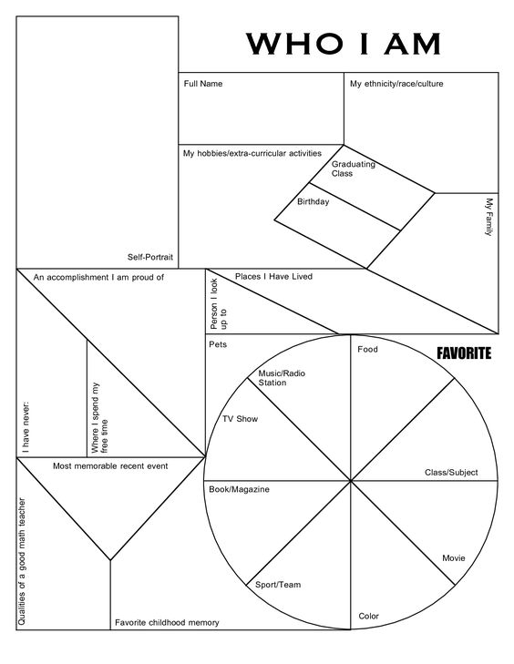

Adapted and updated from: Villegas, A. M., & Lucas, T. (2002). Educating culturally responsive teachers: A coherent approach. Albany: State University of New York Press.

