Science Fiction as Sociotechnical Imaginary

Human beings require frameworks to understand the unknown. In fact, our brains are wired in such a way that, when encountering the unknown, we fit it into familiar categories (schema) in order to make it comprehensible. In particular, within technological modernity – full of the strange, unfamiliar, and cutting edge, in the form of new technologies, data, and scientific discoveries – individuals need intellectual frameworks to conceive of these technological innovations, envision the roles they might play in their lives, and have blueprints for how to interact with such novelty.
Sociotechnical imaginaries, defined by Sheila Jasanoff in a seminal text as “collectively held, institutionally stabilized, and publicly performed visions of desirable futures, animated by shared understandings of forms of social life and social order attainable through, and supportive of, advances in science and technology,” are one way of meeting this need. As sociologist Charles Taylor notes, the social imaginary is “that which enables us to carry out the collective practices that make up our social life,” and Ajun Appadurai refers to the imaginary as a “constructed landscape of collective aspirations.” That is, a sociotechnical imaginary is not an individual vision of the future, but the collective visions, aspirations, hopes, and fears of a nation or community that simultaneously shape, and are shaped by, technoscience.
Jasanoff notes that science fiction serves as “a repository of sociotechnical imaginaries,” and STS already has a rich history of scholarship on this aspect of science fiction as such, even if it is not always framed in such terms. For example, scholars have examined how the film Gattaca influenced U.S. policy on gene editing (source), while MIT Press’ recent title Innovation+Equality bears the subtitle “How to create a future more Star Trek than Terminator.” Thus, although Jasanoff’s work does not have any explicit case studies of sci-fi as sociotechnical imaginary, she gestures towards promising field of investigation in which STS is already engaged.
What I want to do, then, is to provide a theoretical framework for such scholarship, drawing on two case studies of nineteenth century science fiction that demonstrate how such works allowed readers to internalize imaginaries, and consequently behaviors and practices, necessary to existing within technological modernity. Focusing on the works of Albert Robida, Jules Verne, and Rudyard Kipling significant science fiction authors in their time, I intend to show that both authors help the individual deal with, broadly, the epistemological problem of making modernity legible, knowable, and, therefore, livable in the face of new uncertainties or more complex ways of rendering the known world. These two parts deal with parsing data and processing information, and with “knowing” humanity’s place in time at a moment when it had become unmoored. From these case studies, I abstract a framework that, I hope, can guide future work in this domain and aid us in thinking about the work science fiction performs within technological modernity.
Part I: Theoretical Groundwork
[I begin by tracing] the definition of social imaginary by tracing its origin in the thought of earlier social thinkers. For Jasanoff, sociotechnical imaginaries are “associated with active exercises of state power,” but returning to Charles’ Taylor’s broader definition of the imaginary offers a rich way to expand Jasanoff’s theory:
the ways people imagine their social existence, how they fit together with others, how things go on between them and their fellows, the expectations that are normally met, and the deeper normative notions and images that underlie these expectations.
For Taylor, that is, an imaginary is a schema of sorts that allows individuals to understand society as a totality and their relationship to it, which in turn directs their expectations and behaviors as participants in it. And with the explosion of technoscience into society in the nineteenth century, new understandings of “how things fit together” that included technoscience were required. Consequently, new sociotechnical imaginaries emerged that were not always engaged in active exercises of state power, but which performed the necessary work of making coherent existence in a changing world. What I do, then, is look at two case studies from the late nineteenth century to see how science fiction fulfilled the role of sociotechnical imaginary at this moment that might be called the dawn of modernity.
Of course, “modernity” is a complex term, and I don’t want to mire myself in a complicated debate about its definition. For the purposes of this paper, then, it will suffice to say that “modernity” is used by scholars to refer to the period following the Industrial Revolution, which laid the groundwork for our present by incarnating such familiar practices as industrialization, secularization, capitalism, urbanism, and consumerism. Marked by the spread of technology into the lives of individuals, the professionalization of science, and new technologies of surveillance and control, including the rise of data science, modernity, then, makes for a hugely complex world to exist in. Considering works of nineteenth-century science fiction by Jules Verne and Albert Robida, I show how their works helped make modernity legible, a fundamental necessity to existing within it. In the first case, this has to do with teaching the individual how to read and make sense of a newly complex world, which is now increasingly defined through numbers, statistics, fixed laws, scientific terminology, and technical explanations. The second has to do with placing humanity within both natural and human history.
Such a reading of literary works – as sources of (sociotechnical) imaginaries – is arguably something that literary study has already been doing on a small scale, and such scholarship guides me in my endeavor. For example, D.A. Miller’s seminal text The Novel and the Police suggests that the nineteenth-century novel was a form of self-policing for the individual: it functioned as a repository of normative behaviors that the bourgeois subject internalized and imitated. Or, to phrase it in the language of sociology and of Charles Taylor in particular: the nineteenth century novel offered examples of “the deeper normative notions and images” that then guided the behaviors of individuals as social beings, in their interpersonal relations. Meanwhile, on the more explicitly technological side of things, Trish Ferguson has argued that the increased cultural presence of chronometry in the public sphere “led to the creation of innovative literary forms from the seventeenth century on, such as the diary and the newspaper, journals and travel-books, which closely replicated the diurnal form of clocks and calendars.” (5) Nicholas Daly, meanwhile, has compellingly argued that the nineteenth-century suspense novel provided a kind of “temporal training”: “Just as the cinema would later ‘train’ people in the mode of distracted perception necessary to navigate the modern metropolis, in the 1860s the sensation novel trained its readers to live within the temporality of the railway age,” (50) he writes. In short, all these literary scholars suggest the way works of fiction (primarily nineteenth-century novels) enabled new kinds of behaviors required by technological modernity. Such is the work of the sociotechnical imaginary as I define it: a set of ideas about how to exist in a modern, technoscientific world, which then enables the behaviors and practices necessary to that existence. Thus, by drawing on my own background in literary studies, I hope to enrich the literary scholarship already being done in this field through the tools and possibility of STS, while, conversely, allowing STS to benefit from the [steps in this direction] that literary studies has already taken.
Part Ii: Reading Scientifically in a Technoscientific World
Following the Industrial Revolution, “the eruption of what Mumford called ‘technics’ into the social structures of [the] nineteenth-century drastically altered the bases upon which this society had functioned for hundreds of years.” Science and technology, previously the stuff of enlightened entertainments, fundamentally reshaped every aspect of existence and thus became a practical and social concern on a daily basis. Consequently, this technical eruption, so to speak, led to- nay, necessitated - the popularization of science and technical knowledge, both as part of the public school curriculum, as part of various entertainments, and even in periodicals themselves, where accounts of the meetings of the Academy of Sciences appeared “side by side with political, social, economic, and literary columns.” Additionally, part of this education was technical: engineers and manual laborers of all sorts were expected to have some basic understanding of how the technologies they interacted with functioned, leading to the publication of guidebooks and technical manuals. [source?]
In other words, the Industrial Revolution necessitated the rise of scientific and technical literacy – meaning not just a knowledge of scientific and technological facts, but also the skills of processing technical information, integrating new scientific concepts into one’s worldview, and parsing data and unfamiliar terminology. These skills, necessitated by technological modernity, were ones that an individual would be expected to use throughout their daily life: not only in their job, if they were a laborer, but also as an informed citizen. [For one], such a citizen would naturally expect to keep up with the scientific and technological developments being printed alongside the daily news - technologies that might one day enter into, and transform, their private life.
Numerical and data literacy was also necessary to the individual subject of a nation-state that was increasingly using data to classify and quantify individuals, and make governance decisions based on it. This period witnessed what Ian Hacking terms “an avalanche of printed numbers,” as sciences such as statistics and sociology developed for the purposes of the administrative state. Such abstraction away from the individual toward a collective that can be described by mathematical, statistical certainties is well summarized by Sherlock Holmes (so often considered by critics as a representative of scientific, rational modernity) in an early story: “A famous statistician once stated that while the individual man is an insoluble puzzle, in the aggregate he becomes a mathematical certainty. You can, for example, never foretell what any one man will do, but you can, with precision, say what an average man will do.” In short, knowing the world increasingly happened through fixed laws of social behavior, and the numbers that underlay them. [also note on maps]
Such literacy is a skill that science fiction taught its readers. Not explicitly, as a manual might, but implicitly – and this is an important distinction that supports defining science fiction as a sociotechnical imaginary. For, an imaginary is made up of skills and behaviors that have been internalized, that form subconscious schema rather than explicitly learned behaviors. What is interesting about science fiction, then, is the way that, through its form, conceits, and literary technologies, it invites readers to approach the text in ways that lead to very specific ways of reading and processing information that are necessitated by technological modernity: science fiction allows the reader practice in reading scientifically, parsing data and unfamiliar terminology, and finding legibility in a complex and elaborate world.
In fact, though, as Ian Hacking notes, “enumerations in some form have been with us always,…[after the Napoleonic era] a vast amount of it was printed and published.” (2) This “avalanche of printed numbers” (ibid) became so pervasive that one might even say that in this period, data began to build models of the world, and it is only through these models than an individual knew this world. Individual empirical experience played a role, certainly, but it was the data, statistics, and laws that described, on a macro scale, how society functioned as a whole and how parts fit into this whole that allowed an individual to access any kind of conception of the world.
Science fiction, too, is in the business of constructing worlds, often complex ones significantly distinct from our own. Importantly, the tools it uses to map and convey these fictional worlds emulate the knowledge-making practices of modernity: it maps, quantifies, models, and graphs fictional worlds and societies using the same quantitative and statistical practices that emerged in the nineteenth century as a product of industrialization, new technologies of surveillance and control, and state sciences of governing and administration. As Michael Saler demonstrates in his excellent book As If, the nineteenth century witnessed a transformation of its conception of the imagination: the development of the idea of the “ironic” imagination made it acceptable for adults to ‘play” in elaborately constructed fictional worlds. In fact, these worlds were often so elaborately constructed using paratexts and “scholarly paraphernalia” (61) that Saler refers to these worlds as early virtual realities. Science fiction works by authors such as Jules Verne, Robert Louis Stevenson, Arthur Conan Doyle, and Rudyard Kipling used “literary technologies” (Saler) - maps, charts, footnotes, graphs, and chronologies - to build these fictional worlds, and it is these kinds of details and data that a reader had to learn to parse in order to enter into these worlds and play within them. Importantly, then, works of science fiction were using the same kinds of data (sciences) to build their fictional worlds that began to be pervasively used in the nineteenth century to map the real world and its subject. In the process of playing in the virtual worlds of science fiction, readers learned how to read data about the real world.
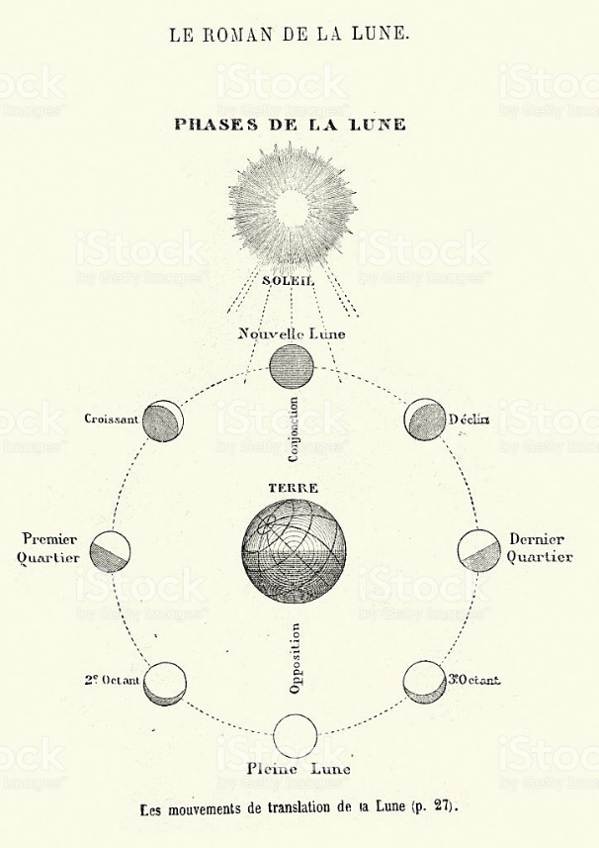
Figure 1: a diagram of the phases of the moon from Jules Verne’s From the Earth to the Moon. Astronomical calculations were one of the earliest uses of statistical science.
Science fiction, then, taught its contemporaries to conceive of their world by teaching them to conceive of the workings of fictional worlds through data. They’re able to do this primarily because, as I have argued elsewhere (Klimchynskaya 2019), works of science fiction perform scientific rigor, thus positioning themselves as scientific texts and inviting the reader to read them as such. Taking as my example Jules Verne’s Extraordinary Voyages, I argued that “they ask the reader to correlate different kinds of data, both textual and visual, while challenging their ability to read for narrative or suspense.” (Klimchynskaya 2019) Through jarring terminology (primarily Latin nomenclature describing the most everyday of objects), maps that give away the trajectory of the story, calculations, and footnotes, the stories preclude suspense and take the reader out of the narrative, forcing them into a detached (and thus “scientific” and analytical) stance in regards to the text. Thus, the conceits or “literary technologies” that make up the text invite – nay, require – the reader to practice scientific ways of reading, necessitating skills such as parsing data, making calculations, processing new information, and confronting unfamiliar terminology.
It is important to note that these skills are not explicitly taught by the narrative, but rather, an implicit part of consuming the narrative, acquired through the process of reading them. Verne’s novels, for example, were written in part to popularize science for both children and adults, and enjoyed a wide readership. Making up for what Verne’s editor Hetzel felt was a distinct lack in in public school education, the novels introduced its readers to basic scientific and technological principles through explanations by its scientist protagonists. But in addition to the explicit scientific facts directly expounded, the novels also allowed the reader to learn the very skills of consuming and processing such scientific and technical information. Consider, then, for example, one of Captain Nemo’s scientific explanations in Twenty Thousand Leagues under the Seas:
[quote]
Such an explanation is not unlike one a reader might encounter in a newspaper or journal intended for a lay public, explaining the workings of a new cutting-edge technology. [example here] In particular, this excerpt includes a host of technical terminology drawn from Greek and Latin. Such terminology would have been ubiquitous in the nineteenth century, when a host of new inventions – telephones, telegraphs, phonographs, electroscopes, telephonoscopes, etc – written about in the newspapers were literally named using such classical etymology. Thus, the reader here is being taught not only the principles themselves of how electricity can create motive force, but how to read and parse that kind of specialized information and make sense of the unfamiliar terminology within that explanation. These were skills l that, as I have argued above, was fundamental to the practice of perusing printed matter within technological modernity, and of keeping up with the workings of a deeply technologized society.
In addition to processing new information and terminology, science fiction asks the reader to read “scientifically” by making calculations, parsing data, reading maps, and correlating such information with the textual narrative. For example, throughout Twenty Thousand Leagues under the Seas, Verne’s protagonist Arronax continuously provides the latitude, longitude, date, and time of day for the submarine Nautilus’ travels, as in the following passage:

The Nautilus kept its south-east heading. On December 1st, it cut across the equator at 142° longitude, and on the 4th of the same month, after a rapid crossing with no notable incidents, we saw the Marquesas islands. I spotted Point Martin of Nouka Riva three miles away, at latitude 8° 57′ south and longitude 139° 32′ west.
Importantly, the information contained within this passage only becomes meaningful through correlation with another piece of information provided by the text: a map of the Earth that traces the Nautilus’ entire journey. It is through cross-referencing the submarine’s trajectory with nearby land masses (Nouka Hiva, the Marquesas Islands) that the reader can place the submarine on a map, This map gives away the entire trajectory of the Nautilus, precluding reading for suspense – but it does teach the reader to correlate information such as latitude, longitude, date, and time (provided textually) with a map, thus teaching the to cross-reference different kinds of data and make it fit together.
Another example is Rudyard Kipling’s 1912 science fiction novel With the Night Mail, which follows a narrative of the adventures of an aerial postal delivery craft with an appendix of all sorts of data: advertisements, weather reports, the rules of the Aerial Board of Control, and reviews (see, for example, Figure 2). In short, it brings to life a fictional world through different kinds of data: traffic laws, weather (temperature, pressure, etc) records, advertisements that include prices and technical specifications. As Michael Saler points out, all these “incidental facts” – not at all necessary to understanding the narrative itself – “reveal how dirigibles upplanted airplanes as major modes of conveyance; how all air transport (and thus nearly all commerce) is governed by a worldwide organization known as the Aerial Board of Control…how the average human lifespan has been extended thirty years due to the beneficial consequences of travelling in the thinner air of high altitudes.” (82) It must be noted, too, that much of this data (in particular, the advertisements) resemble the kind of data alongside which the story itself would have been published in The Windsor Magazine. Just as a reader might develop a conception of what is going on in the fictional world from such data, then, a reader might be expected to develop a conception of what is happening in the real world from correlating amongst similar data, such as what is for sale, what the prices are, what the weather is, what the state of particular forms of travel is, and so on.
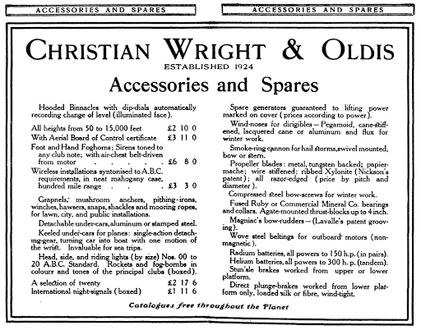
Figure 2. “Advertisement” from the Appendix of With the Night Mail.
[Calculations in Jules Verne’s de la Terre a la Lune ?]
Part III: Humanity Unmoored
The first half of this paper considered the way science fiction made individual and social existence legible in the present, through statistical and numerical “technologies” intended to trace the functioning of social whole. This part, by contrast, considers how science fiction in the nineteenth century made humanity’s place in time legible and comprehensible. For, in this period, humanity began to feel unmoored in time.
In 1785, James Hutton published his Theory of the Earth, followed in 1830-1833 by Charles Lyell’s The Principles of Geology. Both expounded Uniformitarianism – the idea that the Earth had been slowly and uniformly changing over millennia. Their texts, as well as the paleontological discoveries being made in the period, led to the emergence of the notion of deep time: that is, geological time that suggested that the Earth was much older than had been previously believed. On the basis of the geological and fossil record, these disciplines revealed that humanity had not been in existence for nearly as long as the Earth itself – in fact, that human history was merely a blip on the radar of the Earth’s history. Even more than that, deep time posed an epistemological problem: its span is so vast, and the geological changes the Earth undergoes so slow compared to the human lifespan, that neither can be conceived of by the human imagination. Lyell himself emphasized “how fatal every error as to the quantity of time must prove to the introduction of rational views concerning the state of things in former ages.” (66) Moreover, this lengthy past was quite literally illegible: as Lyell maid painfully clear, only limited traces remained of this incomprehensibly long span of years, and so to attempt to read a history of the past in the geological record was to attempt to reconstruct an entire narrative from mere fragments. Humanity, then, struggled not only to place itself within that inconceivably vast history, but also to read that vast history – a problem only exacerbated by Darwin’s 1859 On the Origin of Species. Drawing heavily on Lyell’s work, it corroborated the idea that other species had existed before humanity and insisted that humanity’s dominant place in the world was the product of lengthy processes dictated by nothing more than chance. It suggested “that man was not fully equipped to understand the history of life on earth and that he might not be central to that history.” (Beer, 15) More than that, Darwin’s work, with its emphasis on chance, precluded “the idea of a historical teleology, culminating in the literally blank.
In the sphere of human history, too, the nineteenth century, frequently termed the “Age of Revolutions,” was a time of great unmooring. The French Revolution inaugurated a new historical consciousness: a “recognition of the past as different and of the present as dislodged from what had gone before.” (Samuels, 4) Replacing a sense of continuity with the past was a sense of rupture, as the past was felt to be distinctly different, even as it was being, quite literally, erased. Begun in 1853, Haussmann’s transformation of Paris razed medieval neighborhoods, replacing them with the regular, perfectly proportioned, and identical apartment buildings of today. In fact, the very post of Inspector General of Historical Monuments had only been created some twenty years prior, in 1834, after Victor Hugo penned the novel Notre Dame de Paris to protect the eponymous cathedral and galvanize the public toward restoring it. The nineteenth century’s attitude toward its past was at best ambivalent. There is a certain irony, then, in the fact that even as humanity was slowly becoming aware of just how limited the physical traces of the Earth’s history were, the physical traces of the human past were being systematically removed in the name of progress and modernization.
These factors were exacerbated by multiple others: with the creation of new technologies of communication and transportation, it seemed, quite literally, to pass more quickly (Koselleck, Schivelbusch). The nature of modern life seemed momentary and fleeting, so much so that an entire artistic movement – Impressionism – arose around capturing this instantaneity. At the same time, “philosophical and literary interest in the future increased over the course of the nineteenth century,” (Grubbs, 14) as the future ceased to be the domain of prophets and astrologers to became a serious consideration. These new experiences of time created a new subjectivity: “as such fundamentals as space and time were challenged, the Victorians were existing differently.” (Childers, quoted in Ferguson, 4) Time and the future, then, became serious, frightening, and problematic considerations.
This may seem like a deeply abstract problem, but it was, in fact, a [deeply relevant one]. For one thing, the deep existential malaise that led to the term fin-de-siecle, and its effects on social order, should not be discounted. If teleology had been removed from human history due to Darwin, then there was the pervading question of what it was all for – what ends human society, and the British Empire in particular, should tend towards. How could one define “progress” if its end goal was no longer distinct and recognizable? For another, there was a distinct awareness that even if the past was illegible, the same processes that shaped it were also presently (and invisibly) shaping human existence: [coal].
There was a pervasive need then, to anchor oneself in time, both individual and collectively. Imaginaries, which are by definition collective, were needed that would imagine humanity’s place in time. There are many ways that the cultural production of the time went about doing this, but they all come down to mapping time onto space, both because the processes of deep time could only be read in the physical traces left upon the earth, and because physical space offered an effective visual shorthand. Here, I am reminded of my visit to Jules Verne’s hometown of Nantes in the summer of 2017, when I took a tram the museum that was his childhood home. At the time, the city of Nantes had transformed the tram line into a kind of paleontological museum: each station represented a different period of prehistory – the Jurassic, the Cretaceous, etc – and descriptive panels informed the rider that each meter the tram travelled represented thousands of years of history. This conceit transformed this simple means of transportation into a time machine, making tangible the span of prehistoric time by using physical space. That is, it mapped prehistory onto physical space. Such an approach is useful conceiving of the numerous diagrams of the “strata” of time produced in the nineteenth century, such as the following:
[Figure 1]
These diagrams take as their premise the very simple fact that the farther down one digs into the Earth, the older the traces of the processes of deep time that one finds. Each stratum represents a period of geologic time, while also being premised in a kind of epistemological ideal of perfect knowledge – for, of course, the traces of each of these geologic periods were scarce and incomplete, and the diagram itself based in extrapolation. Visually, then, this diagram represents the various epochs of the earth spatially – just as, in Jules Verne’s Journey to the Center of the Earth, the heroes travel backwards in time as they descend farther and farther into the center of the Earth, traversing the various epochs of the Earth’s past and rendering it with painstaking descriptions of its geology, flora, and fauna.
With the uncertainty of humanity’s place in time in regards not only to the past, but also the future, science fiction, too, engaged in such “geologic” mapping of the epochs of the future onto physical space. This allowed works of science fiction to serve as diagrams of the layers of (future) time, and to function as blueprints for the future – which, even if inaccurate (as predictions of the future sometimes may be), nonetheless served as a collective set of imaginings shared among individuals.
The best example of this phenomenon is the works of prolific French science fiction author and illustrator Albert Robida, who, as an illustrator of his own novels, engaged in exactly this kind of spatial mapping of time. I focus primarily on his 1882 novel Le Vingtieme Siècle, the first of a trilogy set in the Paris of 1952, and which depicts a future in which the cutting-edge technologies of the nineteenth century have become developed, ameliorated, and disseminated throughout society. They have penetrated into the domestic sphere and reshaped daily life on every level, and the story focuses on the Ponto family– M. and Mme. Ponto, their two daughters Barbe and Barnabette, and their adoptive daughter Helene Colobry– as they live in this strange new world. In particular, the narrative follows the protagonist Helene as she attempts to find herself suitable employment in this technologically-advanced future, trying out a variety of professions and consequently allowing Robida to provide the reader with a tour-de-force of his elaborately-designed world. Blending word and image, he depicts an elaborate, immersive the world of the future, in which the city of Paris becomes a temporal palimpsest: the layers of time are literally stacked upon each other. Unlike the fading traces of deep time, then, Robida’s future exists in explicit, legible relation to the reader’s present.
Consider, for example, Robida’s illustration of the International Hotel at the top of the Arc de Triomphe, one of many illustrations that draw on familiar Parisian landmarks:
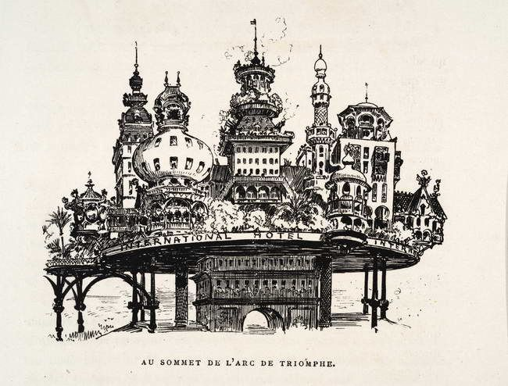
[Figure ]
This illustration puts this futuristic edifice – a union, Robida tells us, both of peoples and of architectural styles – literally on top of the Arc de Triomphe, a monument commissioned by Napoleon in 1806 and recalling a particularly turbulent period of French history. The future exists atop the present (or, from the perspective of a Parisian of 1952, the present exists atop the past), but both are imminently legible. In fact, the illustration recalls the layers of history in diagrams such as the one in Figure 1, though of course here the subject is human, rather than geological, history. Past and future, the passage of time – all here are neatly delineated, mapped onto space, recognizable and comprehensible. The future does not erase the past but builds atop it – a powerful image in an age of revolutions, and one that gives meaning to a present that had lost its sense of telos.
Robida’s future, then, is deeply legible in relation to the cultural touchstones of the present – a sharp contrast to the literal razing of the past being experienced as part of Hausmann’s project of rebuilding Paris in the second half of the nineteenth century. As mentioned above, Hausmann bulldozed entire medieval neighborhoods, replacing them with modern-day apartment – and in doing so, left only fragmentary traces of the past, much like the fragmentary traces that remained of the Earth’s previous geologic epochs. In contrast to the nineteenth century’s literally vanishing past and blank future, then, Robida’s palimpsestic vision must have been a reassuring one:

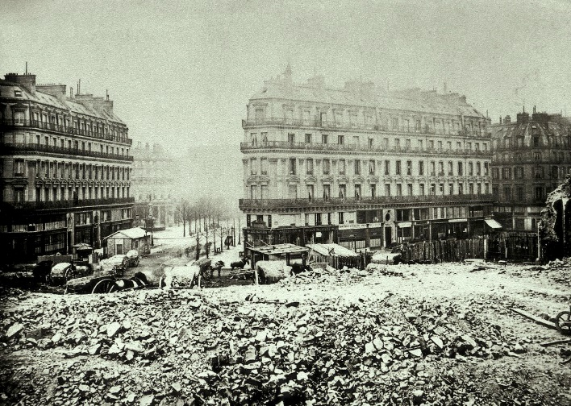
Demolition of Butte des Moulins for the Ave de l’Opera Au Sommet de l’Arc de Triomphe
Past, present, and future frequently appear and intermix as well in the novels of Jules Verne: for example, in his journey on the Nautilus, a futuristic submarine, Arronax is frequently confronted with the undersea remains of long-lost civilizations. Verne’s novels are full of futuristic technologies, and he was considered something of a prophet of modernity by his contemporaries. It is not surprising, then, that these contemporaries drew on Verne as a kind of blueprint to articulate their understanding of the present, the future, and the cutting-edge technologies they were being confronted with. Speeding into a future newly blank, they saw Verne’s novels as maps, or perhaps mile markers in relation to which one might understand contemporary inventions. [examples here from contemporary newspapers – references to Verne to theorize about the future or explain discoveries]
[Conclusion]

I sketch here only a brief summary, for to explore in detail the rise of scientific popularization in the nineteenth century is far beyond the scope of this article. For more on this subject, see Klimchynskaya (manuscript under review), Evans, Bensaude-Vincent.
Reference here to Gottschall, Oatley, flight simulator? Which I talk about more elsewhere
(Gallagher 1994, 273-288): eighteen-century novelists attempted to methodically diminish affective response by periodically interrupting the narrative explore)
It should be noted that the writing of this period frequently drew parallels between the turbulent historical revolutions of the past century and the cataclysmic changes some geologists read in the Earth’s past.
Sheila Jasanoff, “Future Imperfect: Science, Technology, and the Imaginations of Modernity,” in Dreamscapes of Modernity: Sociotechnical Imaginaries and the Fabrication of Power, eds. Sheila Jasanoff and Sang-Hyun Kim (Chicago: University of Chicago Press, 2015), pp. 1-33, p. 6.
Charles Taylor, Modern Social Imaginaries (Durham, NC: Duke University Press, 2003), p. 108 (emphasis mine).
Ajun Appadurai, Modernity at Large: Cultural Dimensions of Globalization (Minneapolis: University of Minnesota Press, 1996), p. 31 (emphasis mine).
Sheila Jasanoff, “Imagined and Invented Worlds,” in Dreamscapes of Modernity: Sociotechnical Imaginaries and the Fabrication of Power, eds. Sheila Jasanoff and Sang-Hyun Kim (Chicago: University of Chicago Press, 2015), pp. 321-341, p. 337.
Sheila Jasanoff, “Imagined and Invented Worlds,” in Dreamscapes of Modernity: Sociotechnical Imaginaries and the Fabrication of Power, eds. Sheila Jasanoff and Sang-Hyun Kim (Chicago: University of Chicago Press, 2015), pp. 321-321, p. 337.
Taylor, Modern Social Imaginaries (above, n. 99), p. 22.
Arthur Evans, Jules Verne Rediscovered: Didacticism and the Scientific Novel (Westport, CT: Greenwood Press, 1988), p. 9.
Bensaude-Vincent, “un public pour la science” (above, n. 16), p. 5.
Verne, Vingt mille lieues (above, n. 30), p. 208.

