How To Use The AstroImageProcessor RGB Plot Wizard
- Download AstroImageProcessor (http://www.nowinski.com/downloads/AstroImageProcessor.jar).
- Ensure Java is installed (https://www.java.com/en/download/).
- Ensure you have (at least) 3 FITS images taken with 3 different color filters (e.g., g’, r’, and i’; or B, V, and R).
- Double-click on AstroImageProcessor.jar (the file you downloaded in Step 1!) to start the program.
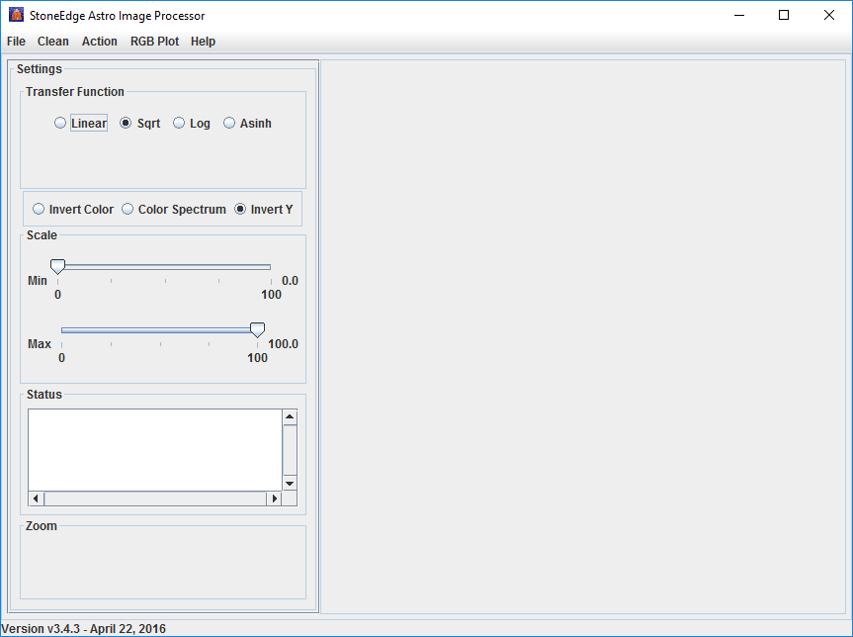
- Click RGB Plot | RGB Plot Wizard.
- To begin, you will need to identify the FITS images that you will use for the “red”, “green”, “blue” (and “reference”) channels in your final image.
- Open the FITS file to which you want to assign the “red” color in your final image (in this case, the i’ filtered image).
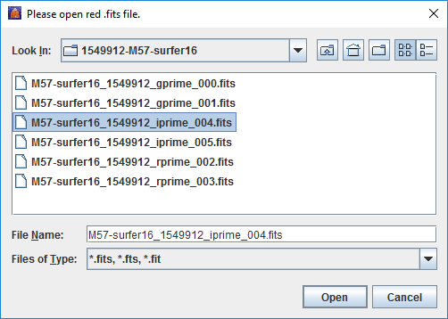
- Open the FITS file to which you want to assign the “green” color in your final image (in this case, the r’ filtered image).
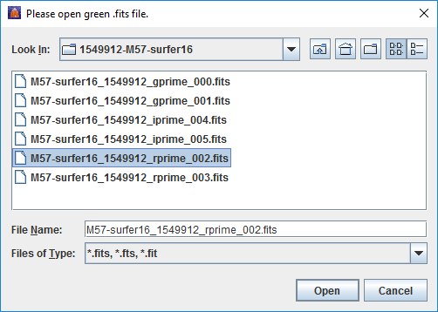
- Open the FITS file to which you want to assign the “blue” color in your final image (in this case, the g’ filtered image).
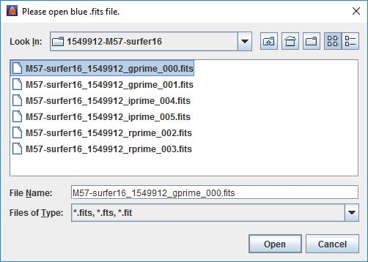

- Open the FITS file which you want to use as a “reference” for combining the three colors in your final image. NOTE: This is usually the same FITS file you chose for “red” in Step 6.
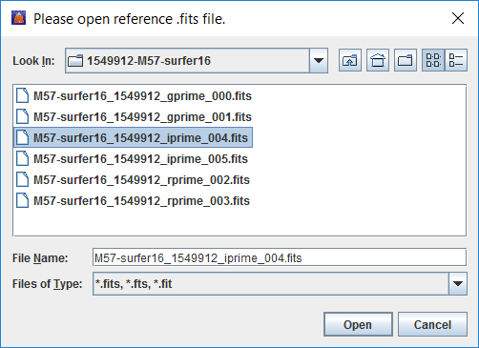
- In the next three steps, you will align the three images you chose for “red”, “green”, and “blue”. In each step, two images will be overlayed, one “tinted” red, one “tinted” blue.
- Click on a bright star in the rightmost image. A close-up view of that star will be presented in the leftmost image. If the images are not aligned, you will see both red and blue “versions” of the star.
- Use the Up, Down, Left, and Right buttons to align the two images. Click Save.
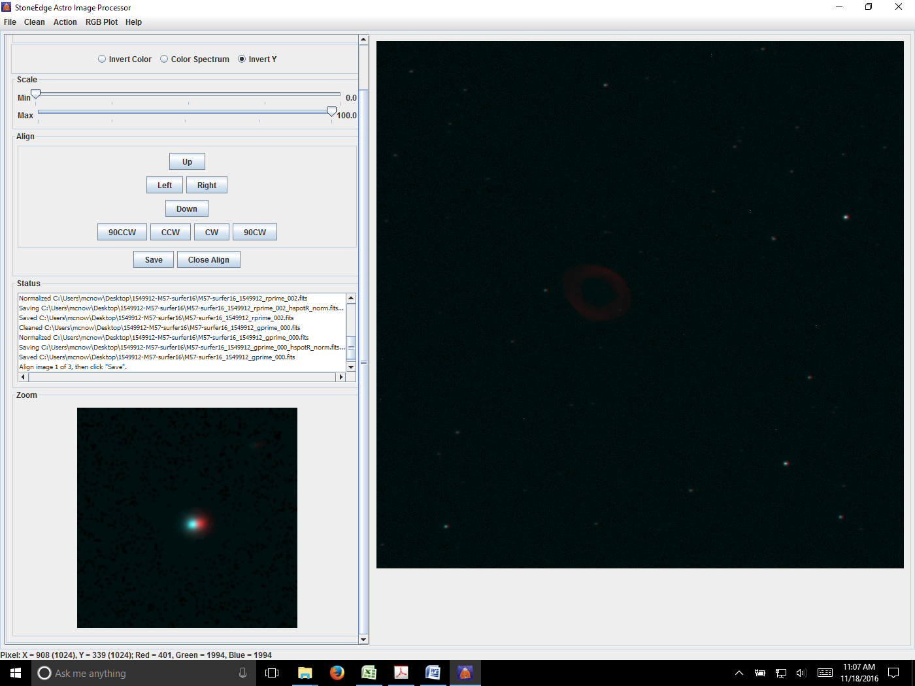
- Repeat Steps 12 and 13 two more times to complete the alignment.
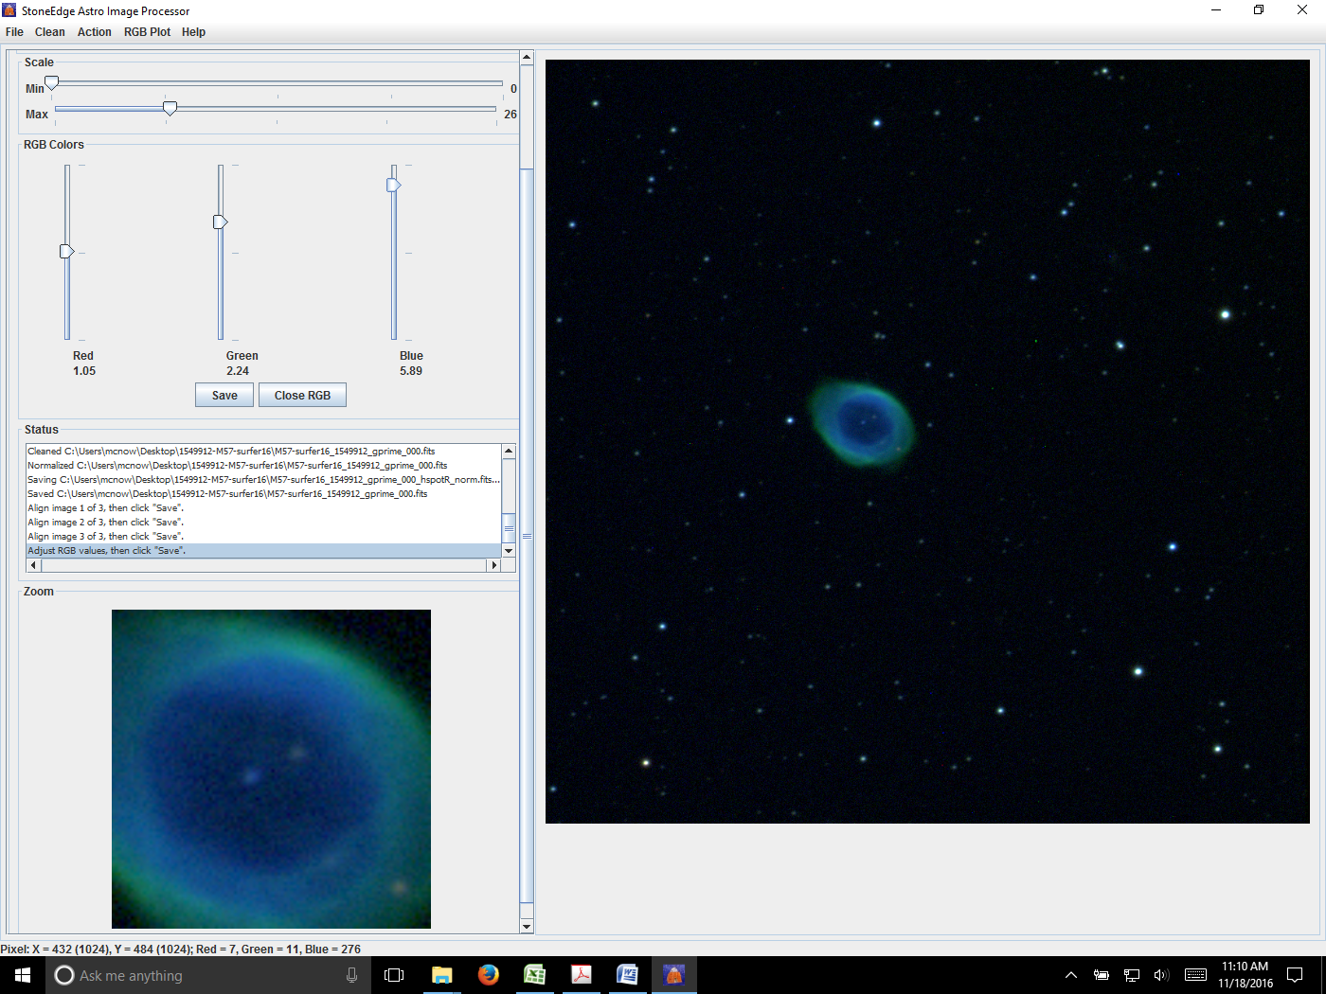
- Use the Scale Min/Max and RGB Colors Red/Green/Blue slider bars to adjust the brightness, contrast, and color of the image, as desired.
- Click Save.
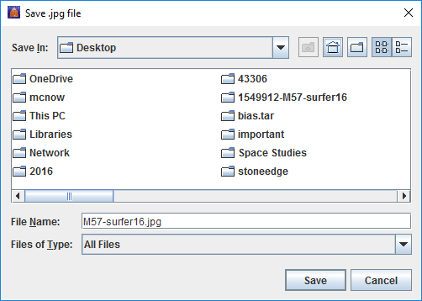
- You’re done! Now, get out there and post your color image to your favorite astrophotography gallery!

